

Property Management System Replacement (PMSR)

Release 2
System Delivery Specification (SDS)
Solution Definition

Version 1.0

Release History
Author(s): Karthik Krishnamoorthy, Hemant Salvi
Date Created: 12/08/2008
Date Modified: 01/18/2009
Purpose: The System Delivery Specification describes the analysis (platform-independent definition) of the proposed solution. The primary work products are the interface definitions, analysis model and data model.
Audience: The System Delivery Specification is usually written by the IT Analyst to obtain Business and Project Management approval. The project team will use this document as input to the other phases/modules.
Routes | Activity Guidance
EN-Enhancement | Complete the Combined SRA & SDS instead.
IN-Infrastructure | Complete a System Prospectus instead.
LC-Large Custom | Complete all sections of this document as directed in the tips.
LP-Large Package | Complete all sections as this document directed in the tips.
NT-Non-Technical | Complete the Combined SRA & SDS for non-technical projects only (minus any user interfaces or detailed design models).
SC-Small Custom | Complete the Combined SRA & SDS instead.
SP-Small Package | Complete the Combined SRA & SDS instead.
VS-Vendor Solution | Complete a System Prospectus instead. The vendor is required to provide the design specification.
For more information, refer to the following references:
- LCM Activity Guidance: http://sena-webapps.wdw.disney.com/lcm%5Fsupport/
- Solution Definition Framework: http://wm-flor-dvvm002/SDF/sdf.htm
- SUMMIT Methodology: http://wdwsummit/

Copyright Notice
This document (written or otherwise displayed on magnetic media or other medium) contains confidential and proprietary information of The Walt Disney Company or its affiliates.
It has been furnished only for informational purposes, and no license or permission is hereby granted to use such information in any manner.
In no event may this information be reproduced, distributed and/or publicly displayed in any form or by any means without prior expressed written permission of Walt Disney World Co.
© Disney. All rights reserved.

Revision History:
Version | Date | Name | Description
0.1 | 12/08/2008 | Siva Govindarajan | Started the draft.
0.2 | 12/31/2008 | PMSR Design Team | Completed draft version. Added Domain , Services and System Interaction diagrams
0.3 | 1/6/2008 | Siva Govindarajan | Updated after the initial feedback from Hemant.
0.4 | 1/8/2008 | Siva Govindarajan | Updates after the second round of feedback from Hemant.
0.5 | 1/09/2009 | Hemant Salvi | Analysis Model authoring
0.6 | 1/10/2009 | Karthik Krishnamoorthy/Hemant Salvi | Authored the Key Features and Business Objectives and System Impacts
0.7 | 1/12/2009 | Karthik Krishnamoorthy/Hemant Salvi | Added System Context and Solution Architecture
0.9 | 01/16/2009 | Hemant Salvi | Reviewed and incorporated final changes
DRAFT | 1/16/2009 | Karthik Krishnamoorthy | Final revisions
1.0 | 02/07/2009 | Hemant Salvi | Incorporated feedback based on reviews
1.1 | 03/03/2009 | Hemant Salvi | Incorporated Pauls Feedback
Key Contributors:
Name | Role | Email
Karthik Krishnamoorthy | Technical Manager | karthik.krishnamoorthy@capgemini.com
Hemant Salvi | Solution Architect | Hemant.a.salvi@capgemini.com
Pradeep Krishnamurthy | Development Manager | Pradeep.krishnamurthy@capgemini.com
Sushant Upadhyay | Res Mgt Design | Sushant.upadhyay@capgemini.com
Sudhir Byna | Folio and Acct Design | Sudhir.byna@capgemini.com
Ganesh Shete  Bhavin Gandhi | Room Inventory Design | Ganesh.shete@capgemini.com  Bhavin.gandhi@capgemini.com
Siva Govindarajan  Jagadish Pasunuri | External Interface Design | Sivaraman.govindarajan@capgemini.com  Jagadish.pasunuri@capgemini.com
Shendge (Onkar) Hemchandra | User Interface Design | Hemchandra.shendge@capgemini.com
Mangesh Patil | Technical Architect | Mangesh.patil@capgemini.com

Table of Contents
1. Introduction 11
1.1 Scope 11
1.2 Business Objectives 11
1.3 Audience 12
1.4 Assumptions 12
2. Solution overview 13
2.1 System Context Diagram 13
2.1.1 User Interfaces 14
2.1.2 Business Domains 14
2.1.3 Conceptual Domain Model 15
2.1.4 Overview of Services 16
2.2 Salient Features 17
2.2.1 Single System of Record for Room Reservations 17
2.2.2 Attribute Level Fulfillment 17
2.2.3 Special Request Fulfillment 17
2.2.4 Automated Room Assignment 17
2.2.5 Seamless Guest Experience 18
2.2.6 Centralized Accounting 18
2.2.7 Multiple Campus Support 18
2.3 Key Architecture Features 19
2.3.1 Service Oriented Architecture (SOA) 19
2.3.2 User Interface Framework 19
2.3.3 Robust Notification Service 19
2.3.4 Enhance Folio / Accounting Performance 20
2.3.5 Coarse Grained Module Level Interactions 20
2.3.6 Decouple Guest and Travel Plan Interactions 21
2.3.7 Direct Point to Point Communications 21
2.3.8 Enhance External Interfaces 21
3. Solution Architecture 22
3.1 Business Architecture 22
3.1.1 Business Domain 22
3.1.2 Component 22
3.1.3 Business Service 22
3.1.4 Component Service 22
3.2 Technology Architecture 24
3.3 Data Architecture 25
3.4 Security Architecture 26
3.4.1 User Security 26
3.4.2 Credit Card Security 26
3.4.3 Service Security 26
3.4.4 Data Security 26
3.4.5 Security Level 27
4. System Impacts 28
4.1 DREAMS Enhancements 28
4.1.1 Folio & Accounting 28
4.1.2 Reservation Management 29
4.1.3 Profile Management 30
4.1.4 Service Request Management 30
4.1.5 Housekeeping Management 30
4.1.6 Inventory Management 30
4.2 External System Impacts 31
4.2.1 D3 – Data warehouse 31
4.2.2 BI / Reporting 31
4.2.3 OneSource 31
4.2.4 DSCS 32
4.2.5 Stratus 32
4.2.6 Recommender 32
4.2.7 Payment and Auth Service (Credit Card Reference) 32
4.2.8 Ticketing Interface 32
4.2.9 Maximo 32
4.2.10 DME 32
4.2.11 RVS 33
4.2.12 HSIA 33
4.2.13 Pricing 33
4.2.14 WDPro 34
4.2.15 EAI 34
4.2.16 Avail 34
4.2.17 DPMS 34
4.2.18 DVC DPMS 34
4.2.19 TARS 34
4.2.20 DVC Corp 35
5. Implementation Strategy 36
5.1 Phased Roll-out Approach 36
5.1.1 Assumptions 36
5.2 Initial Roll-out 37
5.3 First Property / Partial Roll-Out 38
5.4 Complete Roll-out 39
5.5 External Interfaces Roll-out 40
5.5.1 Inbound Interfaces 40
5.5.2 Outbound Interfaces 41
6. Reservation Management 42
6.1 Domain Model 42
6.1.1 Reservation 43
6.1.2 Travel Plan 43
6.1.3 Travel Plan Segment 43
6.1.4 Travel Component Grouping 43
6.1.5 Travel Component 44
6.1.6 Guest Message 44
6.1.7 Rooming List/Mass Option 45
6.1.8 Party 46
6.1.9 KeyToTheWorld (KTTW) 46
6.2 Services 48
6.2.1 AccommodationSalesService 49
6.2.2 TravelPlanSegmentService 50
6.2.3 AccommodationFulfillmentService 50
6.2.4 Rooming List Service 50
6.2.5 TravelPlanService 50
6.2.6 AdmissionSalesService 51
6.2.7 AdmissionFulfillmentService 51
6.2.8 DMEService 52
6.2.9 KTTWService 52
6.3 System Interactions 52
6.3.1 Book Room Reservation 52
6.3.2 Modify Room Reservation 55
6.3.3 Cancel Room Reservation 58
6.3.4 Cancel TravelPlanSegment 59
6.3.5 Re Instate Room 60
6.3.6 Re Instate Travel Plan Segment 61
6.3.7 Share Rooms 61
6.3.8 Maintain Comments 62
6.3.9 Check-In 63
6.3.10 CheckOut 65
6.3.11 CheckIn Not Arrived 66
6.3.12 Pre-Arrival Ticket CheckIn 66
6.3.13 Complete CheckIn 67
6.3.14 Create Service Request 68
6.3.15 Fulfill Service Request 68
6.3.16 Override Accommodation Rate 69
6.3.17 Upgrade Resort or Room Type 70
6.3.18 Upgrade For Count 71
6.3.19 Upgrade Party Mix 71
6.3.20 Upgrade Package 74
6.3.21 Upgrade Dates 76
6.3.22 Book Day Guest Tickets 77
6.3.23 Add Ticket For Resort Guest 78
6.3.24 Exchange Ticket 79
6.3.25 Fulfill WillCall 79
6.3.26 Upgrade Ticket 80
6.3.27 Void Ticket 80
6.3.28 Create and Refill Ticket Bank 81
6.3.29 Cut Key 81
6.3.30 Modify Access 82
6.3.31 Replace Key 82
6.3.32 Late CheckOut Request 82
6.3.33 Maintain Template 83
6.3.34 Create Mass Reservation 83
7. Folio Management 84
7.1 Domain Model 84
7.1.1 Charge Group 85
7.1.2 Charge Allocation 85
7.1.3 Bill Codes 86
7.1.4 Folio 86
7.1.5 Charge 87
7.1.6 Payment 90
7.1.7 Settlement Method 94
7.1.8 Transaction 95
7.1.9 Bank in, Bank Out 97
7.1.10 Commissions 99
7.2 Services 101
7.2.1 ChargeService 102
7.2.2 PaymentService 102
7.2.3 FolioChargeService 103
7.2.4 FolioPaymentService 103
7.2.5 FolioService 103
7.2.6 ChargeGroupService 104
7.2.7 BankInService 105
7.2.8 CommissionsService 105
7.3 System Interactions 106
7.3.1 Post Charge 106
7.3.2 Bill Trap Process 108
7.3.3 Charge Group State Transition 110
7.3.4 Check Out 110
7.3.5 Check In Folio 111
7.3.6 Payment Process 112
7.3.7 Payment trap Process 115
7.3.8 Recognize Charge 115
7.3.9 Recognize Payment 116
7.3.10 Re-filter Process 116
7.3.11 Transfer Process 118
7.3.12 Bank-In Process 119
7.3.13 Bank-Out Process 119
7.3.14 Bank-Out Event 119
7.3.15 Calculate Commissions 120
7.3.16 Reconcile Commissions 120
7.3.17 Create AP Commissions 120
7.3.18 Commissions State Transition Diagram 121
7.3.19 Commissions Activity Diagram 121
8. Inventory Management 122
8.1 Domain Model 122
8.1.1 Assignment Owner 122
8.1.2 Assignment Request 122
8.1.3 Resource 123
8.1.4 Assignment 123
8.1.5 Inventory Resort Configuration 123
8.1.6 Inventory Room Configuration 125
8.1.7 Campus, Resort and Location Configuration 129
8.2 Services 132
8.2.1 AccomomodationInventoryRequestService 132
8.2.2 AccommodationInventoryService 132
8.2.3 AccommodationInventoryServiceRequestService 133
8.2.4 AccommodationAssignmentService 133
8.2.5 AccommodationStatusService 133
8.3 System Interactions 134
8.3.1 Create Inventory Status Request 134
8.3.2 Complete / Cancel Inventory Status Request 134
8.3.3 Retrieve Room Counts 135
8.3.4 Assignment Owner State Transition 135
8.3.5 Status Transitions 136
8.3.6 Auto-Room Assignment Process 137
8.3.7 Adjust Room Counts Process 138
9. Profile Management 139
9.1 Domain Model 139
9.1.1 Profile Management 139
9.2 Services 141
9.2.1 ProfileService 141
10. Service Request Management 142
10.1 Domain Model 142
10.1.1 Service Request 142
10.1.2 Special request 142
10.1.3 Bell Service Request 142
10.1.4 Inventory Request 143
10.1.5 Late CheckOut Request 143
10.2 Services 144
10.2.1 ServiceRequestService 144
11. Entitlement Management 145
11.1 Domain Model 145
11.1.1 Entitlement Plan 145
11.1.2 Coupon 145
11.1.3 Coupon Profile 145
11.2 Services 147
11.2.1 Entitlement Service 147
11.3 System Interactions 148
11.3.1 Share Un-Share Entitlements 148
11.3.2 Unshare Entitlements 148
12. Accounting Management 149
12.1 Domain Model 149
12.1.1 Accounting Centers 149
12.1.2 Natural Posting Item Configuration 150
12.1.3 Offset Posting Group Configuration 150
12.1.4 Analysis Ledger 152
12.2 Services 153
12.2.1 AccountingService 153
12.3 System Interactions 154
12.3.1 Accounting Process 154
13. System Interfaces 156
13.1 User Interfaces 156
13.1.1 Reservation Management 157
13.1.2 Check In Process 158
13.1.3 Folio Management 159
13.1.4 Recommend Tickets 160
13.1.5 Resource Inventory Management 161
13.1.6 Group enhancements 162
13.1.7 Accounting Admin Screens 163
13.1.8 UI Storyboards 163
13.2 External Interfaces 164
13.2.1 Interface Interactions 177
13.3 Batch Interfaces 183
13.3.1 System Dates 183
13.3.2 Batch schedule 183
14. Data Model 187
14.1 Logical Data Model 187
15. Glossary 188
16. Signature Page 191

Introduction

The Disney Property Management Replacement (“PMSR”) Project is a strategic Disney initiative to develop a future state Property Management system that is agile, service oriented and capable of supporting continuously changing business needs.
The project is built and delivered in two phases. Release 1, which delivered the Housekeeping functionality and Release 2, which is delivering the rest of the property management functionalities.

Scope
The Release 2 Service Delivery Specification (“SDS”) document addresses the overall solution design for the Release 2 phase of the PMSR project. It covers the following solution areas:
- Solution Overview
- Solution architecture
- System Impacts
- Analysis model
- System interfaces

Business Objectives
The PMSR solution is guided by the following business objectives defined as part of the project charter:
- Intuitive interface designed for a user friendly experience with Single Sign on Capabilities.
- Streamlining the Check in Process.
- Full campus processing
- Single guest record for reservation and folios
- Group Enhancements support for automated rooming lists
- Centralize accounting functionalities across sales and fulfillment systems
- Multi-currency support
- Seamless Key experience for the Guest’s entire length of stay.
- Enhanced room and rack assignment
- Resort ticketing and sales recommender

Audience
This document caters to the following audience:
- Project Management Team: To gain an understanding of the high level view of the proposed solution, validate the solution against the project charter, to understand the scope involved with any external teams and monitor the implementation plan based on the analysis artifacts.
- Business: To understand the technical solution to ensure and validate the solution against the program charter
- Requirements Team: To validate the requirements realized as part of the composite solution and system interactions.
- Application Architecture Team: To ensure that the proposed solution aligns with the Disney architecture standards and future state vision.
- Development Teams: To be validated and understood by the impacted IT Teams for the ultimate development of the solution.
- QA Team: To gain an understanding of the proposed solution and trace back to the use case requirements to ensure it is tested appropriately.
- Production Support Teams: To understand the solution and the implementation in order to better support the solution once it is in production.

Assumptions
The following assumptions govern the PMSR Release 2 solution design:
- All history information will be stored in D3. This includes accounting and room administration data history
- Charge history, which is currently stored in DREAMS database will be moved to D3. Data conversion will not convert the charge history into the new system. For existing reservations in DREAMS, the current history information stored in D3 will be used for providing charge history functionality.
- The PMSR solution will be deployed on P Series hardware.
- Credit Card numbers will not be stored in the DREAMS Database.
- Will Call Reservation numbers stored in DREAMS are valid Ticket Reservation numbers in ATS
- Due to the change to the DREAMS data model, the current state DREAMS Accounting, Folio and Reservation management reports will be impacted. They will be analyzed and changed by the BI/Reporting team to map to the new DREAMS data model.

Solution overview

PMSR is a strategic Disney initiative to extend the solid foundation laid by the DREAMS to support the fulfillment needs of the resort operations and address some key performance concerns of DREAMS applications along with supporting new architectural directions set forth by the Disney IT architecture.
The DREAMS system currently stores the bookings for Room reservations. It will be undergoing the following enhancements between now and the completion of the PMSR program.
- Scheduled Events: As part of the Scheduled Events project initiative, scheduled events reservations will be migrated to DREAMS as the sales system of record.
- PMSR: As part of the PMSR project, DREAMS will be consolidated as the system of record for the sales and the fulfillment functionality for rooms.
- DVC Phase 1B: As part of the related DVC Phase 1B project initiative, the DVC reservations will also be migrated to DREAMS to enable seamless fulfillment of DVC member reservations.
Note: PMSR Release 2 and DVC Phase 1B projects are being implemented as a unified program and will be deployed together into production.

System Context Diagram
The following picture depicts the system context for the PMSR solution:
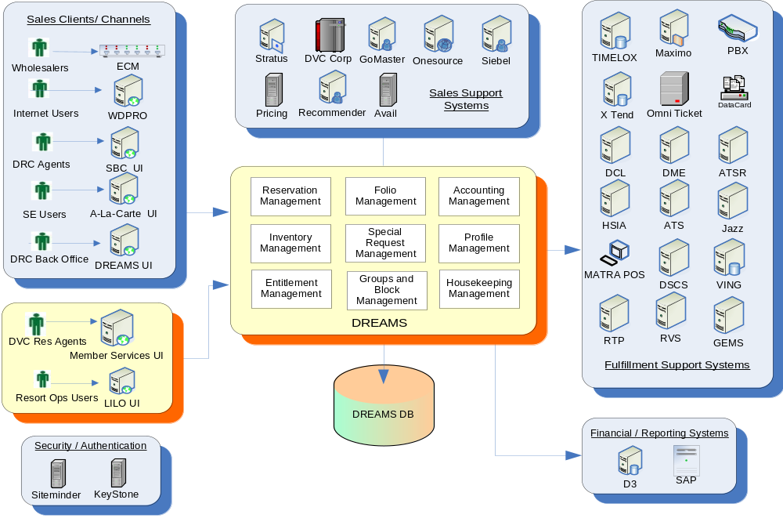
    - User Interfaces
The following user interfaces will be built for the PMSR Release 2 and DVC Phase 1B project phases:
- LILO UI: The LILO UI, represents the user interface functionality for the PMSR project. It houses all the room operations user interface features like Front Desk, Housekeeping, Folio management and Room Assignment functionalities.
- DVC 1B - Member Services UI: The Member Services UI represents the user interface functionality for the DVC Phase 1B project. It houses all the sales and booking functionality for the DVC reservations. It is an enhancement to the DVC Phase 1A UI and uses DREAMS as the system of record for DVC room reservations.
    - Business Domains
The PMSR solution is built over the existing DREAMS architecture. The DREAMS sales functionality is augmented with fulfillment functionality for the PMSR needs.
The following are the business domains that constitute the core PMSR solution:
- Reservation Management: This domain is responsible for managing the lifecycle of a reservation from sales through fulfillment and reporting
- Folio Management: This domain is responsible for managing the reservation specific financial folios for guests and groups.
- Accounting Management: This domain is responsible for managing the front office analysis ledger entries for the reservations. It is responsible for reconciling the end of day financial feeds with SAP (the back office financial accounting system).
- Entitlement Management: This domain is responsible for managing the lifecycle of the guest coupons or entitlements for the reservations.
- Groups and Block Management: This domain is responsible for creation and management of Groups, Wholesalers and Convention Groups along with their inventory blocks in support of the Reservation management domain.
- Inventory Management: This domain is responsible for creation and maintenance of physical room inventory in support of the resort operations. This domain is extendable for managing other kinds of physical inventories.
- Profile Management: This domain is a support domain for the Reservation management domain. It is responsible for maintaining the Coded comments and their associations to the various fulfillment constructs.
- Service Request Management: This domain handles managing the lifecycle of different kinds of service requests that are created for the In-house reservations.
- Housekeeping Management: This domain handles the creation of various daily housekeeping boards for the resort operations.

    - Conceptual Domain Model
The following picture depicts the overview of the domains that have been created or modified as part of the PMSR effort. It shows the high level associations, dependencies between different domains.
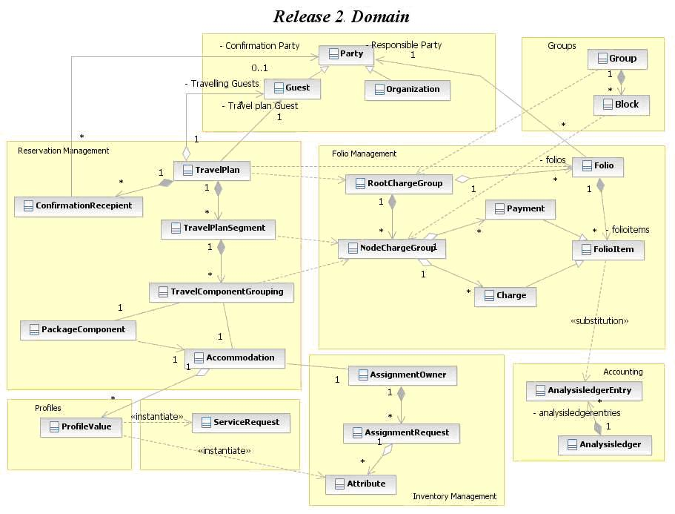

    - Overview of Services
The PMSR solution is built over the existing DREAMS service oriented architecture. The following diagram depicts the overview of the business services built for the PMSR project:
DREAMS Services Overview
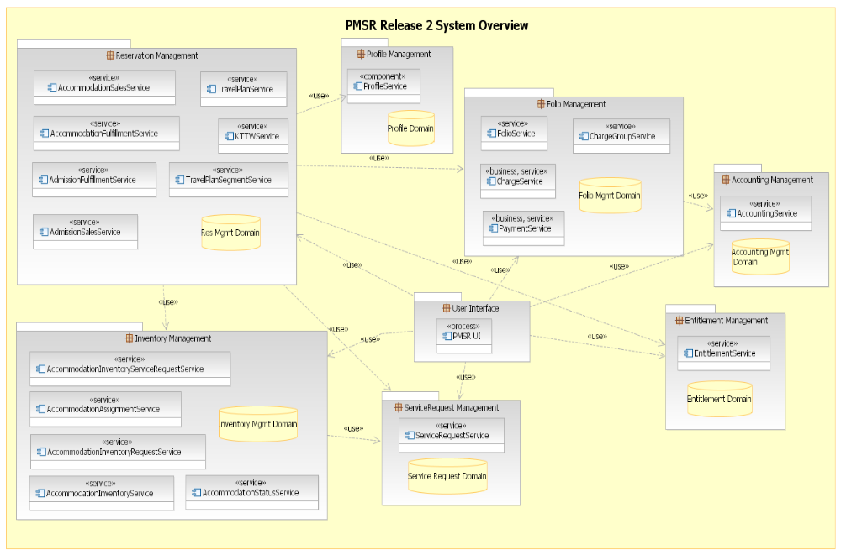

Salient Features
The following section documents some of the salient features of the PMSR solution:
    - Single System of Record for Room Reservations
As part of the PMSR solution, the DREAMS database will serve as a single system of record for the room reservations from sales through fulfillment functionalities. By a single system of record, the need for data synchronization and reconciliation between the sales and the fulfillment systems is avoided.
In addition to WDW room reservations, as part of PMSR / DVC Phase 1B projects, DREAMS database will also serve as the single system of record for the DVC room reservations.
Note: DREAMS will continue to serve as the system of record for scheduled event reservations.
    - Attribute Level Fulfillment
The PMSR solution is built to be able to fulfill rooms using attributes. Attributes are additional features of a room. The System provides the ability to configure attributes at the individual room level for all the resorts.
As part of the automated room assignment process, the room attributes are matched against the reservation attributes in order to ensure an accurate match for the guest.
The PMSR solution is designed to ensure that the upstream sales systems are not impacted by the room attributes. In order to achieve this, the concept of “Coded Comments” is enhanced to ensure that the room attributes that are requested as coded comments are actually fulfilled as true room attributes.
    - Special Request Fulfillment
The fulfillment of special requests is completely automated by the PMSR solution. For those special requests that are delivering a product to the guest unique products are created for each special request with appropriate price and the charging frequency. The system also allows the users to capture the fulfillment frequency for the special request.
Special requests requiring delivery, pickup, dispatch and maintenance are also sent to Maximo interface to generate work orders in the appropriate labor system.
Special requests can also be booked via the existing sales channels by means of Coded comments. Coded comments are configured to map to a unique special request in order to enable fulfillment.
    - Automated Room Assignment
Room assignment process is automated to a large extent in the PMSR solution. The automated room assignment algorithm is built to accommodate the room operations requirements for guest convenience at the same time ensuring optimal room assignment to maximize revenue and minimize operational cost.
The following are the highlights of the room assignment process:
- Attribute level room assignment
- Handle pre-blocked assignments
- Minimize holes in the system. (A hole is defined as the gap between 2 consecutive reservations assigned to a room)
- Optimum room assignment to maximize room revenue and minimize operational cost
- Prioritize DVC member reservations in DVC resorts and ensuring the same room assignment across Member Points and Cash stays
    - Seamless Guest Experience
Seamless guest experience is one of the core architectural features of the PMSR solution. It is achieved by the following functional features:
- Single Guest Folio: A single guest folio is created and maintained for a guest at the Travel Plan level. This folio will help track the charges, payments and the folio balance throughout the entire guest stay spanning across multiple rooms and even resorts. The guest will get a single folio invoice for the entire stay spanning the multiple stays across same or different resort.
- Key To The World (KTTW): The objective of the PMSR solution is to provide the guest with a single key which will allow access to the different rooms the guest will be staying in throughout his/her stay. The single KTTW feature is dependent on a wireless door access system implementation. At the time of PMSR go-live, the wireless technology may not be implemented across all the resorts. But the system is built to enable this feature once we have a door access system that can support wireless access
    - Centralized Accounting
As part of the PMSR solution, the Accounting engine will serve as the single repository for Schedule Events, Resort Ops and DRC revenue accounting (a.k.a Business units). In addition, the SAP feeds are also segregated by business units.
Travel Agency commissions are enhanced for PMSR by processing and sending Accounts payable for commissions directly to SAP, avoiding the need for the TARS system.
    - Multiple Campus Support
The PMSR solution is designed to support multiple campuses and business units. The following are the key features of the multi-campus support:

- Support for multiple time zones
- Support for multiple currencies, along with currency conversions
- Separate date rolls for different campuses and business units
- Support for multiple languages, cast and guest.

Key Architecture Features
Building robust technology architecture has been a key driver to the PMSR solution, driven by Disney IT Architecture. The following section documents the key architecture features of the PMSR solution.
    - Service Oriented Architecture (SOA)
The complete PMSR solution is designed using a service oriented approach. The solution is built over multiple domains, with each domain providing a set of business and component services.
- Separation of concerns: Functionalities are grouped into individual domains in order to handle the separation of concerns. Each domain interacts with other domains through a set of loosely coupled component services in order to achieve a business service (business goal). A business process is achieved by using one or more business services exposed by the individual domains.
- Modular approach: Each module owns its own data and is not replicated in order to avoid data duplication.
- Scalability: The business services are built in such a way that they can be scaled independent of other services within or outside the domain.
    - User Interface Framework
The PMSR solution is built over JSF/AJAX technology stack which provides a rich Web 2.0 user interface experience for the end user. An entire set of UI framework components (“Shared JSF Framework”) have been built on top of the JSF/AJAX platform as a back bone in order to reduce the development effort for the user interface application. The Shared JSF framework provides the following features for the user interface development:
- Seamless integration with Keystone security API
- Single sign-on capability
- Plug and play interface for Web service or EJB implementation
- Built in logging and exception handling capability
    - Robust Notification Service
As the PMSR solution entails communicating to a large number of external interfaces, a robust asynchronous communication mechanism was required to ensure guaranteed delivery of the messages to the target systems. Various vendor based solutions were assessed and generic, configurable notification service was built over a MQ based messaging middleware with a framework component that can be extended to ESB based messaging infrastructure in the future. The features of the notification service include:
- Publish-subscribe (event) based architecture
- Highly configurable - Listeners can be configured for events for a specific Campus or a Resort
- Guaranteed message delivery – Messages will be left back in the queue if the target listeners are down.
- Highly extendable - New adapters can be built with minimal code by extending framework adapters
    - Enhance Folio / Accounting Performance
One of the key technical challenges for the PMSR project is to enhance the performance of the DREAMS folio/accounting transactions as a majority of the time for booking transactions are spent in the Folio/Accounting module. As DREAMS is extended to support the resort operations, it is not possible to support the increased volume, extended operational hours and higher level SLA requirements without some key architecture and performance changes to the Folio/Accounting module. The following section highlights the key performance enhancements that are being addressed as part of the PMSR solution:
- Reduced Analysis Ledger Entries: Currently, all the DREAMS folio transactions for new bookings and modifications are directly stored in the analysis ledger. As analysis ledger entries are never deleted, any modification to the booked transactions entailed creating duplicate transactions, one for negating the old state and another for creating the new state of the reservation. In order to reduce the entries we will only be posting recognized transactions to the analysis ledger. This will allow us to delete or overwrite unrecognized folio transactions instead of having to reverse and repost them.
- Asynchronous Revenue Recognition: Almost all reservation book and modify transactions creates corresponding folio entries as they have financial impacts. In order to improve the overall response time for a book transaction, the Revenue recognition process is decoupled from the folio transaction, thereby avoiding any additional time in creating corresponding Analysis Ledger entries. The revenue recognition process is triggered asynchronously once the folio entries are created. This is expected to improve the overall response time for the book/modify transactions for DREAMS.
- POS Charge Posting: The service oriented nature of the PMSR solution was built keeping in mind specific service level requirements at the individual service level within each module. POS Charge is a classic example of a business service that required a much higher service level response time requirements of about 2 seconds per charge posting. The deployment architecture for PMSR is configurable to ensure scaling of POS Charge as a business service for a higher level of response times.
- Improved Bill Trap Process: Bill trap process is an intensive business process to identify the specific folio onto which a particular charge will be posted. With the PMSR solution, a guest can configure multiple folios for trapping the different charges posted on the reservation. For example, a guest can create a personal folio to trap entertainment charges and a business folio to trap the dine charges to generate different invoices. The bill trap process in Folio management module is enhanced to a complete in-memory process from the current state process involving numerous database calls.
    - Coarse Grained Module Level Interactions
The communication between the different DREAMS modules was enhanced to a macro level in order to avoid too many hops between the modules in order to execute a business transaction. For example, a single book transaction involved multiple calls to folio for each charge posted. This was enhanced to consolidate the calls the folio module to a single call to the folio module for a book or a modify transaction, operating at the reservation level.
    - Decouple Guest and Travel Plan Interactions
A single reservation book transaction involves creating/modifying multiple guests in ODS/Go Master and a travel plan in Siebel. As each of these calls take anywhere between 1 to 3 seconds, in order to improve the overall response time for a book transaction, the calls to Go Master and Siebel are removed from the transaction and have been migrated to a guaranteed asynchronous communication with the target systems. This change is expected to further improve the overall response time for the booking transactions.
    - Direct Point to Point Communications
In order to support the migration of the WDW Sales Composite applications to a service oriented infrastructure, some of the existing interfaces were investigated to directly communicate with the end point system to avoid additional hops in the communication channels. The following interactions will be replaced with direct interaction with the target systems:
- DREAMS to DCL Web Service interactions.
- DREAMS to DME / RVS for reservation updates.
    - Enhance External Interfaces
As part of the PMSR solution, the key external interfaces were assessed for architectural improvements to support the future state Disney IT architecture vision. Existing interfaces wherever applicable were enhanced with web services and/or migrated to the robust notification service platform.
For instance, instead of the asynchronous way of retrieval of work orders from Maximo that is prone to data-loss, the current state implements a web service and the work order number is retrieved real time from Maximo. Additionally, instead of the resource consuming file transfers, the interfaces are replaced with web services for DCL and DME.
External interfaces to the following systems have been streamlined - Maximo, DME, RVS, HSIA, DCL, DSCS, and Omni Ticket.

Solution Architecture

The PMSR solution is implemented in a modular design approach, extending the DREAMS paradigm. The functional areas are segregated into separate business domain; each domain owns its business data and business processes. The business processes are implemented using a “service oriented architecture” (SOA). Each business domain exposes a set of business and component services that collaborate with each other to service a business process.

Business Architecture
PMSR solution extends the existing component based architecture built for DREAMS. Business functions are housed in individual domains. Each Business Domain provides a set of business services and component services. The domain is optionally complemented by additional reusable, embedded components in order to serve a particular business function.
    - Business Domain
A Business Domain or a module represents the business logic specific to a particular business domain such as Housekeeping, Reservation Management etc. Typically, it owns a database schema and is deployed as a single application package as an EAR
    - Component
A Component is a reusable, encapsulated software element capable of executing related tasks. It is context agnostic and can be deployed in multiple modules. It is packaged as JAR.
    - Business Service
A Business Service is a collection of self-contained business functions related to a single business entity. Examples of a business service functions include booking a room, taking a payment etc. It is always executed as a single atomic transaction. It is provided by a business domain in a technology-agnostic, self-descriptive manner. Typically it adheres to a generic specification such as WS-I (Web Service Interoperability). e.g. AccomodationSalesService.
    - Component Service
A Component Service is a collection of sub-process functions that belong to a single business entity that are used in the context of a executing a larger Business Service. Examples of component service functions include pricing a package, posting a charge in the context of a book room business service function. Additionally, a Component Service adds non-functional aspects such as accessibility, transaction, security, scalability etc. Typically it adheres to technology specification such as EJB. e.g. ChargeGroupService.

The following picture depicts the component model on which the PMSR solution is based upon:

Technology Architecture
The PMSR solution is built on a very strong technology architecture that can serve as a foundation for the current and future business needs.
The following diagram depicts the technology architecture for the PMSR program.

- Application Platform: The application architecture is based on Java/J2EE as it is the de facto technology platform of the composite Enterprise Architecture capable of supporting multiple system platforms. It also facilitates the reuse of knowledge, practices and components in an open, rich, scalable and extensible architecture.
- Database Platform: DB2, which is the database platform for DREAMS is extended as the database platform in order to sustain the load and performance requirements of the PMSR solution.
- Hardware Platform: The PMSR solution is being implemented on an IBM P-Series hardware environment.

The following diagram depicts the different hardware platform and operating systems to be used for the PMSR solution.
Note: Please note that the current DREAMS application will need to be migrated to the P-Series hardware architecture prior to PMSR go-live. It is currently tracked as a separate project effort.

Data Architecture
The PMSR solution is extending the modular design approach for DREAMS to ensure that the individual application domains own the data unique to the domain in order to ensure separation of concerns.

The following picture depicts the DREAMS data architecture as a result of the PMSR solution implementation:
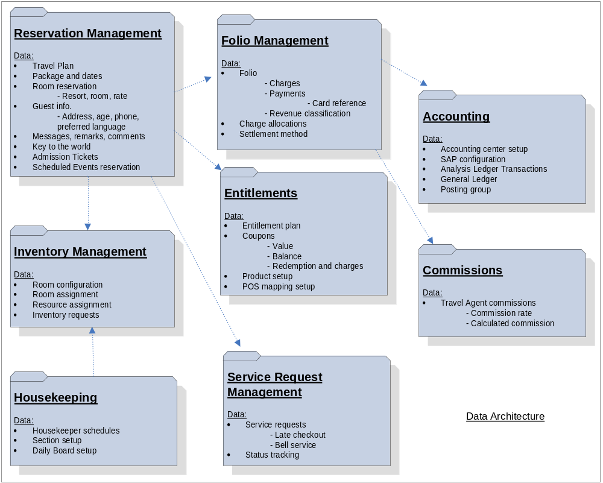

Security Architecture
For the PMSR solution, the business users interact with the system using browser based user interface. Additionally, other systems in the Disney composite interact using various protocols. Typically, modern systems use Webservice (SOAP/HTTP), EJB (RMI/IIOP) or Messaging (MQ); whereas legacy systems use TCP/IP and FTP based protocols.
    - User Security
The PMSR solution uses the Disney enterprise standard single sign-on capability provided through Siteminder. It also uses Keystone authorization for user authorization services over SSL. The user authorization information is stored in memory for the duration of the HTTP session.
    - Credit Card Security
As part of the PMSR solution, credit card information will not be stored within the DREAMS system. For taking credit card payments and other transactions, a separate external “Payment Gateway” will be used. This gateway will provide a secure screen which will be launched through LILO UI. Sensitive information such as credit card number and expiry date etc will be captured and stored by this system in a Level 1, PCI compliant environment. A corresponding credit card reference number will be stored within the DREAMS system for reference.
Note: The Payment Gateway / service will be implemented as part of the Credit Card Reference project which will go-live either prior to or together with the PMSR project go-live.
    - Service Security
The following guidelines govern the service level security for the PMSR solution:
- Webservice communications between DREAMS and the other systems outside the internal firewall in the composite will be secured using Webvan’s 2-way SSL
- LILO UI will not use Webvan to invoke DREAMS services. Such services will also be exposed on a non-secure port to which only LILO UI will have access.
- End of day financial data feeds will be transmitted on a secure protocol (SFTP or equivalent)
    - Data Security
As per Disney security guidelines, the data stored and transferred within the PMSR solution should follow the following data security guidelines:
- The data can not be publicly available
- The access to the data should be controlled
- The data need not be encrypted during storage and transfer
    - Security Level
As per security standards set forth by the Disney IT Security architecture, the data stored and transferred in DREAMS for the PMSR project is set at “Level 2” security.
The following facts about the data handled by PMSR solution decide the security level:
- DREAMS database and services do not store or transfer credit card data.
- DREAMS database does not store sensitive guest information such as SSN, date of birth etc.
It is important to note that during the maintain-guest use-case, LILO UI may capture date of birth and transfer to the ticketing system (Nexus) using XML/MQ.
- DREAMS records username in the database and log-files for auditing purpose. It does not store user password.

The following diagram depicts the security architecture for the PMSR solution:
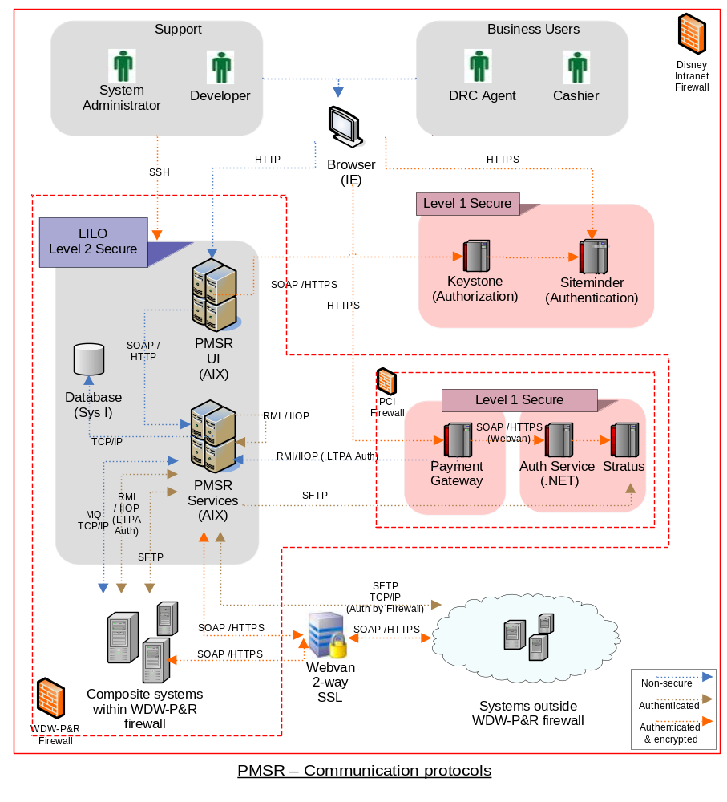

System Impacts

DREAMS Enhancements
As PMSR solution is built over the existing DREAMS suite of applications, changes were required in the DREAMS applications, both in terms of domain model, data model and business processes in order to enhance the system for fulfillment functionality. The following section highlights some of the key changes being incorporated in the DREAMS system.
    - Folio & Accounting
The existing DREAMS Accounting domain has been re-factored into a Folio and Accounting domains for performance reasons.
In the current state DREAMS system, all the folio transactions and dollar amounts for books and modifications are directly stored in the analysis ledger. As analysis ledger entries are never deleted, any modification to the pre-arrival booking transactions entailed creating duplicate analysis ledger entries, one for negating the old state and another for creating the new state of the reservation.
As part of the PMSR solution enhancements, the dollar amount for a charge or a payment is directly stored on the Folio. This helps to decouple the folio activities from Accounting. Only recognized charges and all payments will be moved to Accounting. The only charges which are truly recognized pre-arrival are fees. Additionally, for pre-arrival modifications, the folio entries are directly modified with the new value. The reservation history stored in D3 will provide the required modification history for pre-arrival transactions.
      - Folio Management
This domain is responsible for folios, their balances and settlement process for Guests, Groups or Wholesalers. The folio management module is enhanced to add the following features:
- Travel plan level folio
- Charge suspense folios
- Manage RSR folios
- Settlement process for folios
- Charge allocations and split charges
- Multiple folios per guest
- Commissions processing
- PCI compliance for Credit card payment processing
- Charge Transfer to another folio
- Charge Transfer to an entitlement plan
- ACB processing
- Electronic Bank out
- Points folios

      - Accounting Management
This domain is responsible for recognizing the front office accounting revenue for the reservations booked and fulfilled by the DREAMS system. This domain sends end of day accounting feeds to SAP (back office accounting). The following are the enhancements to the Accounting module:
- Manage RSR accounting
- Accounts payables for commissions
- Accounts receivables
- Bank out processing - electronic deposit feeds and charge codes
- Retail customer interface
- Business unit level SAP feeds

      - Entitlements Management
This is a new domain built for the PMSR project. It houses the entitlements (coupon) configuration and their usage. The following are the features of the Entitlements domain:
- Manage entitlement plans at guest level
- Manage redemptions
- Transfer of charges between entitlement plans and folios
    - Reservation Management
This domain is responsible for managing the entire life cycle of reservations booked in the DREAMS system. It was formerly named as “Booking” module. The following are the enhancements to the Reservation Management domain:
- Introduction of Travel plans
- Fulfillment functionality for room reservations
- Migration of DVC bookings
- Key to the world (KTTW) processing
- Decouple Party and Siebel travel plan services
      - Group Enhancements
The Group Reservation office functionalities for mass booking have been added to the existing booking interface. The following features have been added as part of the enhancements.
- Creation of Rooming list templates – These are vendor specific templates for providing reservation data for each vendor.
- Creating Mass Reservations using Rooming list templates – DREAMS will be able to book mass reservations for Groups by importing data from the templates for each vendor.
    - Profile Management
A new domain is created to manage the coded comments and its relationship to the various fulfillment constructs created to fulfill the guest requests captured via coded comments. The following are the features of Profile Management
- Defaulting the Profiles on a reservation by Package, Resort, RoomType
- Enabling Mapping of existing Profiles to attributes, alerts, service requests and comments.
- Using the mapping and converting the coded comments as part of the booking.
    - Service Request Management
This is a new domain that manages the creation and fulfillment of service requests for the reservations. These service requests can be of different types: housekeeping, bell services etc. The following are the features of Inventory management:
- Create and manage service requests
- Pricing of service requests as products
- Work order generation and integration to dispatching system
- Work order tracking
    - Housekeeping Management
The Housekeeping management domain manages the housekeeping boards for all wdw resorts. The existing housekeeping domain interfaces with the DPMS legacy system for receiving the reservation status updates for determining cleaning schedules for the day. Housekeeping module will be changed to accept the status updates from DREAMS. There is additional data conversion required for the housekeeping data to change the resort Ids to enterprise facility Ids.
    - Inventory Management
The Inventory management domain has the responsibility to manage the life cycle of the physical room inventory. The following are the features of Inventory management:
- Automatic room assignment
- Attribute level fulfillment of rooms
- Inventory Assignments
- Campus, resort and room configurations

External System Impacts
The PMSR project also impacts a host of external systems that interact with either Legacy DPMS or DREAMS system. The following section covers these high level system impacts:
    - D3 – Data warehouse
The following are the summary of impacts to the D3 system:
- Provide Guest history to DREAMS
- Remove the dependency of the ODSGuestId as the primary key.
- Admin History to be to maintained for All Accounting and Room configuration data.
- Store DREAMS TravelPlan Id
- Store Siebel Travel Plan Id as an external reference.
- TravelPlanIds from Siebel being updated asynchronously
- Fetch Inventory Data from the new schema.
- Add data structures for Rooming list.
- Add Data structures for Service request
- Exclude DVC Reservations for Reporting
- Fetch Data from the DREAMS Party Domain
    - BI / Reporting
As part of PMSR project, the existing reports from DPMS system are migrated to the BI / Reporting universe. The following are the high level impacts:
- Migrate all financial reporting to D3
- Migrate all Resort operations (operational reporting) to D3 / BO platform
    - OneSource
- Setup of Service Request products and prices and publishing to Pricing
- Setup of Late Checkout policies and publishing to Facility or Pricing
    - DSCS
- Will adapt to the transaction accounting center of DREAMS
- Discontinue the existing Charge Posting interface with DPMS and use the DREAMS Charge Service for posting event charges.
    - Stratus
- Will receive CC Settlement feed from DREAMS, switch RRN with CC Number and send the file to SAP. This scope will be covered in detail as part of the CC Ref Scope.
    - Recommender
- Recommend Room Offers for frontdesk reservations including Retail Room Only, Groups and RSR bookings
- Recommend tickets based on Guest preferences for Retail, Groups and DVC Members.
    - Payment and Auth Service (Credit Card Reference)
- The PaymentService acts as a gateway for all the payment postings that are coming from external systems to DREAMS.
- AuthService will interface with GoldMaster for Credit Card Authorizations and Balance enquiries for Gift Cards.
    - Ticketing Interface
- DREAMS will interact with the new TicketService for all the ticket fulfillment requirements. The TicketService seamlessly interacts with the actual ticket providing systems (Nexus for WDW and Galaxy for DLR) for catering to the requirements of PMSR.
    - Maximo
- Work order number will be returned to PMSR in real time. This is achieved by Maximo providing a new Web Service and DREAMS using this service to send the Work Order request and returning a work order number on a successful creation of a work order.
- Maximo will not receive PropertyRes from DREAMS for a reservation that has checked in or checked out.
- Maximo will also provide a new service to send the Work Order status to DREAMS.
    - DME
- No PropertyRes message will be sent by DREAMS to DME. DREAMS will use the WebService provided to send the reservation information to DME. The communication will be in TCG level.
- Guest Landed request is discontinued. DME will use a web service provided to send the Guest landed time to DREAMS.
- DME will use a new interface provided by DREAMS to send the motorcoach departure information.
    - RVS
- Instead of using a web service that directly works on PMS database, RVS will now use a web service hosted by DREAMS for all reservation related events.
- RVS will discontinue creating a KTTW number for charge postings and will use the KTTW number generated by DREAMS
    - HSIA
- No PropertyResRQ message will be received from DREAMS to HSIA. Reservation notification service for reservation related events will be provided by RVS and DREAMS will use those services to provide information to RVS.
- HSIA will discontinue creating a KTTW number for charge postings and will use the KTTW number generated by DREAMS
    - Pricing
- Load the chargeable Service Requests from One Source.
- Load the Late Checkout policies from One Source.
- Load the RSR packages and price them according to RSR rules.
- Discontinue the Product Builder Feed sent to DPMS. This will be a phased removal based on implementation strategy.
- Load additional tickets for annual passes and the affiliation tickets to be supported as part of PMSR requirements
- Provide a service for calculating difference in prices for upgrades for room reservations
- Provide a service for pricing all tickets to be sold at the FrontDesk and also calculate the price for ticket upgrades.
- Provide a service for calculating the number for entitlement plans based on sold coupon products.
- Provide Service for providing a Package Component Description
- Provide a Service to Provide Plan Types for a Sales Channel
- Provide Commissionable Packages
- Provide a Service to calculate taxes for manual postings
    - WDPro
- WDPro is currently using the BookingService EJB to store tickets and retrieve Travel Plan by GuestId in DREAMS. BookingService will be replaced with AccommodationSalesService, TravelPlanSegmentService. WDPro will have to make changes to use the new services
    - EAI
- Guest Landed Message is retired and need not be supported after the complete roll out.
- The PropertyRes message is retired and any necessary communication will be made straight with the necessary teams like DME, Maximo etc. by web services.
- EAI to use PaymentService to send payments to DREAMS and discontinue using the Payment XML Message.
- EAI is currently using the BookingService EJB to book reservations in DREAMS. BookingService will be replaced with AccommodationSalesService, TravelPlanSegmentService. EAI will have to make changes to use the new service.
- EAI will also provide the FacilityService for all resorts required by DREAMS and also the room types for each resort. DREAMS will use this Facility SOR for all facility related information.
    - Avail
- Provide an interface for retrieving boxed counts and boxed horizon for room types for a travel period.
    - DPMS
- Change Routing logic for some of the inbound interfaces (Unchanged) to route to DREAMS.
- Discontinue the Rooming list functionality
- Discontinue the RSR booking and billing functionality.
    - DVC DPMS
- DVC DPMS has to discontinue the DDI feed to DVC Corp on the initial go live. DVC DPMS also has to accept the link information, Dine Plan and the Reservation Type from DREAMS after the initial go live.
    - TARS
- TARS sends the Accounts Payable for Travel Agent commissions to SAP . After the complete rollout of DREAMS, TARS will no longer prepare and send the interface. It will be sent from DREAMS.
    - DVC Corp
DVC Corp has the following changes.
- Discontinue the DDI feed to DVC DPMS
- Change the inventory rebuild process to be running as a local process
- Recognize the Points charges nightly without receiving an update from DREAMS.
- Take a Reservation Update from DREAMS for DVC member reservations.

Implementation Strategy

The overall PMSR program is implemented in two releases. The following section describes the implementation strategy for the Release 2 of the PMSR project.
- Release 1: Release 1 implemented the Housekeeping functionality and integrated the solution with Legacy PMS. It was released into production in Summer of 2008.
- Release 2: Release 2 covers the rest of the resort operations functionality. This will be released into production in Fall of 2009. The PMSR Release 2 project is planned to be rolled out in phases. The following section explains the implementation strategy.

Phased Roll-out Approach
During the PMSR roll-out, the DREAMS application will be rolled out in different phases. During the initial phase, all the sales systems will be migrated to the DREAMS application. Once the sales systems are stabilized, then resorts will be migrated to DREAMS in a phased manner (one or two at a time).
- Risk Mitigation: The phased migration approach is taken in order to mitigate the risk of a single deployment issue or critical defect bringing down the entire resort operations to a halt.
- Logistics Nightmare: Additionally, it is a huge support, deployment, training and logistics nightmare to migrate all the 26 properties at the same time.

    - Assumptions
The following are the assumptions for the PMSR implementation strategy:
- During the resort roll-out period, a reservation spanning across more than one resort will not be allowed to be booked inside a Travel Plan until DREAMS is completely rolled out to all the WDW and DVC resorts.
- Deposit downloads will be as per current state.

Initial Roll-out
During the initial roll-out, the DREAMS application will be deployed in production for all the sales and booking channels including DRC, Scheduled Events, Wholesalers, DVC member services and Internet. Initial DREAMS data conversion converts the reservations, inventory and folios from the current DREAMS database into the future state DREAMS database.
- All data is converted from DVC Corp to DREAMS for existing Member reservations.
- All existing sales UIs: SBC UI, Scheduled Events UI, WDPRO, ECM , DREAMS UI migrate to the new DREAMS deployment.
- DVC Phase 1B member services UI will migrate to the new DREAMS deployment.
- DREAMS runs all sales related batch processes
- All the properties continue to run DPMS legacy / DVC DPMS.
- DPMS Legacy UI (Cashier UI and Green screens) will still be used by the Resort Ops users.
- DPMS Legacy / DVC DPMS systems continue to run the batch processes for all the resorts.
- Sync Engine will continue to download/upload reservations from/DPMS.
- LILO UI will be deployed, but will not be actively used by the Resort Ops users, until Phase 2.

The following picture depicts the PMSR Phase 1 - Initial Roll-out:
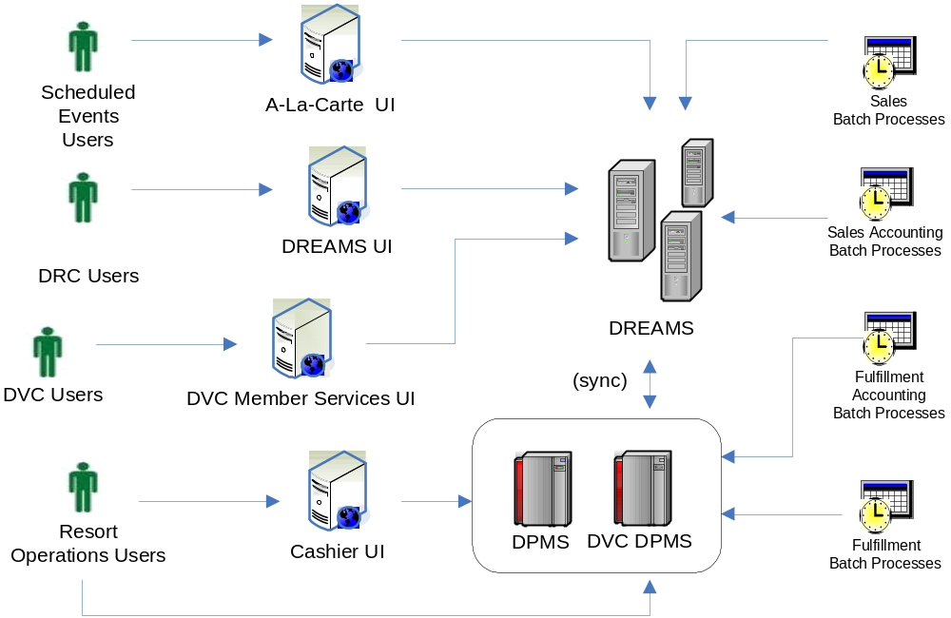

First Property / Partial Roll-Out
During the first property roll-out, the DREAMS application will be rolled out to the first resort or set of resorts. Rolled out property users will be using LILO UI for their operational needs.
The following features describe this roll-out scenario:
- Rolled out property users will be using LILO UI for their operational needs
- Remaining property users (resorts that have not migrated) will continue to use Legacy DPMS UI (Cashier UI, Green screens) for their operational needs
- DREAMS runs all sales related batch processes
- DREAMS runs the end of day and also other daily recurring batch processes for the rolled out property(s).
- DPMS Legacy runs the end of day processes for the remaining properties.
- Sales agents: SBC UI, Scheduled Events UI, WDPRO, ECM, DREAMS UI and DVC Member Services UI continue to use DREAMS system.
- DREAMS will continue the sync process with DPMS for all but the rolled out property/properties.

The following picture depicts the partial roll-out scenario:
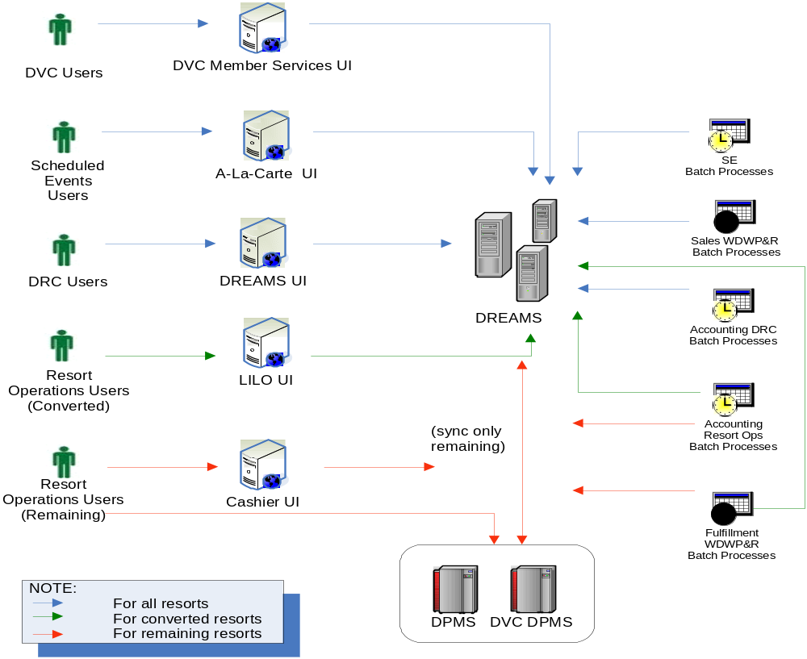

Complete Roll-out
The following section describes the scenario when all the properties are rolled out to the PMSR solution:
- Sales Clients: SBC UI, Scheduled Events UI, WDPRO, ECM, DREAMS UI and DVC Member Services UI continue to use the DREAMS system.
- DREAMS runs all sales related batch processes
- DREAMS runs end of day processes for all the properties.
- Single DREAMS batch schedule for sales and fulfillment jobs.
- All the Resort Ops users will use LILO UI for their operational needs.
- DPMS legacy / DVC DPMS / Cashier UI is retired.
- DREAMS acts as the single backend system for all sales and fulfillment across properties.

The following picture depicts the scenario when all the resorts are rolled out:
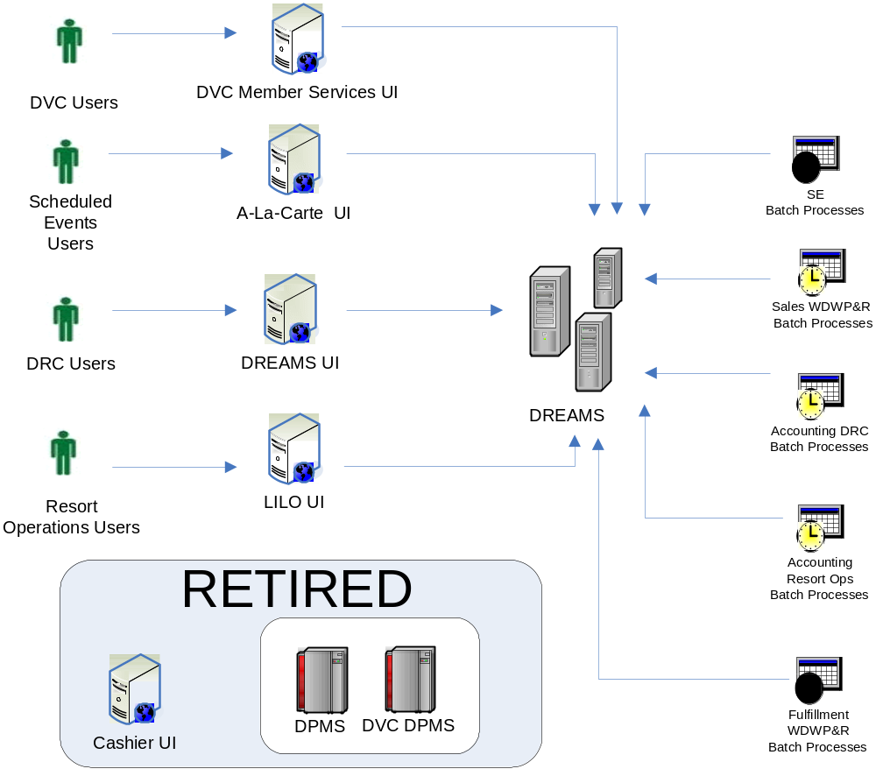

External Interfaces Roll-out
External interfaces, both in-bound and out-bound are affected by the phased roll-out strategy. Some additional work need to be done in order to ensure that the individual external interfaces are routed to the appropriate property management system (DPMS or DREAMS) based on whichever resort is rolled out. The following section documents the strategy that serves as a guideline to minimize the impact to the external systems.
    - Inbound Interfaces
The following decision chart guide is used to decide the roll-out approach for the inbound interfaces:
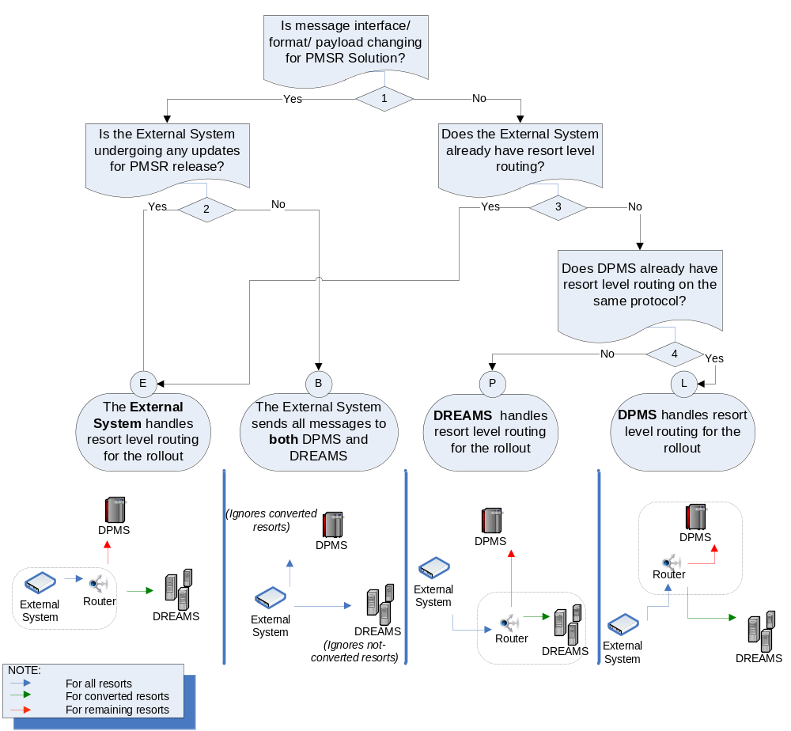

- If the message structure has changed, routing by either DPMS Legacy or PMSR is not advisable since it involves building (futile) complex adapters. In such a scenario, very likely the external system is getting updated and should also take up additional responsibility of resort level routing during PMSR rollout (1-2-E).
- (1-2-B) If the External System can not do so for any reason, it should at least send the message to both DPMS Legacy and PMSR at the same time. DPMS Legacy will ignore the converted resorts and PMSR will ignore the rest.
- If the message structure is intact, and if the External System is already built to communicate with DPMS Legacy at resort level, it should update the locator-properties (host, port etc.) to point to PMSR (1-3-E).
- If the external system communicates with PMS legacy at Campus level and the DPMS Legacy further routes to individual resorts, it should update the locator-properties to point to PMSR (1-3-4-L).
- For any other scenario, external system should switch communication from DPMS Legacy to PMSR along with the first property roll-out. PMSR will handle the resort level routing (1-3-4-P).
    - Outbound Interfaces
DPMS Legacy and PMSR will both send messages to the same external system. No change is required by any system. As the resorts are converted, the origination of corresponding messages will move from DPMS Legacy to PMSR. (See Special Scenarios below)
The following are the special scenarios which require some special care:
- Single Connection: Certain external systems involving TCP/IP communication (e.g. PBX) have a limitation of staying connected to only one port at a time. For outbound communication, both DPMS Legacy and PMSR can not be connected to the external system at the same time. In such a scenario, PMSR will establish connection with the external system and DPMS Legacy will route messages through PMSR.
If the same channel is used for inbound messages as well, PMSR will route the relevant inbound messages to PMS Legacy.

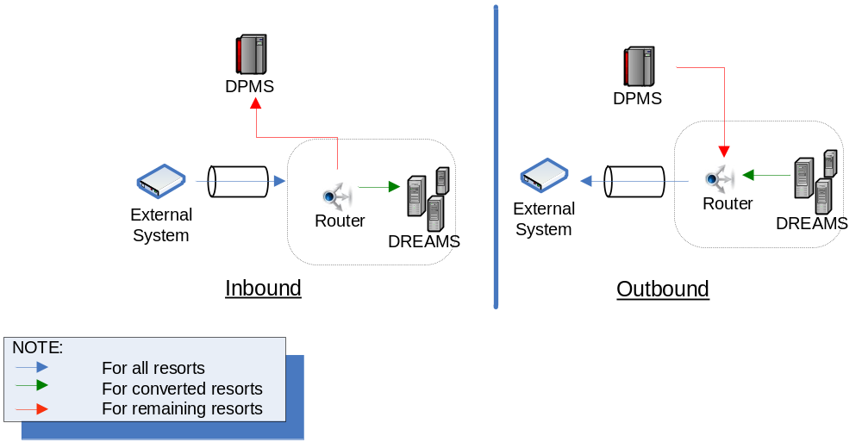

- FTP: Outbound FTP messages carry the risk of files being overwritten. (E.g. PMSR may replace GSR feed from Legacy). To avoid this, FTP should be done in ‘Append’ mode.
- Shared Devices: The resorts sharing a single instance of an External System / Device (e.g. PBX/Lantronix) should go live together.

Reservation Management

Domain Model
The Reservation Management domain stores the reservation information during the entire life cycle from the time it is booked till the time it is checked out and maintained in the system for research purposes. It also maintains the additional data needed for sales and the fulfillment of the reservation.

The following picture depicts the conceptual domain for the Reservation Management module:
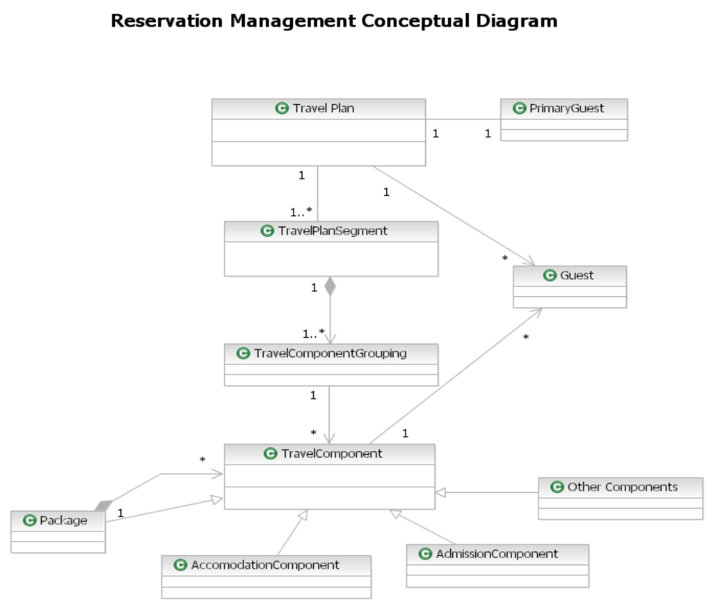
Reservation Management – Conceptual Domain Model

    - Reservation
A creation of a “Reservation” results in creation of a Travel Plan in the Reservation Mgt module. A Travel Plan also includes a Travel Plan Segment and Travel Component Grouping.
Following are the definitions of the above mentioned concepts.
    - Travel Plan
A Travel Plan represents the entire duration of the Guest trip.
- A Travel plan holds all the reservations made for the length of stay.
- It stores the guest list for that TravelPlan along with the Primary Guest and Settlement Method information of the Guest.
- A Travel Plan holds room reservations and other reservations such as Dinner shows, Activities.
- A Travel Plan is always created for every reservation created in the System.
- A Travel Plan is associated with one to many Travel Plan Segments.
    - Travel Plan Segment
TravelPlanSegment represents the owner/ booking source of the transaction. The construct holds together all the travel components booked for an owner. E.g. WDTC, WDW, DVC etc.
- Multiple accommodation reservations sent for Wholesaler bookings with the same WHO # are stored in the System with the same Travel Plan Segment.
- Every Retail Accommodation booking creates a TravelPlanSegment.
- A Scheduled event reservation (Dinner Show, Recreation etc) made with the Room Reservation creates new Travel Plan Segments for each scheduled event reservation. It creates Scheduled event Travel Plan Segments.
- A Travel Plan Segment is associated with multiple Travel Component Groupings.
    - Travel Component Grouping
Travel Component Grouping groups together components which are fulfilled together. e.g., accommodation, tickets for each guest, Dine Plans etc.
- A Travel Component Grouping is always associated to one resort stay. Stays in multiple rooms at the same time or continuous stays create multiple Travel Component Groupings.
- A Travel Component Grouping is also created for Scheduled events related bookings such as Dinner shows, Recreation etc.
    - Travel Component
These are the actual components booked while making a reservation. These are further categories as Package, Accommodation, Admission and Component Travel Components.
    - Guest Message
Guest Messages are Messages captured at the Resort frontdesk to be eventually delivered to the Resort Guests. The Guest Messages are captured in the System in the context of specific guest within the Travel Plan.The System also allows to change the delivery status of the message and delivery methods.
The Message will store the actual message , the guest for which message was placed and the source of the message(which is name of the person who placed the message).
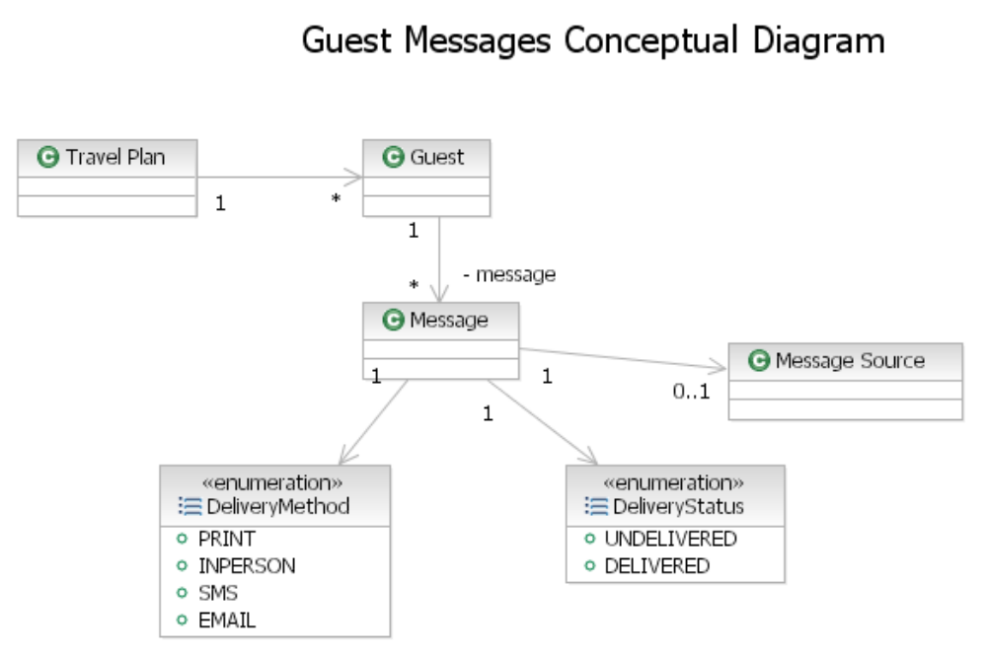

    - Rooming List/Mass Option
Group reservation office needs to upload reservations received from External Booking Sources. These reservations are received in bulk and manual entry of each reservation is time consuming. The constructs depicted herein allows the System to process mass booking of reservations.
Additionally, there are several formats that the reservation data is sent from each Booking Source. These formats differ for each source. To allow the System to streamline the reservation upload process, templates are maintained for each source and the data parsed based on the template to load the reservations in the System.
This model shows the entities which are used to maintain Rooming List templates. It also covers the entities which are used for all the Mass options to stage the data.
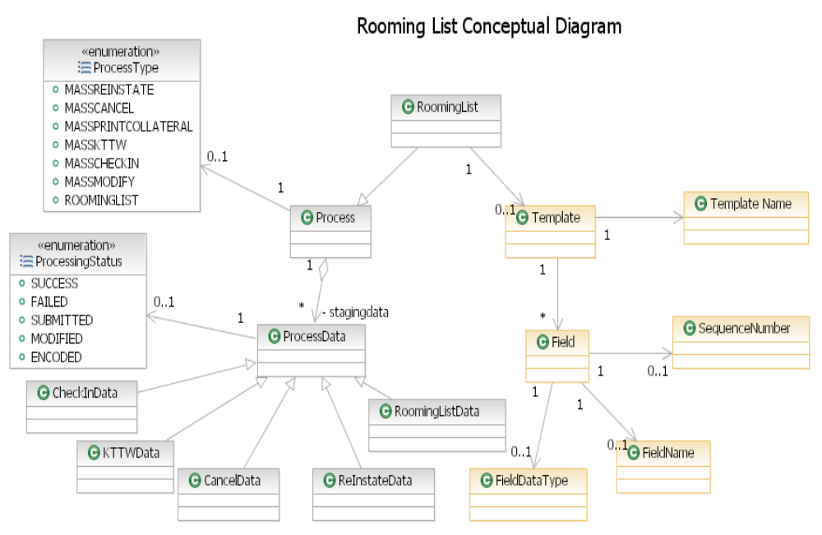
    - Party
Guests associated with the reservation and their corresponding data for the reservation such as address, phone, and email are captured. Additionally, the System allows adding Confirmation recipients with name and address information.Travel Agencies booking on the Guests behalf also need to be maintained in the System.At the Front Desk, incidental Folios are created to track additional charges at the Property. Name and Address information is provided for these folios.
In the above mentioned scenarios, the Guest and locator information needs to be stored in the context of a Travel Plan pre or post arrival.
The constructs listed below are used to store the Guest and Travel Agency information associated with the reservation. The same constructs are leveraged to store the Responsible Party information in the context of Folios.
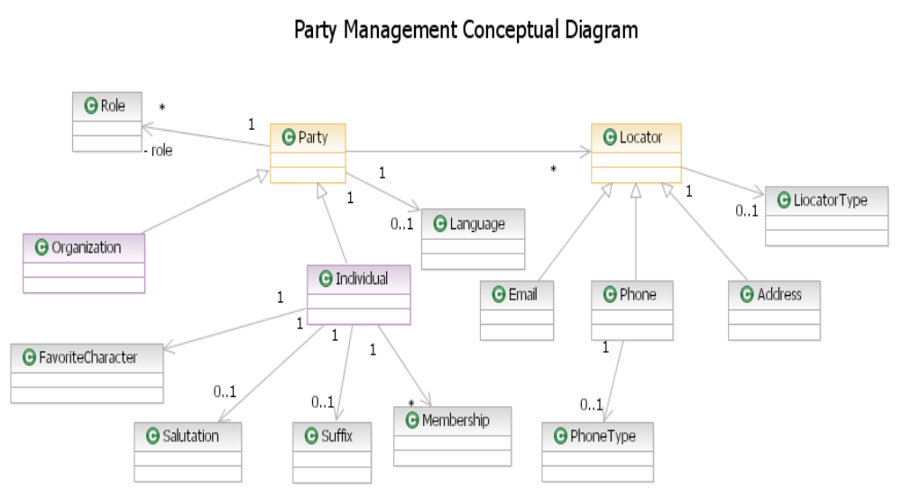

    - KeyToTheWorld (KTTW)
On a Guest Check-in, the System creates the Key to the World information and tracks the door access and the entitlements for the stay per Guest.
The System maintains the Key to the World Card per Resort Guest for a Travel Plan.
A Key to the World Card provides the following
- Access to the coupon entitlements stored in the System
- Allows the Guest to charge using the KTTW
- Allows access to the room or connecting rooms or common rooms in the resort
- Access to the Parks ( Ticket Entitlements are encoded on the KTTW)
Note: Door Access is maintained by an external System.
For Day Guests, the tickets are issued at the Front desk and the same media (KTTW) is used to issue tickets. In the case of day guests, the Keys issued do not have charging privileges and any room access and have tickets encoded for park access.
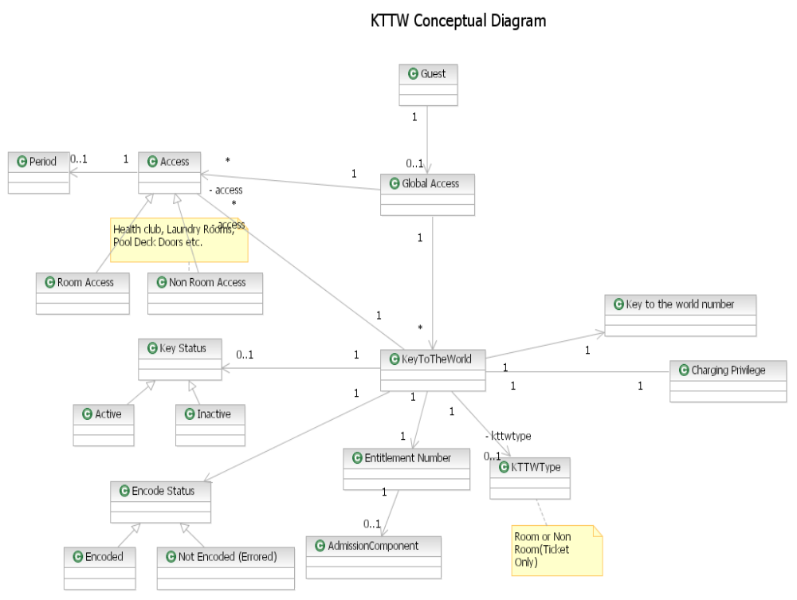

Services
Reservation Management Module covers the majority of the Sales and Fulfillment functionality related to the reservations. This section covers the services provided by the Reservation Management Module and documents the significance of each service.
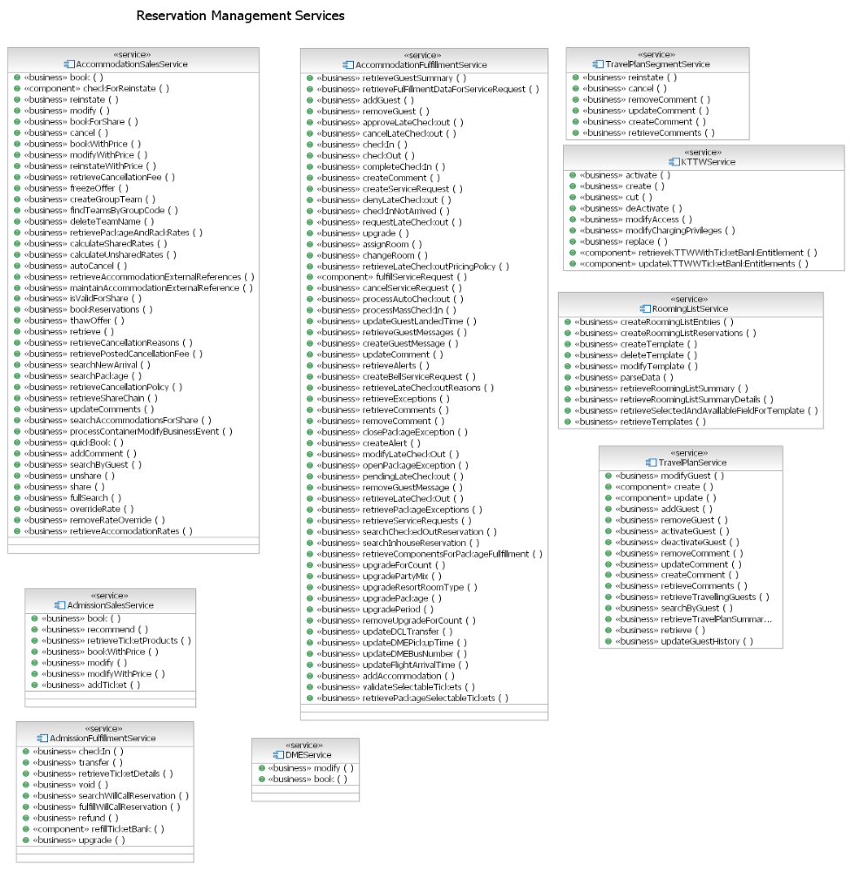
    - AccommodationSalesService
AccommodationSalesService is a business service used by all Sales Clients for all booking channels to book room reservations in the DREAMS System. It also provides additional abilities to modify an existing accommodation including updates, cancels, reinstates. It caters for all the pre arrival activity related to an accommodation reservation.
This Service will be available for a host of Sales Client / Channels:
Business Unit / Channel | Application | Types of Reservations
DRC Reservation Agents | SBC UI | WDTC Package Reservations  WDW Retail Reservations  Swan and Dolphin Room only reservations  DDRAH Room Only reservations  Speech Agent
Wholesalers | ECM/ABS/EAI | Wholesaler Package and Room Only reservations
DCL | Seaware/ABS/EAI | Disney Cruise Line Package Reservations
Operations Support | DREAMS UI | Wholesaler Reservations
DRC Back Office | DREAMS UI | Wholesaler, Groups , WDW, Swan and Dolphin and DDRAH room only reservations  BackOffice functions like rate and inventory overrides , adding confirmation recepients,
Group Res Office | DREAMS UI | Group Res bookings, Sharing and Unsharing
Group Res Office | LILO UI | Group Res bookings, Sharing and Unsharing
DVC Member Services, Teamline | Member Services UI | DVC Member reservations  ( MP, M$, R$, EO, EI,EZ, WDW RT)
Internet | WDPRO | Internet Packages and Room only reservations
Resort Operations ( Frontdesk and Guest Services) | LILO UI | Walk ins , Quick Books, Group Res bookings
      - Business Functions
Listed below are some of the Key business functions provided by the AccommodationSalesService.
- Book
- Modify
- Cancel
- Share
- Unshare
- Search
- Override Accommodation Rates
    - TravelPlanSegmentService
TravelPlanSegmentService provides the abilities to perform business functions for all room reservations inside a TravelPlanSegment. It also provides an ability to add internal comments to a Travel Plan Segment. This service is used by all the Clients using AccommodationSalesService.
    - AccommodationFulfillmentService
AccommodationFulfillmentService is a business service which provides the abilities to perform all business functions in the course of fulfillment for an accommodation reservation. This Service is used primarily by the LILO UI and is restricted to the Resort Operations users.
The Service is used by a variety of business functions.
Listed below are some of the Key business functions provided by this service.
- Checkin, Checkout
- Assigning and Changing Rooms
- Adding Special Requests to a Room Resevation
- Perform Upgrades
- Request for Late Checkouts.
- Approve or Deny the late Checkout requests
- Add Messages and Comments on a Accommodation
    - Rooming List Service
RoomingListService is a business service providing abilities for the Group Reservation Office for creating templates for multiple vendors and booking mass reservations.
Group Reservation Office is the main consumer of this service using the LILO UI.
This service will primarily provide these business functions
- Maintain Templates for each Vendor
- Load Rooming Lists.
    - TravelPlanService
TravelPlanService is a business service providing abilities for the Resort Operations to maintain Guest lists for a Travel Plan and add comments.
The Frontdesk is the primary consumer of this service using LILO UI.
The service will provide these business functions.
- Maintain Guests
- Maintain Comments
    - AdmissionSalesService
AdmissionSalesService is a business service which provides business functions for selling of tickets with a room reservation or as a Freesell ticket. It also provides recommendations for tickets based on the Guests preferences.
This service is used by the following users/clients/channels:

Business Unit/Channels | Application | Types of Reservations
Wholesalers Tickets | ECM/ABS/EAI | MYW Package included tickets
DRC Reservation Agents | SBC UI | KTTW Tickets, Freesell tickets
Internet | WDPRO | Freesell tickets
Resort Ops ( Frontdesk and Guest Services) | LILO UI | Freesell tickets, Hard ticketed events, Annual Passes

This service will provide these business functions
- Sell tickets
- Recommend Tickets
- Store Freesell tickets
    - AdmissionFulfillmentService
AdmissionFulfillmentService is a business service used for all the fulfillment business functions for tickets. It also checks in the ticket pre arrival.
This service is used by Resort Ops (FrontDesk and Guest Services) using the LILO UI.
This service will provide the following business functions
- Pre Arrival ticket check-in
- Upgrade tickets
- Refund tickets
- Search for Will Call Reservations
- Fulfill Will Call Reservations
- Transfer tickets
- Void Tickets.
Besides the above mentioned Resort Ops business functions, this service also maintains a ticket bank and refills the ticket bank. The ticket Bank is maintained to keep the System operational in case of the Ticket Provider undergoing a downtime or not responding because of some performance issues.
    - DMEService
DME Service is a business service which is used to book a “shadow” reservation of the DME Component in DREAMS.
This service is used by DRC users using SBC UI. This service is called when a DRC agent books a transfer component (Disney Magical Express) and this component has to be created in DREAMS to reconcile with DME.
The service provides the following business functions.
- Adding a DME Component to a Travel Plan
- Modifying a DME Component to a Travel Plan
    - KTTWService
The KTTW Service is a business service providing the business functions required for maintaining the KTTW Cards for Resort Guests in the context of Room Reservations and Day Guests for Ticket Reservations.
This service is used by the Frontdesk and GuestServices using LILO UI.
The service provides the following business functions
- Cutting New Keys
- Replace Keys
- Deactivate Keys
- Modify Access to rooms
- Enable/ Disable Charging privileges

System Interactions
    - Book Room Reservation
The book operation is used by all the Sales Clients across all Sales Channels.
At a high level, the booking process performs the following
- Freezes the inventory OR Revalidates the Frozen inventory. The inventory is blocked to ensure availability before confirming the booking. The booking process fails to complete if the inventory for the reservation is not available. WDW Inventory is held by Avail Server and the validation is made against that System. For DVC Inventory, however this validation is performed against DVC Corp which holds inventory for DVC Member reservations.
- Prices the Package for Charge Postings. Pricing for Cash based reservations is performed by using DREAMS Pricing. Pricing for room reservations is always done by sending the package, resort, room type, travel dates and booking Date. The selectable components are passed for pricing. Currently, tickets are setup as selectable components within the package.
- Creates the ChargeGroup, Folio and associated entries in the Folio Domain. A Default Folio is created on a creation of a Travel Plan in Reservation Management Domain. The Root Charge Group is created for a Travel Plan.
- A booking update is sent to the Inventory System e.g. Avail Vs DVC Corp for confirming the booking.
- Based on the Guest information for the Travel Plan, the system prepares information to be sent in the confirmation with the appropriate confirmation method.
- Once the booking is completed, the notification is sent to ODS to create Guests. On a successful response which sends the ODS Ids for guests, the System creates a Travel Plan in Siebel.
- For DVC Member reservations, the DREAMS booking process will send a copy of the booked reservation to DVC Corp.
- For Resorts which will be using PMS as their fulfillment system, DREAMS will download reservations if the arrival date is within 10 days.

Listed below is the collaboration diagram of the sequence of activities with the external systems and DREAMS Component Services performed by this business function.
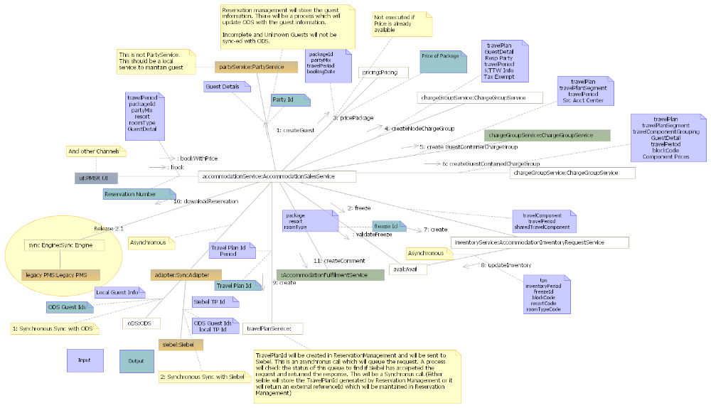
    - Modify Room Reservation
The Modification process performs the following
- Analyzes the modification impact to the following changes to the following- Resort, RoomType, Package, Travel Dates, Tickets and Guests.
- Prices the Package in case of Modifications resulting in change of price
- Modifies the Charges on the Folio with the Modified price
- Releases inventory in case of a resort or room type update and blocks modified inventory
- Generates confirmations
- Downloads reservations to PMS in case the modification is already downloaded to Property.

Listed below is the collaboration diagram of the sequence of activities with the external systems and DREAMS Component Services performed by this business function.
    - Cancel Room Reservation
The cancellation process performs the following
- Determines and applies the cancellation fees
- Releases inventory
- Reverses Charges applied on the Folio
Listed below is the collaboration diagram of the sequence of activities with the external systems and DREAMS Component Services performed by this business function.

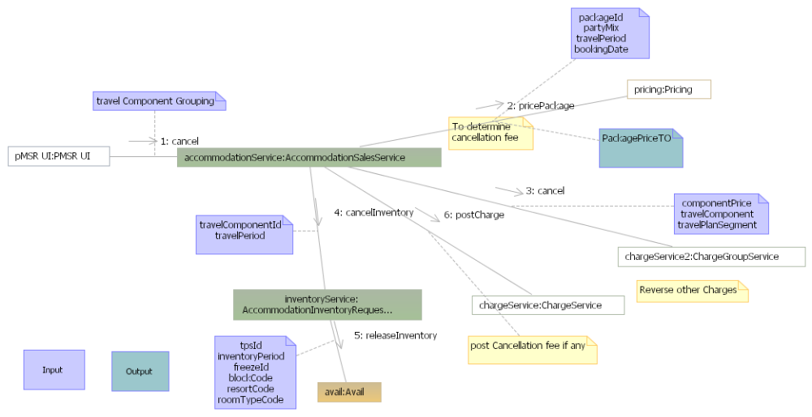
    - Cancel TravelPlanSegment
The cancel process at a Travel Plan Segment performs the following
- Cancels all room reservations for that Travel Plan Segment
- Calculates and applies cancellation fees for every accommodation for that Travel Plan Segment
- Releases Inventory for all the accommodations booked.
Listed below is the collaboration diagram of the sequence of activities with the external systems and DREAMS Component Services performed by this business function.
    - Re Instate Room
A Reinstate process performs the following.
- Re-prices the package in case the accommodation was manually cancelled.
- Optionally reverses the cancellation fee applied for a room cancellation
- Checks and blocks inventory for reinstating the room reservation
Listed below is the collaboration diagram of the sequence of activities with the external systems and DREAMS Component Services performed by this business function.
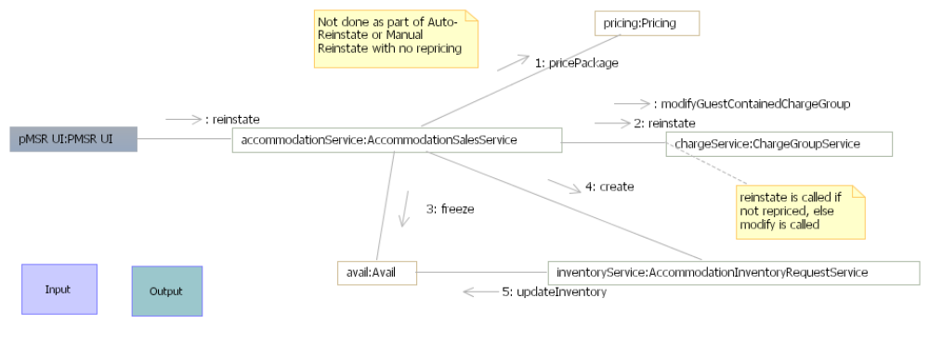
    - Re Instate Travel Plan Segment
The reinstate process uses the reinstate process for each accommodation in the Travel Plan Segments.
Listed below is the collaboration diagram of the sequence of activities with the external systems and DREAMS Component Services performed by this business function.
    - Share Rooms
A share process performs the following.
- Calculates the split in prices and applies the split charges based on shares
- Shares the inventory and releases the additional inventory
Listed below is the collaboration diagram of the sequence of activities with the external systems and DREAMS Component Services performed by this business function.

    - Maintain Comments
The process performs the following
- Retrieves the Accommodation
- Adds the Comments sent in the request.

    - Check-In
The Check-in process performs the following for Resorts rolled out using DREAMS.
- Changes the status of the Accommodation
- Recognizes the Non Room Revenue and approves the Room Revenue for the length of stay for recognition.
- Earns Payments made pre arrival into the Guest Ledger.
- Changes the Folio Status to Earned
- Calculates the number of coupons to be issued and creates entitlement plans
- Creates the tickets in the Ticketing System (ATS) and gets an entitlement number for each ticket associated to the guests in the room.
- In case tickets have not been purchased, based on a resort configuration, DREAMS fetches empty entitlements to be encoded on the KTTW tickets for each guest e.g. No empty entitlements are retrieved for Hilton Head and Vero Beach Resort.
- If the Ticketing Interface is not functional, fetch the empty entitlement or a valid ticket from the Ticket Bank.
- If the room number assigned is ready for occupancy , notify all the downstream fulfillment systems of the check-in of the guest ( Phone System, Guest Call Center, Phone Switch etc)
For Resorts not rolled out in DREAMS and still on DPMS, following process applies
- The checkin happens in DPMS
- DREAMS is notified by DPMS
- DREAMS updates the status of the Accommodation and the Travel Plan.
- DREAMS updates the Folio status
Note : No additional processing happens for checkin in DREAMS for Non Rolled out resorts.

Listed below is the collaboration diagram of the sequence of activities with the external systems and DREAMS Component Services performed by this business function.

    - CheckOut
The checkout operation is the common operation for manual checkouts, late checkouts and early checkouts. The checkout process performs the following for Resorts rolled out in DREAMS.
- Releases the Room
- Releases the Door Access to the Key
- Prices late checkout fees, if any.
- Reverses the future charges and releases inventory, if this is an early checkout.
- Notifies the external systems.
For Resorts on DPMS, the DREAMS process will update the status of the Accommodation and TravelPlan and release inventory with Avail Server in case of early checkouts.
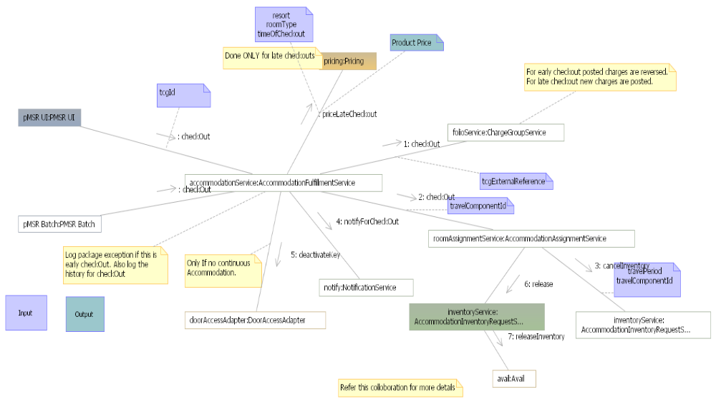
    - CheckIn Not Arrived
Only the Accommodation Component charges are approved whereas the Non Room Charges are kept pending .The process performs the following for Resorts rolled out in DREAMS
- Checks in the Accommodation
- Earns the Payments
- Recognizes the First Night Room
- Reverse the first night room and tax and recognize the same as Deposit Forfeiture Fees
- Establishes the Door Access for the assigned room.
For Resorts not rolled out, DREAMS performs the same process as explained in the checkin section.
Listed below is the collaboration diagram of the sequence of activities with the external systems and DREAMS Component Services performed by this business function.
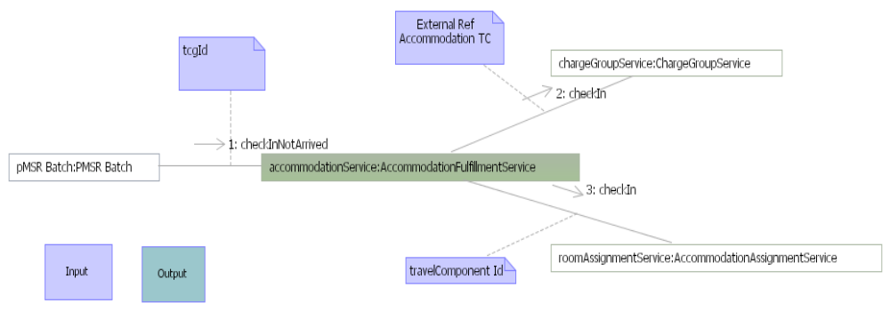

    - Pre-Arrival Ticket CheckIn
The process performs the following
- Checks in just the Admission Component
- Recognizes the revenue for the Admission Components being checked in
- Fetches the entitlements for the Admission Components from the Ticketing System
- Checks in the Folio
- Earns the Payments
- Cuts the Key for the tickets.

Listed below is the collaboration diagram of the sequence of activities with the external systems and DREAMS Component Services performed by this business function.
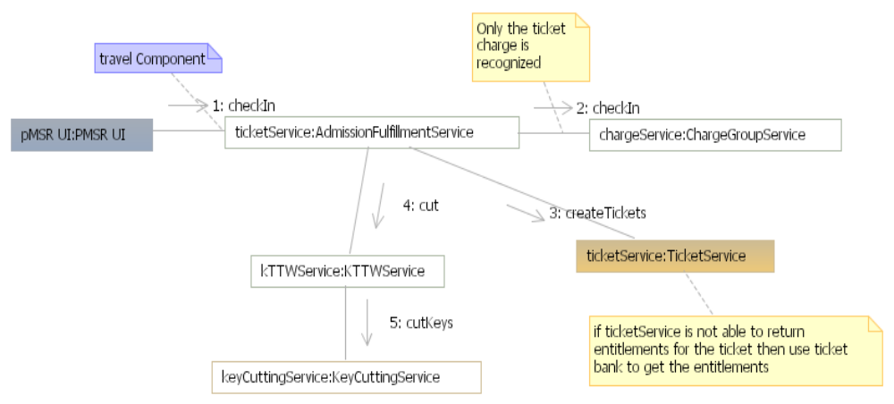
    - Complete CheckIn
The process performs the following.
- Updates the Room number on the Accommodation Component
- Creates a comment to be sent to the Guest.
- Notifies the Guest
- Notifies the Downstream fulfillment Systems
Listed below is the collaboration diagram of the sequence of activities with the external systems and DREAMS Component Services performed by this business function.
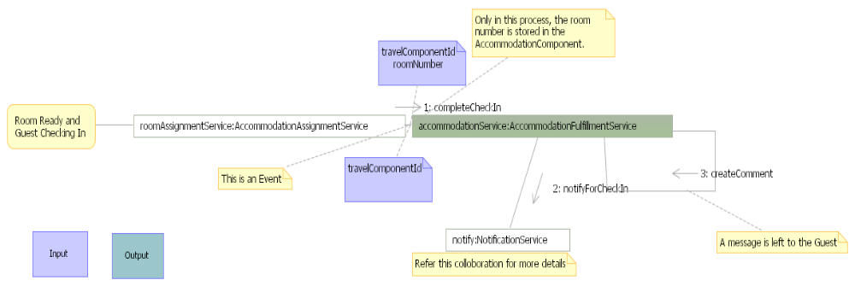
    - Create Service Request
The process determines number of Service requests based on recurrence OR Fulfillment frequency and creates Service requests each with a fulfillment date in the context of a Accommodation Stay.
Listed below is the collaboration diagram of the sequence of activities with the external systems and DREAMS Component Services performed by this business function.
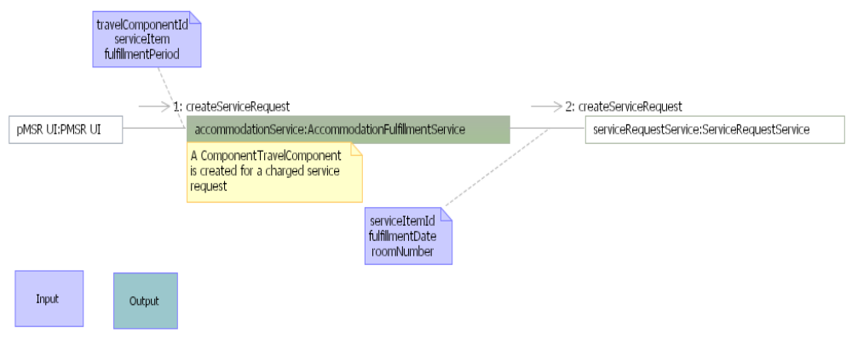
    - Fulfill Service Request
The fulfill service request process performs the following
- Posts the Charges for the Service request ( In case the Service request is chargeable)
- Sends a Work Order Request to Maximo if the request has Delivery, Pickup, Dispatch or a Maintenance action associated.
- Updates the work order number on the service request.
Listed below is the collaboration diagram of the sequence of activities with the external systems and DREAMS Component Services performed by this business function.
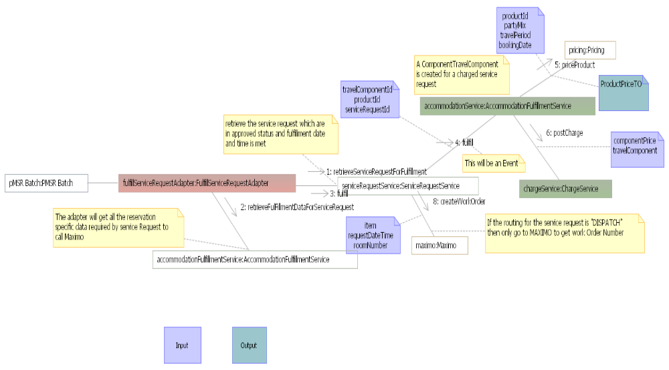
    - Override Accommodation Rate
The process performs the following
- Calculates the taxes off the overridden rates for each accommodation
- Optionally , Overrides the additional charges for the accommodation
Listed below is the collaboration diagram of the sequence of activities with the external systems and DREAMS Component Services performed by this business function.
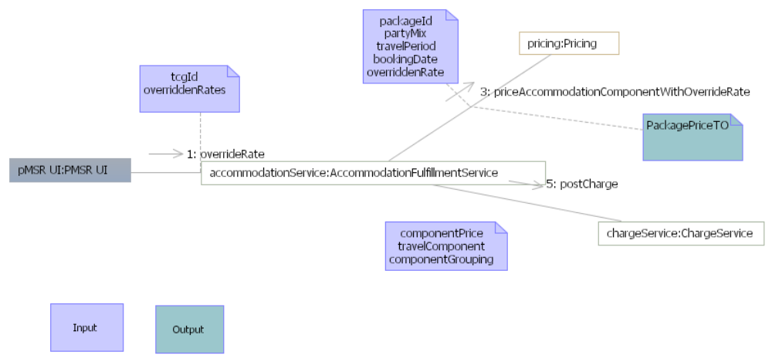

    - Upgrade Resort or Room Type
For the Resort and Room Type updates for Wholesalers, Retail and Groups Res, System will perform the following steps.
- Any upgrade charged to the wholesaler or the group is performed by calculating the net difference between the new resort and room type rates and the old resort and the room type rates.
- Room and tax will reflect the wholesaler discounted room rate.
- For upgrade charge to the Guest, the difference is calculated based on the retail to retail price of the old and the new roomtype / resort. This difference is calculated from the date of modification onwards.
- If the guest is walked, the wholesaler gets billed from the original resort at original rate, but room and tax gets recognized at the new resort.
- No upgrades are allowed for DVC Member Points and Member Cash reservations

Listed below is the collaboration diagram of the sequence of activities with the external systems and DREAMS Component Services performed by this business function.
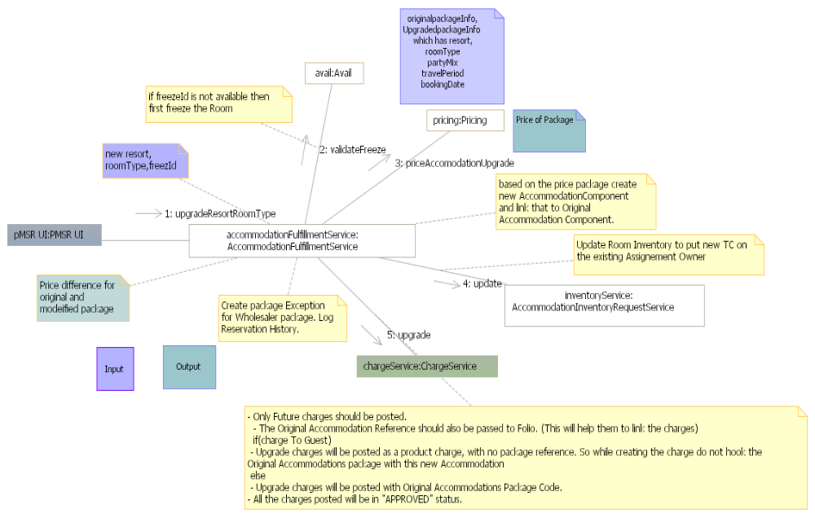
    - Upgrade For Count
The process covers the following
- Price the Room with zero dollars
- Upgrade the Room Type
Listed below is the collaboration diagram of the sequence of activities with the external systems and DREAMS Component Services performed by this business function.
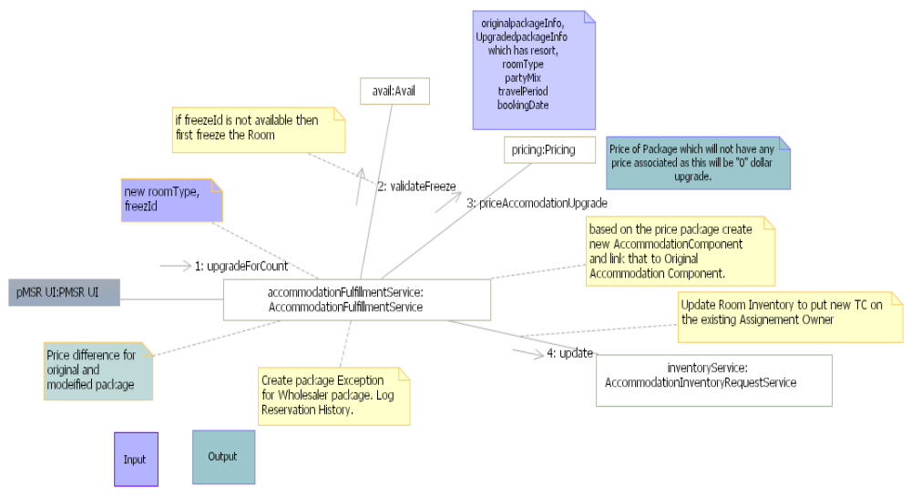
    - Upgrade Party Mix
      - Decreasing the Party Mix
These upgrades are applicable for Wholesaler, Retail and Groups reservations.
Following System Steps will be followed to handle this scenario for wholesaler bookings (Upgrade to Wholesaler)
- If there is a discrepancy in the Party Mix, the Guests will be deactivated during the checkin process. No Keys will be cut for them but ticket entitlements will be fetched.
- Post check in, if the party mix needs to be decreased, the accommodation needs to be modified. During the modification the System will perform the following
- The Charges for the Party mix being decreased will be reversed. Any ALT’s posted will be reversed.
- All Coupon Charges will be transferred to the Guest Pay Folio
- The entitlement Plan for the party mix being removed will be deleted if there are no other members sharing the entitlement plan.
      - Increasing the Party Mix
        - Groups/Retail
For a Group and Retail reservations, the system will allow to increase the party mix. The difference in price will be posted to the appropriate folio based on the billing profile configuration. This behavior is identical to pre-check in modification.
        - Wholesalers
The System will re-price the package and will post the additional entitlements required and create entitlement plans.
Additional Charges posted due to this upgrade are charged to the Wholesaler (Upgrade to Wholesaler).
Upgrade no Charge will not be allowed for Increasing the Party Mix. The System will determine additional charges before the modification and allow the ability to override the additional charges for the room.
Following System Steps will be followed to handle this scenario (Upgrade to Wholesaler).
- Price the Package for the complete party mix from the original arrival date. (The complete party mix includes the additional party mix added to the original party mix).
- Post Charges for the additional Party Mix.
- For the Room Charges, if this is after date roll, and there are additional adult charges for the revised party mix then reverse the charges for the room and reverse the analysis ledger entries for the past nights. And rebook room and tax with additional adult charge.
- If tickets are part of the package, create ticket entitlements only for the added Party. The tickets for existing Party Members exist and are not subject to change.
- Post Recognize the Non Room Charges for only the additional party mix. (Tickets and Coupons, if any)
- Increment counts for existing entitlement Plans, if any for the additional party mix for that package.
Assumptions:
Package is not changing.
        - DVC Member Reservations (Member Points and Member Cash)
No price difference will be calculated. System will check to with DVC Room occupancy if the additional party mix can be accommodated.

      - Change Age Type
        - Wholesalers/Retail/Groups
In a post check in scenario, the front desk will have an ability to perform age type modifications. The System behaviors for handling party mix changes post check in are as follows.
For wholesaler bookings, this will be upgrade to Wholesaler only.
System will perform the following steps:
- Price the Package for the updated party mix from the original arrival date
- Post Charges for the updated Party Mix.
- Tickets, if present, will be handled like upgrades for the person with the updated age type (If an Age type is changed from a Child to an Adult)
- Coupon Charges posted on the entitlement plan for the updated party’s age type will be moved to the default Guest Folio.
- Delete the entitlement plan if it is no longer applicable. E.g. Once a Age type for a Party is updated from a Child to an Adult, the entitlement plans for the Child will be deleted if it is no longer valid for that party mix. i.e the party mix does not have any other children.
- Update the counts on the entitlement plans if the entitlement plan cannot be deleted.
- For Room Only reservations, upgrade to Guest Option will be provided and the difference, if any will be posted to the Guest Folio.
        - Manual Process
The transfer of coupon charges to the entitlement plans will be handled manually.
Accounting/folio entries required when moving coupon transactions between folios.
        - DVC Member Reservations (Member Points and Member Cash)
The package will not be re-priced.

Listed below is the collaboration diagram of the sequence of activities with the external systems and DREAMS Component Services performed by this business function.
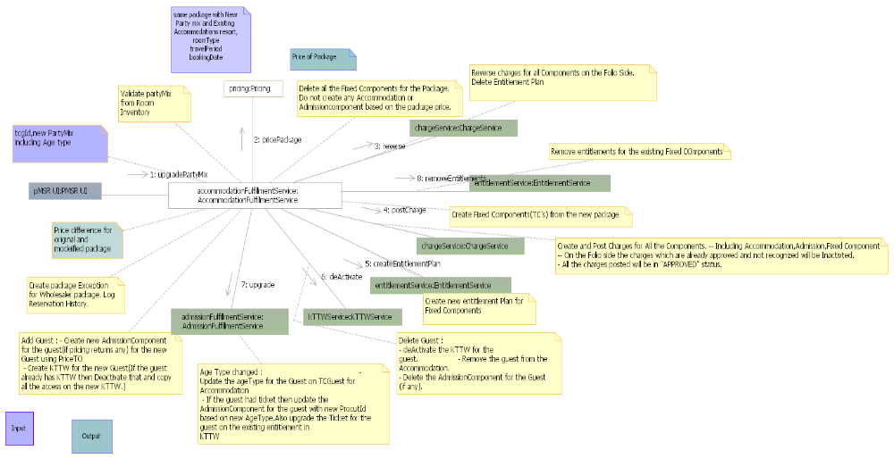

    - Upgrade Package
      - Wholesalers/Retail/Groups
For wholesaler package modifications, this applies to Upgrade to Wholesaler only as the System cannot price a like for like retail version of a wholesaler package. The upgrade charge to guest applies only for retail and DVC cash packages. The group packages will be trapped as per the bill profile setup for that group.
System will perform the following steps:
- Reverse all the charges and the ALT's for the booked package
- If coupon charges have been posted on any entitlement plans, move the coupon charges to the post the same on the Default folio
- Delete the entitlement plans created.
- Price the new package
- Recognize non room charges and create entitlement plans for the new package and recognizing room charges for the previous night.
- In this process, use the earlier ticket entitlements in case of same ticket type.
Assumptions
- Only package is changing, party mix, dates and everything else remains the same.
- The ticket group of the upgraded to package needs to be the same.
- Static Packages with tickets will not be allowed for modifications.
- Package modifications are allowed from a package with no ticket to a package with required ticket in which case a ticket has to be picked.
- System will not allow a package modification from a Package with a ticket to a package with no ticket.
- Dine Plan packages cannot be added from the FrontDesk.
Manual Process
The transfer of coupon charges to the entitlement plans will be handled manually.
DVC Member Reservations
No modification of DVC Member Points and Member Cash reservations allowed from front desk.
Listed below is the collaboration diagram of the sequence of activities with the external systems and DREAMS Component Services performed by this business function.
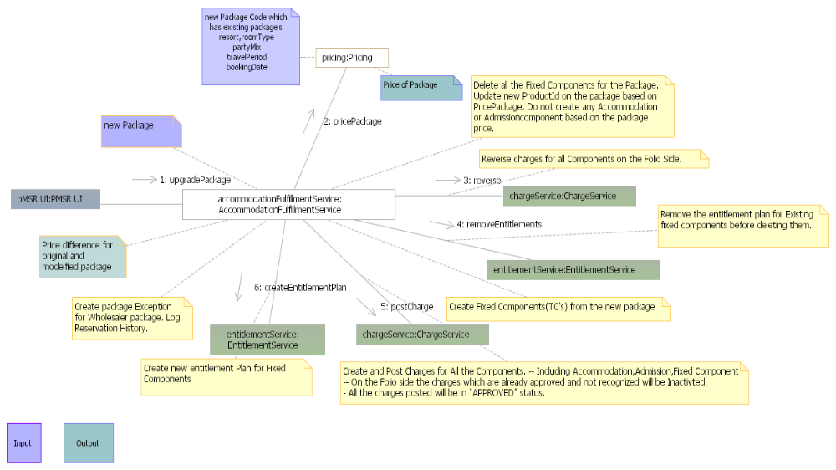
    - Upgrade Dates
      - Extend Length of Stay
For Wholesaler package reservations , if the intent is to extend the dates and charge to guest , the System will retain the original booked accommodation and create another accommodation component with retail room only package.
- Upgrade no charge will not be an option for extending a LOS.
- For upgrade to wholesaler, system will re-price the package and post charges to the group pay folio for the additional nights.
- For Groups and Retail, System will allow extending LOS.
- If the guests are in house, the room should be available for the additional stay. If the Guest is not in house, an available room needs to be selected.
- For DVC Points, modifications are not allowed.
      - Shorten Length of Stay
In an early checkout scenario, the future room charges will not be recognized for retail, group convention room only DVC Cash and Wholesaler reservations.
- Credits will be processed manually for tickets and coupons, if applicable.
- For DVC points, early checkouts will not be processed. The points to be given back, however will be based on DVC Corp policies and will be determined and charged by the DVC Corp System.
Listed below is the collaboration diagram of the sequence of activities with the external systems and DREAMS Component Services performed by this business function.
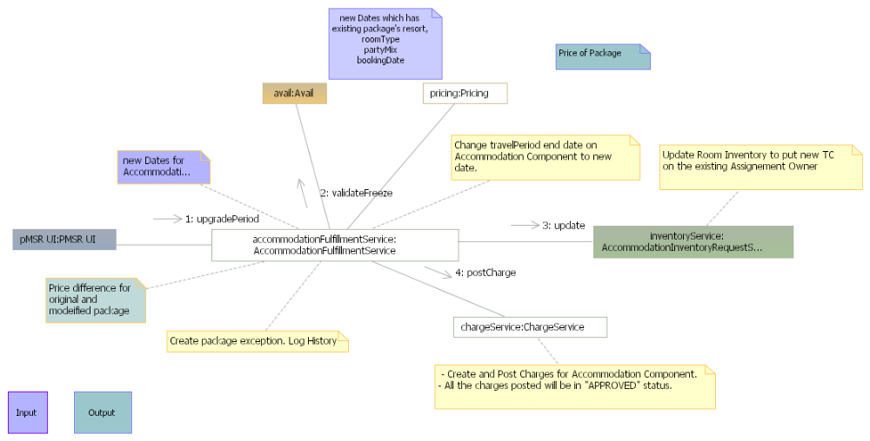
    - Book Day Guest Tickets
The process performs the following:
- Creates a Ticket Reservation by creating a Travel Plan, Travel Plan Segment and a Travel Component Grouping
- Creates Charge Groups and Folio.
- Checkin the Folio
- Prices the ticket
- Posts the charges
- Gets the entitlements for the tickets from the ticketing system
- Cut Key
- Checkout the Folio
Listed below is the collaboration diagram of the sequence of activities with the external systems and DREAMS Component Services performed by this business function.
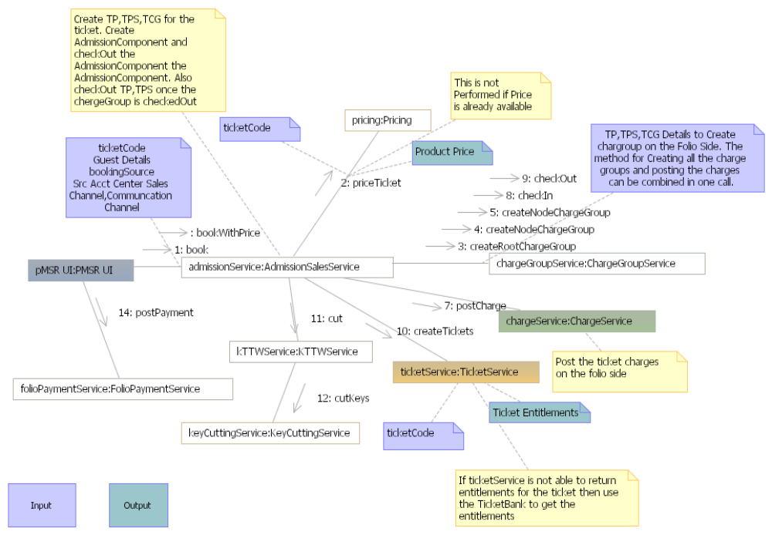

    - Add Ticket For Resort Guest
The process performs the following
- Prices the ticket
- Post Charges for the ticket
- Creates ticket entitlements for Admission Component with the ticketing system
- If these are complimentary tickets , notify GSR
- Cut Keys
Listed below is the collaboration diagram of the sequence of activities with the external systems and DREAMS Component Services performed by this business function.
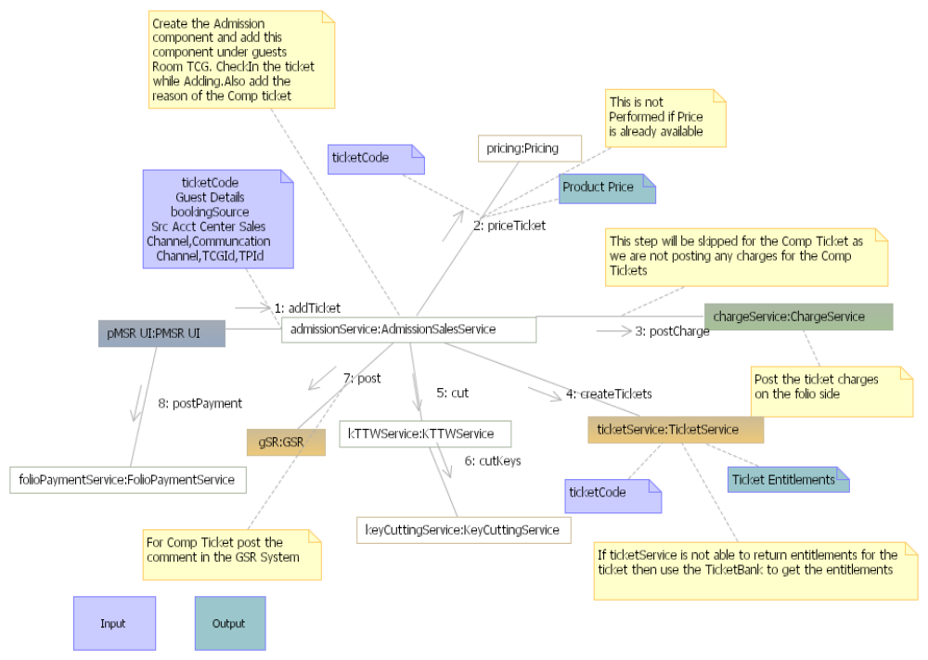
    - Exchange Ticket
The exchange ticket process performs the following
- Send Existing Entitlement to the Ticketing System for an exchange
- Get the entitlement number from the Ticketing System ( Usage is copied over )
- Create the Key with this entitlement number
Listed below is the collaboration diagram of the sequence of activities with the external systems and DREAMS Component Services performed by this business function.
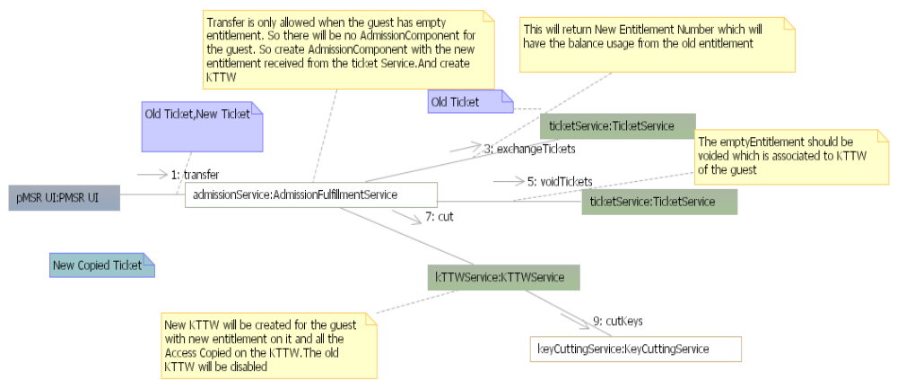
    - Fulfill WillCall
This process performs the following
- Send the Ticket Res number to the Ticketing System and get an entitlement number
- Create a Key with the entitlement number.
Listed below is the collaboration diagram of the sequence of activities with the external systems and DREAMS Component Services performed by this business function.
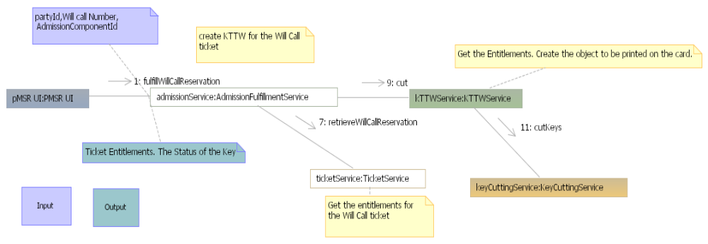
    - Upgrade Ticket
The process performs the following
- Prices the ticket difference
- Post the ticket charges for the difference in price
- Upgrades the existing entitlement with the new ticket.
Listed below is the collaboration diagram of the sequence of activities with the external systems and DREAMS Component Services performed by this business function.
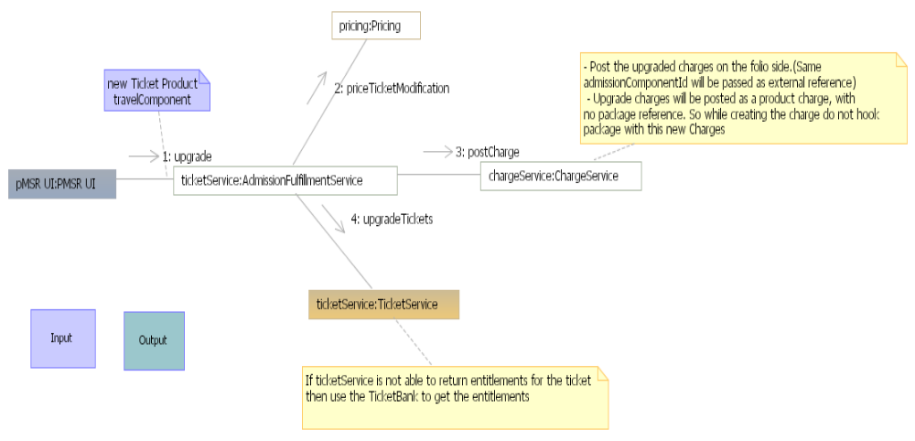
    - Void Ticket
The process performs the following
- Sends an entitlement number to the ticketing system for voiding the ticket.
Listed below is the collaboration diagram of the sequence of activities with the external systems and DREAMS Component Services performed by this business function.
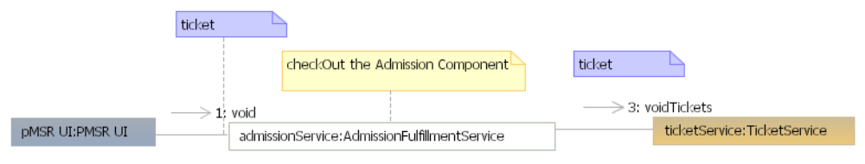
    - Create and Refill Ticket Bank
A Ticket bank is created and maintained by the Res Domain for ensuring that ticket entitlements can be issued at the Resort Ops even when the Ticketing System is undergoing a downtime or is facing performance issues.
As part of this solution , Res Mgt Domain will maintain a bank of 5000 empty tickets and 5000 3 Day Park hopper tickets. These ticket bank will be refilled if the count in the bank falls below 75% of the bank size.
Following diagram shows the flow to populate the ticket bank with Empty and Actual tickets using a batch process, which will be used when the ticket service is not able to return the entitlements real time.
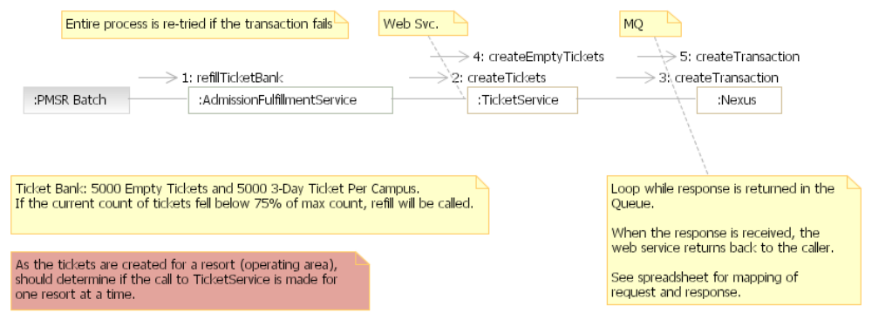
    - Cut Key
Following diagram shows the flow to cut key for a guest. Client calls KTTWService which orchestrates the flow to create data to be printed on card and calls KeyCuttingService cut the key. The response returned by service will be used to update encoding status on KTTW.
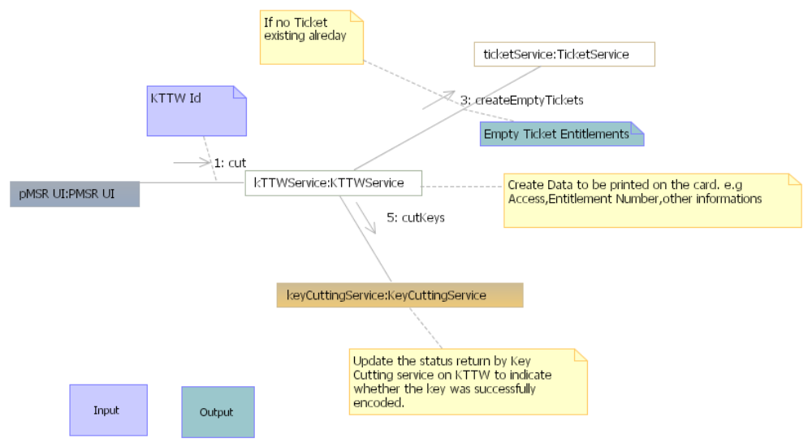
    - Modify Access
Room Change triggers this interaction. Also , based on the implementation technology of the Door Access Provider , same key can be used for providing the changed room access or a different key has to be cut.
Following diagram shows the flow to modify Access (Room or non room) on a key. Client calls KTTWService which orchestrates the flow to determine if the new key is to be cut or the same key can be used to give additional access using KeyCuttingService.
    - Replace Key
In case the Key is lost or damaged, the System has the ability to replace the earlier key.
Following diagram shows the flow to replace an existing key. Client calls KTTWService which orchestrates the flow to create new KTTW by copying all the information from existing key(the entilement from the old key will be voided and the new key will have new set of entitlements fpr the same key. This will be achieved by exchanging the entitlements.). Also the Door access and charging privileged from the existing key will be removed.
    - Late CheckOut Request
Late Check out requests can be made at any point of time. Late check out requests is not priced at the point of time they are requested. A Service request is created for every late checkout request and tracked by the System.
The fulfillment of the late checkout request happens at the checkout as depicted in the checkout flow and the late checkout request is priced as per the policy of the resort.
Following diagram shows the flow to create late checkout request. Client calls AdmissionfulfillmentService which orchestrates the flow to validate the request and create this as Service request.
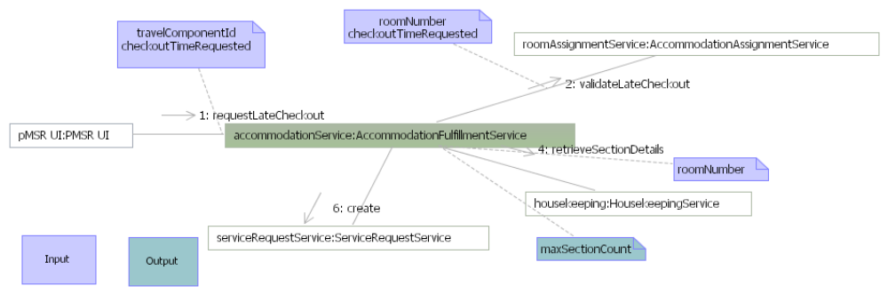
    - Maintain Template
Following diagram shows the flow to create modify or delete Templates which is used to create Mass reservations. Client calls RoomingListService which orchestrates the flow to create,modify or delete template.
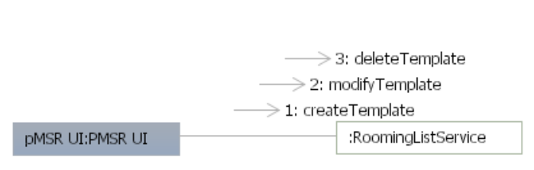

    - Create Mass Reservation
Following diagram shows the flow to Modify the Accommodations in Mass (user can modify resort, room type, group code in Mass). Client calls RoomingListService which orchestrates the flow to call AccommodationSalesService to modify Accommodations.
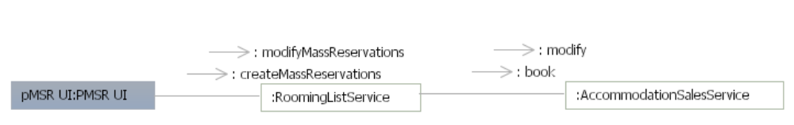

Folio Management

Domain Model

The following diagram depicts the conceptual domain model for the Folio management domain:
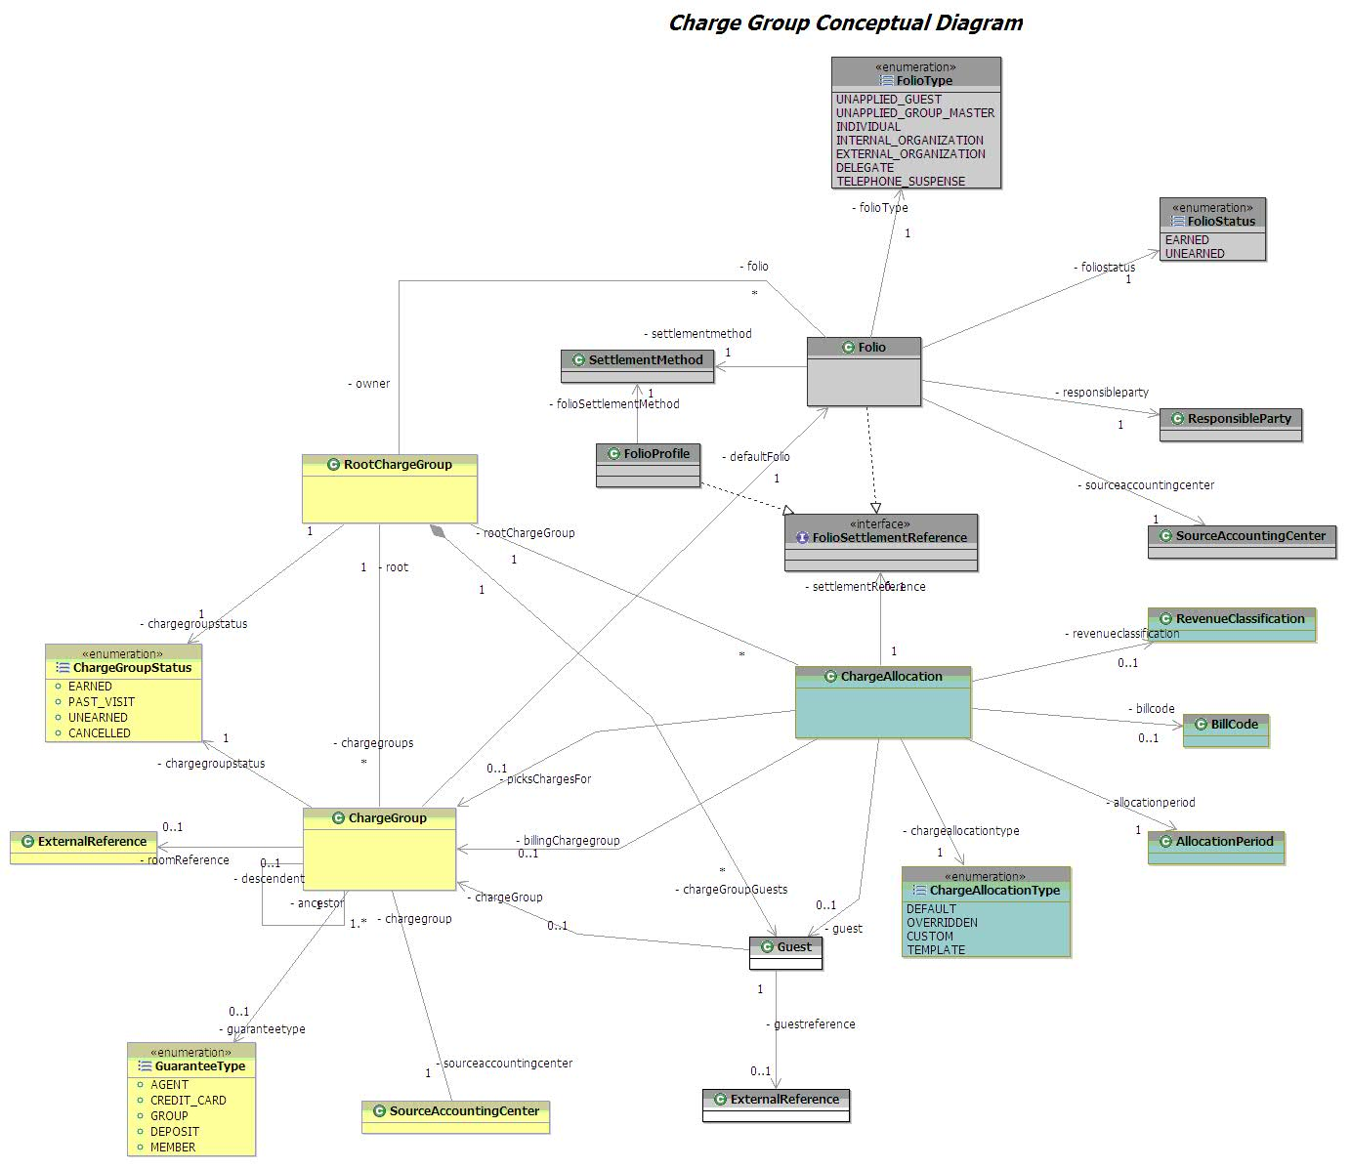
    - Charge Group
Charge Group is the surrogate entity created for a Travel Plan, Travel Plan Segment, Group and block. A Root Charge Group is created for a Travel Plan and Group. A Charge Group is created for a Travel Plan Segment, Travel Component Grouping and a Block.
    - Charge Allocation
Charge Allocations are set of billing rules based on which a charge can be trapped to the right folio. These rules primarily define who is responsible for picking whose charges, what charges for which duration (when) and how much. Charge allocations can be defined on the packages, products and revenue classification. Charge allocations can be also defined to share a charge between two folios.
- WHO pays for a charge?
- WHEN it is paid for?
- For WHAT it is paid for?
Packages and a combination of multiple revenue classifications are also setup as Bill Codes. The Bill Codes are setup with the Charge Allocations to trap the charges. Apart from a bill code, a charge allocation also defines the following:
- Billing Period - A billing period defines WHEN a charge is paid for.
- Facility – defines for WHAT resort the charge is paid for.
- Product / Revenue Classification – defines for WHAT Product/Rev Class the charge is paid for.
There are different types of charge allocations maintained by DREAMS.
      - Template Charge Allocations
Template Charge Allocations are allocations that are setup on the block created for a Group. These are the default charge allocations to be used for trapping charges across all reservations made against the block.
      - Overridden Charge Allocations
Overridden Charge Allocations are charge allocations that are setup on specific accommodations. For accommodations booked against a block, the overridden allocation will be used to trap a charge.
      - Custom Charge Allocations
These are created for incidental folios created at the Resorts to trap specific charges incurred during the Guest Stay.
      - Default Charge Allocations
These are System generated allocations to associate a charge group to a folio. These are used in the system processes to determine the default folios for a charge group.
    - Bill Codes
A Bill Code defines WHO pays for the charges. Some of the example bill codes defined is as follows:
- GNADA – Group Pays No Charges
- *DCL – Disney Cruise Line Pays the Charges
- *WDTC – Walt Disney Travel Company Pays the Charges.
    - Folio
A folio is a “bucket” representing the billable entity which traps charge and payment items.
There are two types of Folio, ChargeGroupFolio and Suspense Folio. Charge group folio is associated with a charge group and is created in the context of a reservation or a group. Suspense folios are not associated with any charge group and a payment or charge or a payment is posted to suspense folio when a reservation to which the folio item is to be posted cannot be identified.
This diagram depicts the concepts of different types of Folios and the structure of the Folio maintained in the System.

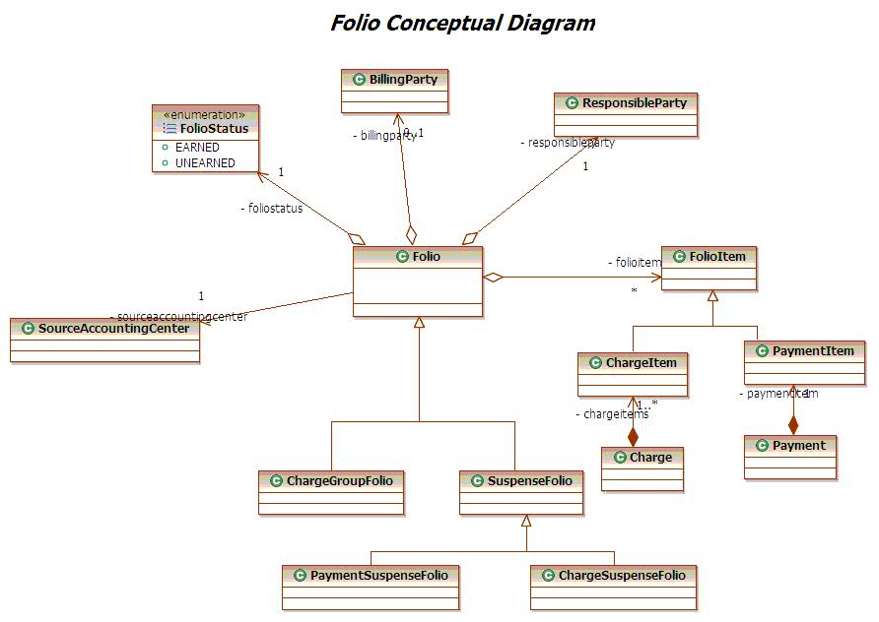
      - ChargeGroup Folio
ChargeGroupFolio represents the responsible party that is responsible for settling of the folio. There are several types of ChargeGroup Folios that are created in DREAMS.
Listed below the types of ChargeGroup Folios
- Guest Pay Folio - Responsible party is a Guest
- Group Pay Folio – The folio created for every reservation for the charges that the group is responsible for.
- RSR Folio – Created to keep track of the charges posted for a resort special reservation.
- Group Master Folio – The folio to which all the group pay folios will settle to on check out. This folio also receives charges incurred by the Group.
      - Suspense Folio
The Suspense Folio is further categorized as payment suspense and charge suspense folio
- Charge Suspense Folio
A charge will be posted to a charge suspense folio, if a right folio cannot be found for that charge. These folios are set up by revenue classifications. Examples are telephone suspense folios that trap telephone charges posted after check out of an accommodation.
- Payment Suspense Folio
Any payment for which the folio cannot be found are posted into the payment suspense folios. Two payment suspense folios in the system are Unapplied Guest and Unapplied Group folios.
    - Charge
A charge is a unit of posting which is based on the requirement frequency of a component product. For example: A room is priced per night. (In accounting, a room equates to a charge per night). A ticket is priced per person / per reservation (In accounting, a ticket equates to a charge per person per reservation).
Each charge posted will have a revenue classification, the transaction accounting center it is associated with, the source accounting center it should belong to and one or more charge items. Each charge item will have its own revenue type. Every charge should have at least one charge item with the revenue type as Base.
Charges can be posted for a reservation component that is booked (Product Charge, Fee Charge), group conventions (Event Charge), or anything that the guest incurs during the course of stay (POS Charge, Phone Charge).
The following sections describe the different types of charges.
      - Reservation Related Charges
These are posted when a reservation is booked in the System. A Room Reservation will result in posting of room charges for each night. Tickets included in the package will post charges per person for that reservation, excluding infants. Other Package included components such as Dine, Recreation etc also post charges based on the charging frequency of the products.
      - Fee Charges
These charges are related to the policies setup on the packages. Some examples of these charges are
- Cancellation Fees
- Cancellation Fees are applied when a manual cancellation of reservation is processed in the System. Based on the Cancellation Date and the arrival date, the package policy applies the cancellation fee which is posted to the appropriate Folio.
- Exchange Fees
- Exchange fees are posted with DVC Exchange reservations and Disney Collection reservations
      - POS Charges
POS Charges are either redeemed against an existing entitlement plan or posted as hotel charges.
      - Hotel Charges
Hotel Charges are charges that come thru the POS posting channel and posted on the Guest, Group, RSR or incidental folio. Some examples of these charges are valet service charges and room service charges.
      - Coupon Charges
Coupon Charges are charges that are redeemed against an existing entitlement plan. An example of this charge is the Dine Plan included as part of the package. A Dine Plan creates entitlement plans for components of the Dine Plan i.e. Quick Service, Snacks, and Table Service. When the Guest uses that service and uses the Key to the World Card for Payment, the resulting charge is posted in DREAMS and is redeemed against an existing entitlement plan.
      - Phone Charges
These charges are posted from the Phone System into DREAMS when the Phone in the Room is used for making local or international calls. These charges are posted against the room number.
      - Event Charges (BEO Postings)
Guests booking events along with the room stays get event charges posted from the Event Management System (DSCS). These charges are posted against the Group Master Folio and not the Guest Folio.
      - Charge life cycle
Any Charge posted to Folio will be revenue recognized immediately or later depending on the fulfillment date. A charge that will be fulfilled at a later date than posting date will have the revenue recognition status of Pending. The status will be changed to 'Approved' at the time of fulfillment or Check-in. On the other hand a charge posted for a fulfilled service will have the revenue recognition status as Approved. Charges with 'Approved' status qualify for revenue recognition.
Typically, all the room related charges have a fulfillment date of the stay dates and end of day as the time. All Other non room related charges in the context of package components have the fulfillment date of the arrival date of the reservation and the time as start of the day. Fees are posted and recognized immediately. This applies for all other postings as well.
      - Charge Items
Each charge posted in Accounting is further categorized into charge items. Charge Items are types of revenue categorization for the charge posting for a product or fee.
- Base price
- Additional price
- Discount
- Taxes
- Deposit requirements
This diagram depicts the concepts of charges and charge items.
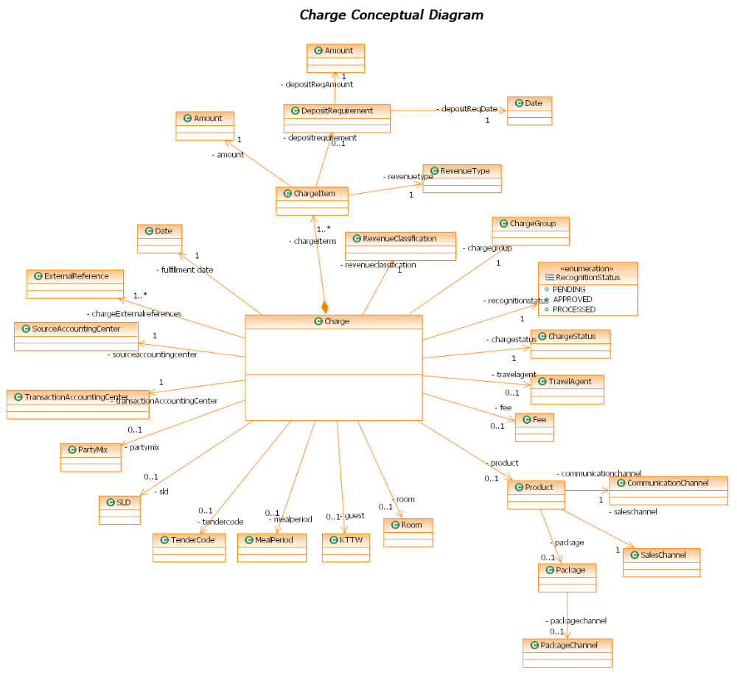
    - Payment
Payment is the money posted to the Folio to balance the charges.
      - Client Channels for Payment
DREAMS receives payments from the following channels:
- SBC
- Accovia
- DCL
- Special events
- Lockbox
- DREAMS UI
- LILO UI
- A La Carte UI
- DVC Member Services UI
      - Modes of Payment
These payments are received by DREAMS as a File based payment or individual postings.
- File based Payment
WDTC and DCL send a payment file for the wholesaler reservations. These are inter-company transfers from the Wholesaler Company to WDW. Special events reservations and lockbox payments also send a file based payment.
- Individual Postings
Individual Payments are made using most of the User Interface Clients using several payment methods.
      - Payment Method Type and Payment Methods
There are several payment methods that are supported by DREAMS. Some of these are available for User Payment Postings whereas some of these are used by System Driven Processes for setting settlement methods or posting special payments.
        - Common User Interface Payment Postings
Listed below are the Payment methods types and payment methods available for DRC, Resort Ops users and Scheduled Events users for posting payments for Guest Folios
Purpose | Types of Payment Method | Payment Methods
UI Payment Postings | Credit Card | VISA
UI Payment Postings | Credit Card | AMEX
UI Payment Postings | Credit Card | MASTERCARD
UI Payment Postings | Credit Card | DINERS CLUB
UI Payment Postings | Credit Card | Others
UI Payment Postings | Pre Paid Card | Gift Card
UI Payment Postings | Check | Manual Check
UI Payment Postings | Check | Travelers Check
UI Payment Postings | Check | Lockbox
UI Payment Postings | Vouchers
UI Payment Postings | Cash | Cash
UI Payment Postings | Cash | Disney Dollars
UI Payment Postings | Rewards Card | Disney Rewards Card
        - System Payments
Listed below are the Payment Method types and the payment methods that DREAMS uses for file based and system initiated payments.
Purpose | Types of Payment Method | Payment Methods | Description
System Applied Payments | RSR | RSR | Used when the RSR Settlement method is specified on a folio
System Applied Payments | Bill to A/R | Bill to A/R | Created for invoices to be sent to Wholesalers or Guests. Bill to A/R cannot be setup as Settlement method on a Folio
System Applied Payments | Redeem | Redeem | Applied for payments for downloading payments to current state DPMS or earning payments at check-in
System Applied Payments | Settle to Folio | Settle to Folio | Used for the settlement of the charges from the Group Pay Folio to the Group Master Folio.  This Payment method type can not be set as a settlement method from the User Interface
System Applied Payments | Inter-Company Transfer | WDTC | Inter Company transfers processed as File based Payments
System Applied Payments | Inter-Company Transfer | Special Events | Inter Company transfers processed as File based Payments
System Applied Payments | Inter-Company Transfer | DCL | Inter Company transfers processed as File based Payments
        - Direct Bill
Direct bill is a Payment method type that is only used for setting a settlement method on the Folio. This is never used by the System to post a Payment. The Bill to A/R process takes the SAP Customer number for Wholesalers from the Direct Bill Settlement Method. The Payment methods associated to this payment method type are: Direct Bill
        - Scheduled Event Payments
The A La Carte UI can accept the Key to the World Card issued to Guests as for posting payments. These payments are used to pay at the Food & beverage, Merchandise, Recreation locations etc.
In case the coupons are available for redemption on the Guests Folio, the payments are posted as Entitlement Payments. The Payments are posted as Hotel Charges in case the Guest is going to pay as part of the final checkout or does not want to use the coupons.
Purpose | Types of Payment Method | Payment Methods | Description
Special Scheduled Events Payments | Entitlement Payment | Child Table Service | All Entitlement Payments posted to the System are categorized under this payment method type.  All Entitlement Payments are made with a Tender Code.  An Entitlement Payment made for the Scheduled Events Reservation is a Charge on the Guest Folio for the Guests
Special Scheduled Events Payments | Entitlement Payment | Adult Table Service
Special Scheduled Events Payments | Entitlement Payment | Premium Food and Beverage Plan
Special Scheduled Events Payments | Entitlement Payment | Platinum Food and Beverage Plan
Special Scheduled Events Payments | Hotel Charge | Hotel Charge | All Hotel Charge Payments posted to the System are categorized under this payment method type.  These Hotel Charge Payments are posted as Hotel Charges on the Guests Folio
Special Scheduled Events Payments | Hotel Charge | GMR Charge
Note: A La Carte UI is the only Client that accepts payments by Key to the World Card issued to the Resort Guest.
        - Special Payments from Resorts
There are certain scenarios at the Resorts in which Payments are posted to the System. The Following Payment method types are created in the System to handle these payments.
- Non Folio Refunds
A Guest requesting a refund at the Frontdesk for cash used at the arcades or a parking refund is processed as a non folio refund. This money is given from the till provided to the Cashier and cannot be necessarily recorded against a Guest Folio as these Guests can be Non Resort Guests. These Payments made, however have to be recorded in the System and reported in a bank out process.
- Paid Outs
Any Payment made by the frontdesk from the till on behalf of the Resort Guest for services provided by an external agency e.g. a payment made out of the Cashier till for a package delivery by Fed ex. On behalf of a Resort Guest is considered as a Paid Out. These payments are posted to the Guest Folio.
Note: Paid Outs are displayed as Charges on the Folio View of the LILO UI.
      - Payment Life Cycle
A Payment is created in the System in “Approved” State. It is processed immediately and a analysis ledger transaction created as soon as the Payment is posted to the Folio. The Payment is then changed to a status “Processed”.
The only exception to the above is for Refunds. Refunds are created with a Status of “Pending” and are approved after a number of days as per the Business. The refunds are changed to “Approved” status and then eventually “Processed”.
This diagram depicts the structure of payment in the system.
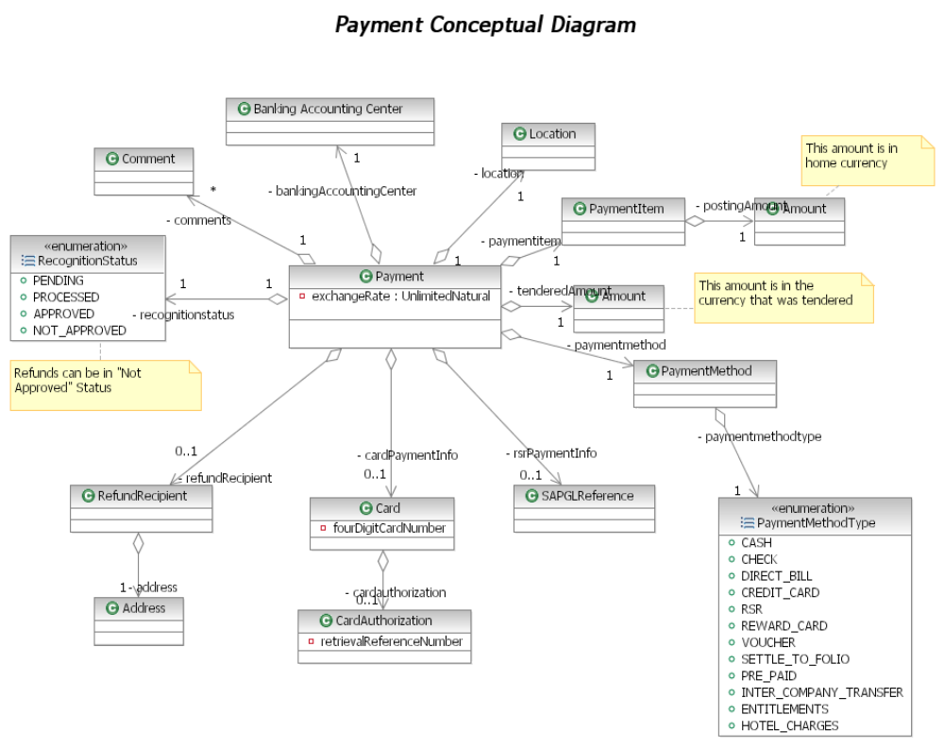
    - Settlement Method
A Settlement Method is the Mode of Payment and the Payment Information to be used by the System for settling the folio balance. This information is either provided by the Guest or defaulted by the System in some scenarios. A Payment applied to a Folio can also be designated as the settlement method.
- Guest Settlement Methods: In Case of Guest Pay Folios, the Default Folio is created with “Cash” as Settlement Method. On Payment of the balance due of the Folio, the Payment can be optionally set as Settlement Method. Additionally, the Guest can specify a Settlement Method. Rewards, Gift Cards and Vouchers cannot be specified as Settlement Methods. The System can maintain multiple settlement methods but only one can be active or default. Any Credit Card can be specified as Settlement Method. The System performs a dollar auth for the Credit Cards. It stores the authorization information and the masked card number to use for actual payments.
- Group Reservation Settlement Methods: In case of Group Pay Folios, the Settlement Method is the Group Master Folio. The balance of the Group Pay Folio is settled to the Group Master Folio.
- Groups Settlement Methods: A Group (Convention, Wedding, Sports) etc can have Settlement Methods similar to the Guest Settlement Methods
- Wholesaler Settlement Methods: For Wholesalers, the Settlement Method is Direct Bill where the SAP Customer number is specified and the Wholesalers are invoiced nightly.
- RSR Settlement Methods: In Case of RSR Folios, the Settlement Method is an Internal Account Number. The balance of a RSR Folio settles against this SAP account number.
This diagram depicts the entities of various settlement methods that can be created. Each settlement method is associated with a payment method type and a payment method.
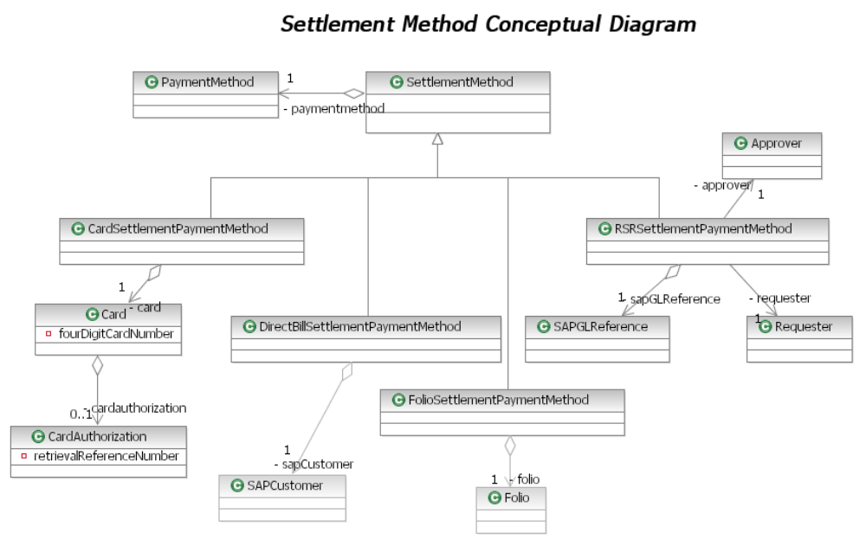
    - Transaction
Each Entry for a Charge or a Payment to be recorded in the Analysis Ledger is categorized as a Transaction. Each Transaction is categorized into Several Types.
The following diagram depicts the types of transactions supported for both charges and payments in DREAMS.
      - Charge Transactions
DREAMS supports the following types of Charge Transactions:
Transaction Type | Description
Sale | All Charges recognized in the System as recorded as Sale transactions.
Write-Off | On every Settlement process, if the Folio Balance is below a certain amount, the amount remaining is not processed for billing but is written off.  These are recorded in the System as Write Off transactions.
Adjustment | Incorrect postings done manually can be adjusted. These adjustments for charges are recorded as adjustment transactions.
Settle | A Settlement process for Group Pay Folios results in creation of a Settlement Transaction. A Settlement transaction is associated to a Settlement Method on the Group pay folio and a Settlement Charge on the Group Master Folio.
UPGRADE | Any upgrade / downgrade of a component is recorded in the System as an Upgrade Ticket transaction.
Void | A voiding of a charge is recorded in the System as a Void transaction.
ACB | Component refunds processed from the Resort ops are recorded as ACB transactions.
Transfer | Charges can be manually transferred between folios. This is recorded as a Transfer Transaction which has a Transfer from and a Transfer to Folio and Charge information.
REDEEM | Fee Charges need to be moved from an unearned account to a Guest Ledger at check-in to DPMS. This is accomplished by using REDEEM transaction

      - Payment Transactions
DREAMS supports the following types of transactions that can be operated on the payments received.
Transaction Type | Description
Receipt | All Payment received in the System are recorded as RECEIPT transactions.
Settle | This transaction is created when a Group pay folio is settled. The Settlement Transaction for Payment is recorded on the Group Pay Folio. This gets balanced by the Settlement transaction for a Charge on the GroupMaster Folio.
Transfer | This transaction is recorded in case a payment is transferred between folios. The amount to transfer would be spread across based on the folio balance. The trsnasfer can also be done for a single payment . Money can be transferred from a Group Master Folio to all its delegate folios. Every Transfer Transaction tracks the Transfer from and the Transfer to Folio.
Refund | In case a payment is posted after the reservation has cancelled with an existing deposit, a refund transaction is created and the remaining money on the guest pay folio is settled to the guest.  In case where there is a folio balance on the group pay folio, the money has to be transferred to the Group master folio using the delegate settle process.  When a Group profile is checked out or cancelled with a folio balance, the money on the group master folio is settled according to the settlement method on the group master folio.  Refunds are created in the System as Payments and the Status of the Refund is tracked using the normal status of the payment. The refund status goes through a process, changing from pending to approved, paid and hold.  Note: For a Non-Disney resort reservation, any payment received is immediately processed as a refund and the money is refunded to the specific Non-Disney resort.
Reversal | Incorrect Payment postings are reversed by using the User Interface. These reversals are recorded in the System as reversal transactions. The folio balance is adjusted based on the reversal transaction being posted.
Adjustment | An Adjustment transaction is created for a specific payment posted in case the original posting has to be adjusted to a different amount..
Bank Return Transaction | Based on business criteria, certain payments are returned to the Bank. Example: When a check is received with insufficient funds, the payment is sent back to the bank via a Bank Return transaction. A bank return transaction is created when a credit card is charged back or cash/check deposits receive a correction from the bank/financial institution.
REDEEM | Pre Arrival Payments need to be moved from an unearned account to a Guest Ledger at check-in or deposit download to DPMS. This is accomplished by using REDEEM transaction

    - Bank in, Bank Out
      - Bank in Process
A Bank in process is of notifying the system of the starting balance, in case the Cashier Session has started with a till. Additionally, the Users who take payments in DREAMS can also bank in without a till.
The bank in process is based on an overall solution which is based on setup of users in Keystone. This profile is assumed to associate the users of the System to one role. On a successful login, following steps are performed by the System for the bank in process
- The role will define the need to bank in.
- If the user can bank in, the role will also be used to define the need for a till while banking into the System and the types of tills available to that role.
- The user will have the ability to choose no till or choose the till that users role has access to.
- Roles would have access to choose different tills. For example, an FSA could choose no till, cashier till or FSA till.
- Each till has a change fund associated. Those amounts would be configured by RCC in the System and automatically populate when the appropriate till is selected. Also, these amounts cannot be overridden by the user of the system and are used as the starting balance for the till.
- Optionally, the user can choose not to bank in .A Bank in ability will be available for the user to bank in at any point in time.
- The System uses the register number configured for the banking accounting center of the location. This number will represent the banked in number for that user.
- A user can be banked into only one location at a time.
- The Cast members can bank in multiple times in a day. They have to bank out before banking in.
- The process of bank out will be controlled by the bank in process.
      - Bank out Process
A Bankout is notifying the System of the ending balance and the financial activity that happened in the bankin session.
- The actor can do advance or late deposits during a bank-in session.
- An actor has to bank out before banking in to another location.
- Any actor that is not banked out, will be auto banked out by an end of day batch.
- Only the user entered items like coins, currency, non-folio refunds are captured and the rest of the payment activity is derived from the payments taken by the cashier during the bank in session.

      - Types of Bank Out
- Advance: An Advance deposit is made in the System in case of excessive cash in the till or a partial Deposit. The System tracks these Deposits in a bank in session for the final bank out. The total foreign currency and cash amount is captured for the Advance Deposit. The System allows many advance deposits for a bank in session. A unique bag number is assigned by the user for an advanced deposit. An advanced deposit is notified to SAP using the EDS and Charge Code interface.
- Late: A Late Deposit is made in case leftover currency is found from previous day or a previous shift. The User deposits this money in the System using this type of bank out. A unique bag number is provided by the user for this deposit. The amount of the late deposit does not count towards total deposit. A Late Deposit is notified to SAP using the EDS and Charge Code Interface.
- Final: The Final bankout considers all the payments made in the System for that bank in session. This includes all Advanced Deposits, Foreign Currency, Special tenders (Non Folio Refunds) and all other payments taken by that User in that banked in session.
      - TCR Vs Non TCR Locations
Each Location is configured to a TCR Vs Non TCR Location.
TCR – TCR Teller Cash Recycler
The System provides the user for keying in denominations breakup for Cash and Coins at Non TCR Locations. For TCR locations, Cash totals are captured.
The below diagram depicts the entities involved in Bank In and Bank Out session

    - Commissions
The travel agent commission is remuneration for products sold. There are several business processes involved in the commission’s domain including the setup of commissions, the calculation of commissions on the commission rates, the reconciliation and approval process and finally the sending of commissions to SAP.
      - Commission Rate Setup
For each travel agency, commissions are set up at the package, product or revenue classification levels either as a flat rate or a percentage of the product price.
The commission rate can be setup for a package for all the product categories inside the package. Optionally, different rates can be setup for specific product categories inside a package.
Commissions can also be setup for specific revenue classifications e.g. Accommodations, Admissions etc.
The travel agency can be additionally set up to use global ticket commission rates.
      - Calculation of Commissions
Any Travel Agency booking made in the System stores the Travel Agency at the Travel Plan Segment Level. It also stores the Travel Agency on each charge posted for that reservation.
Commissions are always calculated on all product charges after the travel plan checks out. This implies that these are commissions based on the actual stay of the Guest. In case of an early checkout, the commissions, if applicable will be calculated based on the nights stayed.
Potential commissions are calculated for charges in the Travel Plan which do not have Travel Agency information stored on the charges. The actual commissions will not be calculated for these charges.
In case the commission rate is not setup for a combination of Admission Products and Packages, the rate defaults to the Global ticket commission rate in case it is configured for that ticket.
      - Reconciliation and Approval Process
Calculated commissions are reconciled and approved. In case of discrepancies between potential and actual commissions, the Finance team has the ability to change actual commission using the User Interface and also approve the commissions.
Any calculated commissions will be in a pending status unless it is manually approved. If a pending commission is not manually approved, then the commission is put in a “Hold” status.
Approved commissions will be sent to SAP in the AP Commissions interface.

This diagram depicts the Commission rate set up for a travel agency and the entities involved in calculating commissions.

Services
This diagram depicts the service components of Folio. The services are classified as business services and component services. Component services are the boundary classes of a functional component. Business services serve as façades to component services and are used if services from different components are involved in the completion of a transaction.
    - ChargeService
ChargeService is a business service used for posting charges across all channels. It is used by the following channels / clients
- DREAMS UI – Used by DRC back office for posting cancellation fees.
- LILO UI – Used by the Resort Ops for posting, voiding , adjusting manual charge postings
- Jazz – Sends Phone Charges
- DSCS – Sends Event Charges
- Stratus – Sends Postings thru RVS/HSIA/POS terminals/ATS
- RTP – Sends a Repost file for all online stratus postings
- ATS – Sends a Repost file for all online ATS postings.
It provides these high level business functions
- Posting of Charges
- Pre Authorizing Charges
- Transferring charges from entitlement plan to folios and vice versa
- Voiding Charges
    - PaymentService
PaymentService is a business service used for posting payments across all channels. It is used by the following channels / clients:
- DREAMS UI – DRC back Office posts payments
- LILO UI – Resort ops posting payments
- SBC Payment for WDW – DRC Res Agents posting payments
It provides these high level business functions:
- Posting all online payments from the User Interfaces
- Enquire Balance for a Pre Paid Card and Rewards Card.
    - FolioChargeService
FolioChargeService is a component service used for posting charges from the following channels/clients.
- Charge Service – The Business Service uses this component service for posting, voiding, authorizing charges
- AccommodationSalesService – AccommodationSalesService posts charges for new bookings, modifications, cancellations, shares, unshares, reinstates, rate overrides and upgrades.
- AccommodationFulfillmentService – AccommodationFulfillmentService posts charges for upgrade to this service.
- Revenue Recognition Daemon – The Daemon recognizes charges due and updates the status of recognized charges
It provides these high level business functions
- New Postings, Voids, Auth for Charges
- All Res Modifications of Charges
- All Post Arrival Upgrades for Charges
- Revenue Recognition of Charges
    - FolioPaymentService
FolioPaymentService is a component service used for posting payments across all channels. It is used by the following channels / clients:
- PaymentService – PaymentService delegates the actual creation of Payment in the System to this service. It also retrieves information from this service for validation for posting a payment.
- Revenue Recognition Daemon – The Revenue Recognition Daemon uses this service for earning payments.
It provides these high level business functions:
- Earn Payments ( Move payments from unearned account to guest ledger)
- Post Payments ( Post payments to the Folio)
- Get Folio Payment Validation Information
    - FolioService
FolioService is a business service used for posting charges across all channels. It is used by the following channels / clients
- LILO UI – Resort Ops uses this for transfers of charges and payments and creating incidental folios and viewing folios
- DREAMS UI – DRC back office uses this for retrieving folios for display and transfer of payments
- System Driven Processes – Billing Profile Changes and changes in tax exemption status trigger refilter of all charges on the folios for a Travel Plan.
It provides these high level business functions:
- Transfer of Charges and Payments within Folios
- Creating Responsible Party
- Retrieving Folio
- Refilter
    - ChargeGroupService
ChargeService is a component service used for posting charges across all channels. It is used by the following channels / clients:
- AccommodationSalesService – This business service uses this service for all res related functionalities
- AccommodationFulfillmentService – This business service uses this service for all fulfillment related functionalities.
It also provides the following business functions:
- Creation, Modification and Maintaining Status of Charge Groups
- Checkin , Checkout Charge Group
- Determine Guarantee Status
    - BankInService
BankInService is a business service used by the following Clients/Channels
- LILO UI – Resort Ops users for banking in and banking out
- EOD Jobs – Auto bankout and Creating bankout interfaces
This service provides these business functions
- Auto Bankout
- Bankin
- Bankout
- Create Bankout Interfaces
    - CommissionsService
CommissionsService is a business service used for calculating and reconciling commissions. It is used by the following clients.
- LILO UI – Finance team uses this mainly for approvals and reconciling commissions
- EOD Jobs – Calculating commissions.

System Interactions
    - Post Charge
ChargeService is a business service that intercepts the post charge requests from JAZZ, Stratus, RTP, ATS adapters and LILO UI and does validations as necessary and passes the request to Entitlement Service or Folio Charge service for posting charges. Charge is passed to Entitlements if the charge is found to be valid to redeem coupons. DREAMS UI and Booking services call FolioChargeService for posting charges.
POS Postings originate from a host of channels
- POS Terminals: Guests using the Key to the World Cards at Food and Beverage, Merchandise and other locations within the WDW Property end up posting a charge on their reservation. These charges are either redeemed against coupons available as part of the package entitlements or posted as hotel charges
- Resort Valet Service: A Valet Parking Placard is issued at the time of checkin of the room reservation. The parking placard holds reservation information. Whenever a Valet Service is used by the Guest, the parking placard is used for getting the reservation information (Room number KTTW) and the Valet Charge is posted to folio using the KTTW.
- High Speed Internet Access: Guest using High Speed Internet access in the rooms gets charged on the charging frequency of the Internet usage. These charges are also posted against the KTTW of the Primary Guest.
- ATS: Guests using the KTTW to purchase tickets at Guest Services result in posting of charges from ATS into DREAMS.

The Posting of Charges performs the following steps
- Determines if the Charge needs to be posted to a Folio or an entitlement for POS Charges
- For Other Charges and the charges to be posted on the Folio for POS Charges , perform the Bill Trap Process
- Post the charge to the folio based on the Bill Trap.
- If a charge is partially trapped by the folio as a result of the bill trap, perform the bill trap for the remaining balance of the charge.
- Adapters parse and interpret the request coming from various channels and translate to appropriate message formats to invoke the respective ChargeBusinessService methods.
This diagram demonstrates the various channels that post charges and the interface methods they use.

    - Bill Trap Process
Bill Trap Process is going thru the Folios Charge Allocations to determine if a Charge can be trapped to that Folio. A Charge Posted is always posted for a Charge Group, KTTW, and Room number. The Charge Group is determined if the Charge is posted with a KTTW or a room number. All The Charge Allocations for the Root Charge Group are retrieved and sorted in the following order.
- Overridden Allocations – Any allocations that are customized for specific reservations which override the template allocations. These are setup as trapping Bill Codes
- Template Allocations - The Allocations Setup on a block that applies for all bookings made against that block. These are setup as trapping Bill Codes
- RSR Allocations – Setup for RSR reservations, These trap specific revenue classifications for RSR reservations
- Custom Allocations – Setup for Incidental Folios trapping specific revenue classifications
- Default Allocations – Setup for the default folios, Traps all.
Each Charge is passed thru these Charge Allocations to determine the Folio that traps the charge. Once the Folio is determined, a check is made against the spend limit of the Folio to ensure that trapping the charge will not exceed the limit.

      - KTTW Pre-Authorization for a Charge
The process performs the following:
- Performs bill trap
- Returns successfully if the Folio is found for trapping a charge.
This diagram depicts the orchestration of pre authorization of a KTTW card prior to posting a POS Charge. The only difference in pre authorization process and post charge process is that the former does all the validations necessary to post a charge, including identifying the folio and validating the spend limits on the folio but does not actually post the charge to the folio.

    - Charge Group State Transition
This diagram depicts the various states that a charge group can be in and the transitions that are valid. Each state of charge group corresponds to one or more states of Travel Component in Booking.

    - Check Out
This collaboration demonstrates the process that happens when a state transition of Checkout is requested on a charge group. The Checkout process on a Charge group performs the following
- Updates the Charge Group Status to Past Visit
- Deletes Charges which do not have a revenue recognition status of “Processed”
    - Check In Folio
This collaboration demonstrates the process that happens at the check in of a travel component group charge group. The process performs the following:
- Earn Payments - On a Check in, the Payment posted Pre Arrival has to be earned. The earning of Payments has a different behavior for Resorts rolled out in DREAMS Vs Resorts that are still on DPMS.
For Resorts which are on DPMS, any payment made after posted using DREAMS UI post arrival will go thru the following transactions ( All the references made are for Natural Side entries for the Analysis Ledger)
- Redeem – Moves the Money to a Clearing Account
- Download - Sends the Money down to Property.
- Earn-The PMS Legacy receives the money and moves the money from the Clearing A/C to Guest Ledger
For Resorts rolled out, for earning payments will perform the following
- Redeem – Moves the Money to a Clearing Account
- Earn – Moves the Money from the Clearing Account to a Guest Ledger Account
- Update Status to EARNED
- Validate and re-authorize Settlement Method on all Folios
- Sets Guarantee Status to Deposit ( This is done to ensure that accommodations under this Travel Plan is not auto cancelled after checked in)
    - Payment Process
This collaboration demonstrates the payment posting process. PaymentService exposes different methods to post payments based on the payment method type. It does necessary validations and passes on the request to FolioPaymentService. For payment method types (Card) that need authorization, it invokes the authorization service and upon authorization, passes the request to FolioPaymentService with the masked card number and the retrieval reference number.
PaymentService runs on a PCI compliant server while FolioPaymentService runs on a non PCI compliant server.
The Payment Process performs the following
- If this is a card payment , retrieves validation information from FolioPaymentService
- Does basic validations and then performs the authorization for the payment amount with the AuthService
- On a successful authorization , posts the Payment to the FolioPaymentService

The FolioPaymentService performs the following steps
- The FolioPaymentService traps the Folio to the appropriate ( Group Pay or Guest Folio) based on the payment input ( Folio , ChargeGroup , Block Code , Group Code etc)
- The Payment is created with an “Approved” status
- Every payment posted prompts the system to reevaluate the guaranteed status of the reservation.
- Payments are posted to unapplied folios if the folios cannot be located for reservations.
- Payments can be searched for within DREAMS using several search criteria.
- Payments made in DREAMS will be downloaded to Property on the day of check in of the reservation. This process will be discontinued when the Resort rolls out.
- Any payment made in DREAMS after the day of check in will be downloaded to Property real time. This process will be discontinued when the Resort rolls out.

    - Payment trap Process
The Payments posted in DREAMS are sent with varied inputs. These inputs have to be used to find the appropriate folio for posting the payment
Payment Source | Payment Reference | Trap Process
File Payments | WHO # and Block Code | Retrieve Travel Plan by using the WHO #  Retrieve Group Pay Folio in the Travel Plan having settlement method as the GroupMasterFolio for the block’s Group Profile
SE Payments | Travel Plan Segment number | Retrieve the Travel Plan Segment Level Default Folio.  If default does not exist at the Travel Plan Segment level , post to the Travel Plan default folio
SBC Payments | Travel Plan Segment number
Lockbox Payments | Travel Plan Segment number
LILO UI Payments | Folio Id | Find Folio by Folio Id and post to the Folio
System based Payments | Folio Id | Find Folio by Folio Id and post to the Folio

    - Recognize Charge
This collaboration demonstrates the charge recognition process.
Recognition Engine picks all charges whose fulfillment date time is less than the current accounting date and time and whose revenue recognition status is approved. It creates analysis ledger entries for the charge.
The recognition process of the charge changes the status of the charge from “Approved” to “Processed”.
    - Recognize Payment
This collaboration demonstrates the payment recognition process. Recognition Engine picks all un-recognized payments and creates analysis ledger entries for them.
    - Re-filter Process
Refilter is a business process that re-evaluates every charge across all folios on a Travel Plan and performs a bill trap. This process is done as the trapping criteria have changed and the charges that were earlier trapped to folios within the Travel Plan may no longer be valid. This process is meant to trap the charges to the appropriate folio.
Re-filter process is triggered by the following
- Bill Codes Changes: Bill Codes are setup to trap packages or a combination of revenue classifications. In case of incorrect or no bill codes setup on the package being published, the charges for that package are trapped incorrectly. The correction is applied by adding the bill code to the package and republishing the package. This republish of the package retrieves all active reservations for that package and performs the trapping process for each charge belonging to the all folios across all Travel Plans.
Bill Codes can also be added or removed for Group reservations on the Template Charge Allocations. Any change in the template charge allocation triggers all active reservations made against that block and refilters all charges for reservations made against that block.
- Charge allocation modifications: Any Changes to the Charge Allocations for overridden or custom charge allocations prompts the user to refilter all the charges across all folios within that Travel Plan.
- Resort Change: Any change to the resort on an accommodation component has a potential to refilter the charges as the template charge allocations in case of reservations against a block are setup for specific resorts. E.g. A Group picking up charges for a specific resort will not pick up charges if the reservation is modified to stay in some other resort.
- Changes in the Tax Exemption Status: A change in the Tax exemption status of the Group or the Guest refilters all the charges for the GroupMaster Folio or all the Folios for the Guests Travel Plan. DREAMS does not post taxes in case the responsible party associated to the Folio is tax exempt. Conversely, taxes are posted if the responsible party is not exempt. Any changes to the tax exemption status triggers the refilter process to apply or withdraw the taxes posted.
Re-filter triggers bill trap process for all the impacted charges and reverses and reposts them to analysis ledger if they were recognized.
    - Transfer Process
This collaboration demonstrates the processing of charge transfer. Charge can be transferred from a folio to another folio. Charge can also be transferred from Folio to Entitlements and vice versa. Transferring a charge creates a transfer-out charge and a transfer-in charge with a transaction type of “Transfer”.
    - Bank-In Process
The below collaboration demonstrates the bank in process and the data that is captured as part of bank in. Bank In is required for a cashier to create any payment transactions. Bank In with a till is required for specific payment transactions configured within the system.
    - Bank-Out Process
A bank in must be followed by a bank out. Bank out ends a bank in session and all payment transactions that the cashier created are summarized. The information is sent to SAP through charge code and EDS interfaces.
    - Bank-Out Event
This collaboration demonstrates the process of creating staging data for sending the EDS and Charge code interfaces followed by a bank out.
    - Calculate Commissions
This collaboration depicts the process of calculating commissions. Commissions are calculated by a batch program for all the charge groups that checked out on that day. Commissions with a status of pending and hold can be optionally re-calculated for any if any rates are modified.
    - Reconcile Commissions
The collaboration below depicts the process of retrieving calculated commissions for reconciliation. The actor can make changes to calculated commissions and the status. Updated information is saved.
    - Create AP Commissions
The collaboration below depicts the process of creating staging data for approved commissions.
    - Commissions State Transition Diagram
The diagram below depicts the state transition of commissions
    - Commissions Activity Diagram
The diagram below depicts the various activities involved in commission’s process.

Inventory Management

Domain Model
Each room Reservation in the System has an associated inventory. Certain Components e.g. Tables, Boat Rentals etc also need an inventory request associated to the reservation. The inventory in the system is maintained by the following constructs.
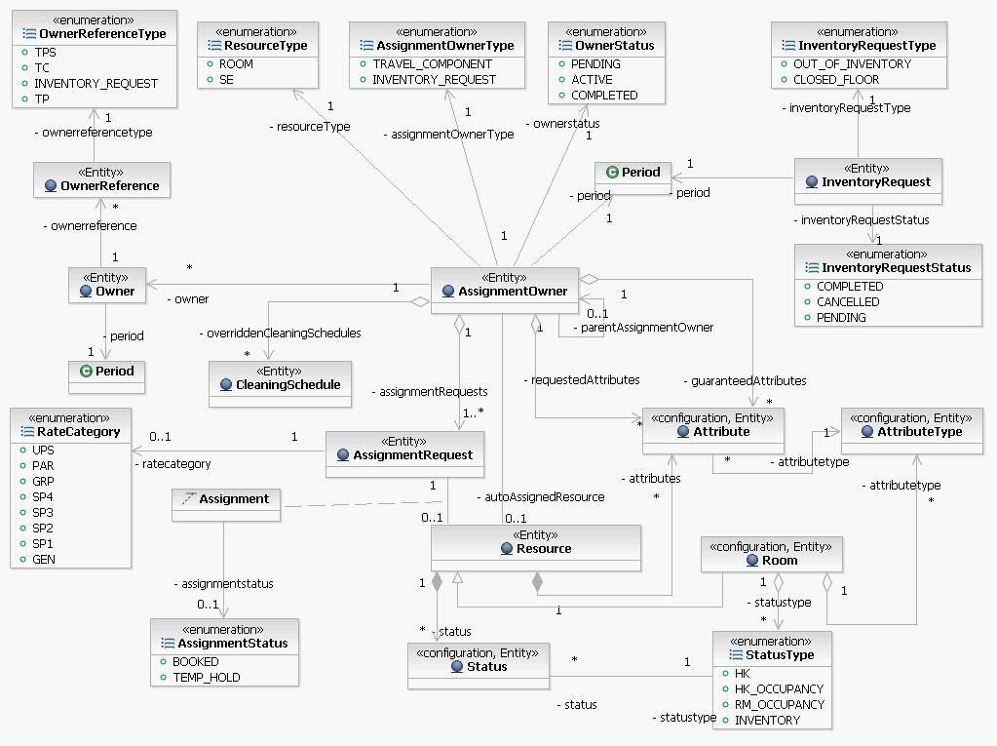
    - Assignment Owner
Assignment Owner is the grouping of inventory for a resort stay or another inventory request for tables, Dinner shows, boat rentals etc. It is also created for each room taken out of order. Assignment Owner holds on to the assignment request.
    - Assignment Request
This is the logical inventory request for each unit of the inventory. E.g. Room is tracked per night; tables are tracked per dinner show, boat rentals every half an hour.
    - Resource
Resource is the physical resource assigned to the reservation for fulfilling the assignment request. In case of room reservations, resource is the room.
    - Assignment
Assignment is created once the room is assigned to the reservation. Assignment is tracked for the room nightly.

    - Cleaning Schedule
Cleaning Schedule is for tracking the extra cleaning schedules purchased by the guest (for Accommodation). This is applicable only for Resource type of Room. This is similar to Assignment request, tracked per day if guest has purchased any Cleaning schedule for the day. Housekeeping date roll batch will read this data and apply cleaning schedule accordingly.

    - Inventory Resort Configuration
The setup of configuration data for fulfillment functionality requires data to be setup at the Resort level. The configuration can be broadly categorized into the following
- Rules for Automated Room Assignment by Resort
- Rules for Room Adjustment by Resort
- Rules used by the System for Checkin Process
- Resort level Recipient Information for Alerts

The following diagram depicts the Resort level configuration data:
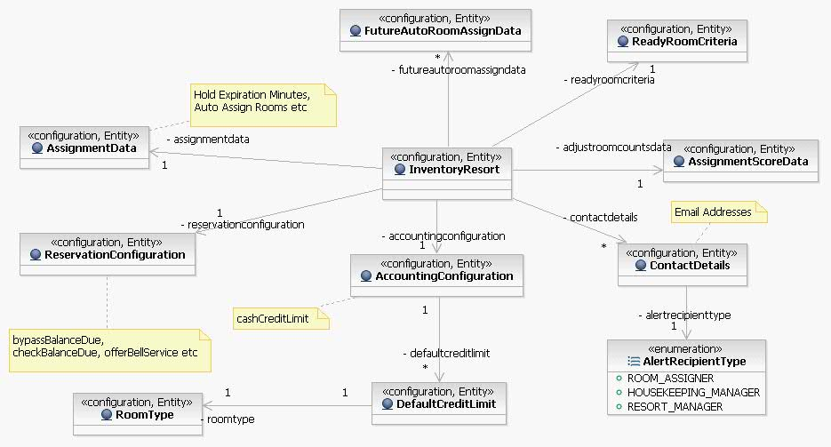
      - Rules for Automated Room Assignment by Resort
- Enable Auto Assignment by Resort
- Hold expiration time specified in case of room assignments before check-in
      - Rules for Room Adjustment by Resort
This is the criteria defined at the Resort level for making adjustments (upgrade for counts). The score category is defined to calculate an adjustment score for each room assigned to a reservation. This adjustment score is utilized by the Room assigners to decide the reservations to adjust.
Score Category
- Ability for reservation to fill a lock out
- Length of Stay
- Rate Category
- Booking Date
- Transfers In
      - Rules used by the System for Check-in Process
- Resort Cash Credit limit: The Cash Credit limit is specified at the Resort level. This is used by DREAMS to specify the limit on Guest folios at check –in and all incidental folios created at the Resorts.
- Credit limit for a Room Type within that Resort: Credit limit can also be specified at the Room Type level. This is used as the overridden credit limit if the room type for the stay is a suite having a higher credit limit than the one specified at the Resort level.
- Collecting Folio Balance at check in: Based on each resort, there are different rules for collecting the balance on the folio in the check-in process. This is achieved by configuring the rules for prompting the Cashier to collect the balance and also providing a way to collect it later (not during check-in).
- Ready Room Criteria: A room assigned in the check-in could be ready for occupancy based on each resort. There are some resorts whose occupancy criteria is that the room should be both inspected and cleaned whereas some resorts have the occupancy criteria based on a clean room. This configuration enables to specify the room ready occupancy criteria per resort.
- Offering Bell Service: This helps drive the prompt in the check-in process to offer bell services.
      - Resort level Recipient Information for Alerts
New Inventory statuses and room sequences can be created in the DREAMS System. Whenever a new inventory status or room sequences are created, they can be configured for sending alters to emails belonging to the following roles by each resort.
- Room Assigner
- Housekeeping Manager
- Resort Manager
This information is used by DREAMS when a certain business event occurs and an alert is sent to the list of emails configured above. Some examples of the business events are
- The Housekeeping Manager will be notified when a reservation is assigned to a room that is not in the active Room Rack sequence.
- The Housekeeping Manager will be notified when a room is added to an active Room Rack sequence.
- The Housekeeping Manager will be notified when a room is removed from an active Room Rack sequence.

    - Inventory Room Configuration
As part of the PMSR Solution, the inventory domain has configuration data required for the room inventory related business processes. Listed below are the concepts maintained by this domain.
      - Inventory Resort
This concept is created to the represent the Resort. The Resorts are published by Onesource in the WDW Composite Application. DREAMS retrieves the resorts using the FacililtyService. DREAMS stores the Inventory Resort to maintain additional data for fulfillment in the context of each resort.
      - Room Type
Room Types are logical constructs depicting different categorizations of rooms within each resort. Onesource publishes the room types for each resort and DREAMS retrieves the list of room types for each Resort using FacilityService. DREAMS stores the Room type to further associate additional data required for fulfillment.
For DVC Resorts, there are additional Room Types created in DVC Corp for selling specific rooms to DVC Members. These room types are not available for selling to Non member reservations at DVC Resorts.
      - Room Type Hierarchy
The Room Type hierarchy is defined for the room adjustment process to qualify the next available upgrades to be recommended by the system for the room assigners.
      - Room
Room is the physical resource that is assigned for fulfilling a room reservation in the resort. The Room is created in the DREAMS system using the LILO UI by the Resort Ops. The only exception to this rule is for DVC Resorts. Since the Rooms for DVC Resorts are created in DVC Corp, the initial room load is sent from DVC Corp. These rooms cannot be added or deleted by using LILO UI.
A Room created in the System has to be associated to a Room Type belonging to that Resort.
- Room Categories: A Room could be associated to multiple Room Categories. Some examples of room categories are Suite and Concierge. A Suite can also be configured to a concierge room type. A room could also be categorized for a turndown service.
- Virtual Rooms: Besides representing physical rooms, there are business processes that require creation of virtual rooms. Virtual rooms are used for selling and are the ‘sold” room types.
  - Lock Off is a Virtual room which is created for connected rooms, which can be sold together as single Room Type. Lock Off Room Types also have virtual room numbers that are assigned to the accommodation. These lock off rooms have a door between the physical rooms.
  - All Connecting rooms in a resort are not lock off rooms. However, all Lock off Rooms are connected.
  - All virtual rooms are categorized as Virtual
  - Virtual rooms are always associated to its connecting rooms in the system.
      - Room Sequence
- Room Rack Sequence: Room Rack Sequence is the sequence of rooms in the resort to be used by the room assignment process based on a specified resort occupancy percentage range.
Example
  - If the resort has a low occupancy percentage, use a certain sequence of rooms for assignment
  - If the resort has a high occupancy percentage, use a different sequence for assignment.
- Housekeeping Sequence: Housekeeping Sequence is the sequence of rooms in the resort to be used by the room assignment process based on a specified resort occupancy percentage range.
- Resort Occupancy Percentage: (number of occupied rooms + number of due in rooms + rooms in Out of Inventory status – number of due out rooms) / (total number of rooms in Resort ) multiplied by 100.
      - Attribute Type
Attribute Type is a high level categorization of features that are configured for each room in the resort. Some examples of attribute types are listed below.
- View
- Proximity
- Bedding
- Connects
      - Attribute
Attributes are features on rooms specified for each room configured in the system. Attributes are used for the automated room assignment process to ensure fulfillment of the attributes requested as part of the reservation.
- Each attribute is always categorized for one Attribute type e.g. Queen Bed belongs to attribute type Bedding.
- Each Room can have multiple attributes.
- Each Room cannot have multiple attributes belonging to the same attribute type. i.e. A room cannot have queen bed and king bed as attributes for the Bedding attribute type. Some examples of the attributes of the room are as follows
  - Queen Bed
  - Pool View
      - Status Types
- Housekeeping: These statuses are changed based on the reservation statuses associated to that room and also determine the room ready criteria. Some examples of Housekeeping statuses are as follows
  - Dirty, Clean, Pick up, Inspected etc.
Example: When a reservation checks out, the housekeeping status changes to Dirty. A room with the housekeeping status of Clean and Inspected completes the check-in process.
- Housekeeping Occupancy: These are housekeeping reported occupancy statuses and are not transitioned by the rules in the System. These are maintained on the room and help track housekeeping productivity.
  - Occupied, Empty.
- Room Occupancy: The room occupancy statuses are driven off the assignment of the reservation to the room. These are the values of the room occupancy statuses:
  - When a reservation is checked-in to a room, the room occupancy status is occupied.
  - When a reservation is checked out off a room, the room occupancy is vacant.
- Inventory
  - Closed Floor
Rooms are put on Closed floor for group reservations or during times of low occupancy. The rooms that are on Closed floor are not used for normal room assignments.
  - Out of Inventory
Rooms are taken out of inventory for maintenance purposes. These rooms are not available for assignments and also impact the true availability counts for that resort.

The following diagram depicts the concepts of Physical Inventory of the Resort
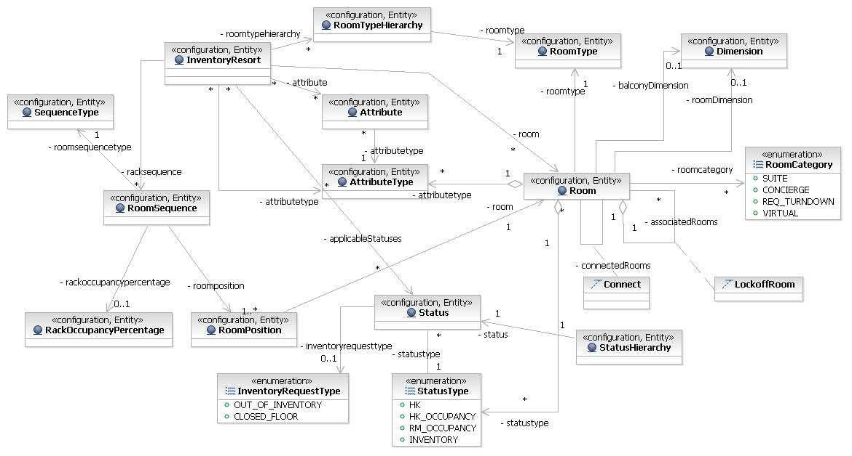
Inventory Resort & Room Configuration Conceptual Diagram
    - Campus, Resort and Location Configuration
This section elaborates the concept of location, campus and business unit and all the aspects of the PMSR Solution which depends on these concepts.
      - Campus
Campus is the concept that is represented in the System to depict the groupings of all the business units with a single geographical time zone maintaining reservations in Facilities belonging to that Campus.
- Campus also controls the booking/posting date of all the booking transactions.
- The default language is defined on the Campus. All the user interfaces and applications that are running business processes use the default language of the Campus.
- All the users logging into the System will be operating within one Campus.
- Each Cast Member will have one Portal id shared across all Campuses
- A Campus also defines the default currency to be used for that Campus.
Some examples of a Campus are WDW, DLR and DRP.
A Finance Actor will be able to setup Accounting Centers for all the business units within that Campus. E.g. A finance team actor is logged into the WDW Campus can setup accounting centers for business units like WDW Resorts, Scheduled Events and DRC and others within WDW Campus.
      - Business Unit
Business Unit is a specific business related entity operating within a Campus and performing reservations and financial activity.
- Business unit is a concept specifically introduced to segregate the financial feeds.
- Some examples of Business units are DRC, Resort Ops and SE.
- The EOD financial feeds will be sent separately for each of the above mentioned business units.
- The accounting dates will be set on each business unit and the financial activity can be controlled for each business unit.
      - Location
The concept of location is to represent the physical location where the cast members are using the system. Some examples of location are:
- Contemporary Front Desk
- DRC
- Welcome Center
- Grand Floridian Concierge Desk
The Location always belongs to one Business Unit. Cast members using the system are always associated to a location. The environment setup, access to resources and other business processes are driven off the location. Every Location is associated with One Source Accounting Center and a banking accounting center (if this location accepts payments). A Default location is created for every Transaction Accounting Center created in the System.
Each Accounting Center - Method of Payment should define whether the Cast Member is required to be banked in (with or without a Till) to use the appropriate MOP for posting payments. DREAMS will only display the Method of Payment's for the location which are acceptable by the actor currently logged in. (i.e. if the user is not banked in with a till, cash will not appear in the drop down)
- Cast Member Association to a Location and a Role
  - Each Cast Member will be associated with multiple locations and one role at a point in time to use the System.
  - The user has to select one location for login.
  - The Role will be used to define the abilities of the user.
  - If a user’s role or location is changed while the user is logged in, the change will be effective only on the next login.
  - A user’s location cannot be changed while the user is banked in.
  - If a user is banked in and logged out and the role is changed, the System will force the user to bank out on the next login in a different role.
Note: No changes can be made directly in Keystone. It is recommended to use the Manage User Profile screen to perform this action as the rule of preventing the changing of the user profile can be enforced by the System.
- Environment Setup: This concept is important for the cast members as it drives the environment setup (Resources) used by the cast member. The environment setup covers setting up the following in the context of a location.
  - WorkStations
  - Printers
  - Encoders
  - Default Printer for the WorkStations.
  - Default Encoder for the WorkStations
  - Specify Collateral Printer Trays for each location – This will ensure that the collateral is routed to the appropriate trays in the predefined printer for that location.
- Resort Access: A location will be setup for a Mini Campus (Group of resorts or a resort). Example: All Star Movies, Sports and Music front desk will be setup for all the All Star Resorts.
- User Interfaces
  - The quick search from the Cashier UI will search for the arrivals in the Mini Campus setup for that location. The User has the ability to search for resort arrivals not belonging to the Mini Campus by using the Advanced Search screen
  - The View Inventory Availability will default to resort for that location within the Mini Campus. The users will have the ability to select any resort within the Campus and view the availability for resort within the entire Campus.
  - The room assignment screen will default to resort for that location within the mini Campus. The user of that screen can optionally choose from resorts within the mini Campus. Other resorts not part of the mini Campus will not be allowed for selection.
  - The Manage Arrivals Screen will default to the resort for that location within the Mini Campus. The user of that screen can optionally choose from resorts within the mini Campus. Other resorts not part of the mini Campus will not be allowed for selection.
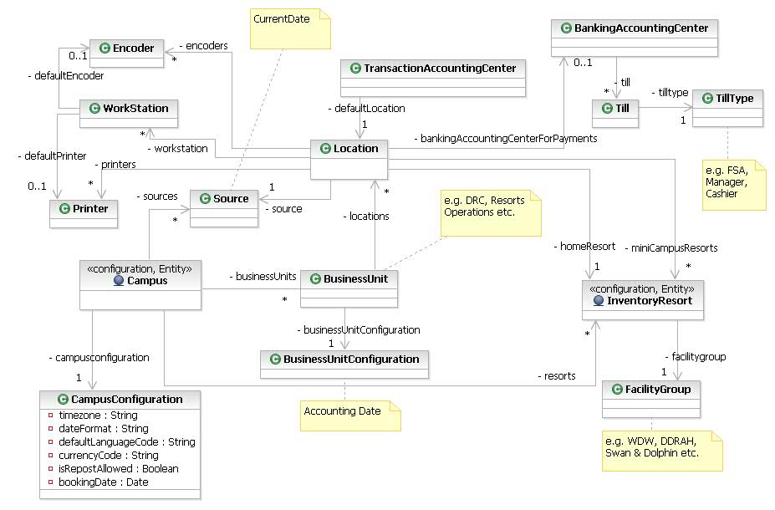
Inventory Resort, Campus & Location Configuration Conceptual Diagram

Services
This diagram depicts the service components of Room Inventory Management:
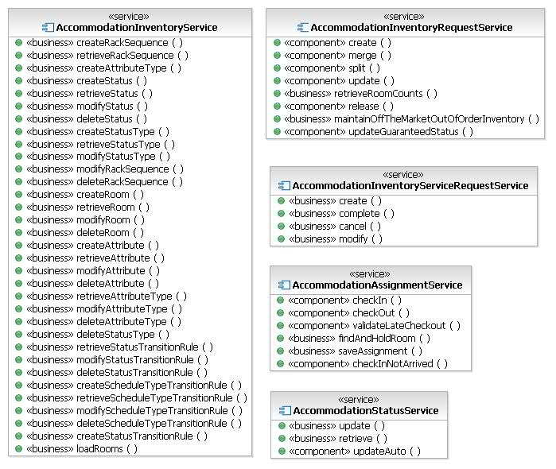
    - AccomomodationInventoryRequestService
The business service AccomomodationInventoryRequestService used by the following Clients/Channels.
- AccommodationSalesService – This business service uses this service to create Assignment requests for every Accommodation Component.
The service provides these business functions:
- Create, modify, release, share, and unshare Assignment requests.
    - AccommodationInventoryService
AccommodationInventoryService is a business service used to setup new Inventories (Rooms) for a Resort. This service is primarily used by the following Client
- LILO UI – Resort Ops actors setting up Rooms for the Resort.
The Service provides the following business functions
  - Creates Rooms
  - Creates Attributes
  - Creates Rack Sequences
  - Creates Schedule Type transition Rules
  - Load Rooms for DVC Resorts.
    - AccommodationInventoryServiceRequestService
AccommodationInventoryServiceRequestService is a business service. This Service is used primarily by Resort Ops.
The service provides the following business functions
- Create , Cancel , Modify Inventory Requests for Out of Inventory or Closed Floor
    - AccommodationAssignmentService
AccommodationAssignmentService is a business service. This service is used primarily by the Res Mgt Services as part of fulfillment processes and by the Resort Frontdesk for reassigning rooms during the checkin process.
- AccommodationFulfillmentService – Uses this service to checkin and checkout the room
- LILO UI – Finds an available room and saves the assignment.
This service provides the following business functions
- Checkin , Checkout of the rooms
- Finds an available room and saves the assignment.
    - AccommodationStatusService
AccommodationStatusService is a business service. This service is used primarily by the Inventory Mgt Services as part of fulfillment processes and by the Resort Frontdesk for changing the housekeeping statuses of the rooms.
- PBX Maid Dial In – Uses this service to change the status of the room
- LILO UI – Displays and updates the status of the room.
This service provides the following business functions
- Display housekeeping status of the room
- Update housekeeping status of the room.

System Interactions
    - Create Inventory Status Request
An Inventory Status request is created when a room is taken on Closed Floor or Out of Inventory. In case of DVC Resorts, the Inventory request is sent to DVC Corp as a DVC reservation.
This collaboration demonstrates the process of Creating Inventory Status Request i.e. Out Of Inventory & Closed Floor request. In case of creating a Status which generates Service Request, ServiceRequestService is called to create & fulfill the Service Request.
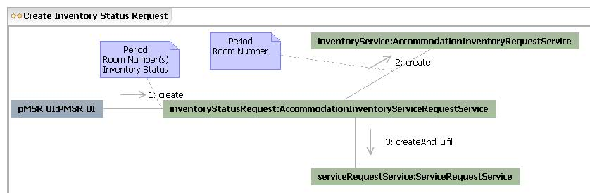

    - Complete / Cancel Inventory Status Request
This collaboration demonstrates the process of Completing or Cancelling Inventory Status Request i.e. Out Of Inventory & Closed Floor request.
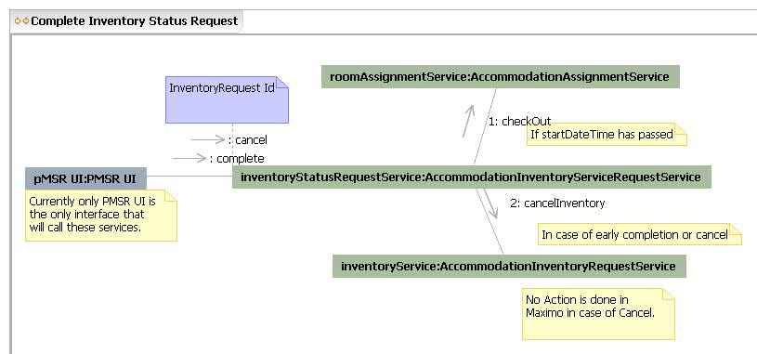

    - Retrieve Room Counts
This collaboration demonstrates the process of fetching the Inventory Summary of the Resort. Physical Counts are determined from Resource Inventory Management and Box Indicators are fetched from Avail based on Horizon Count.
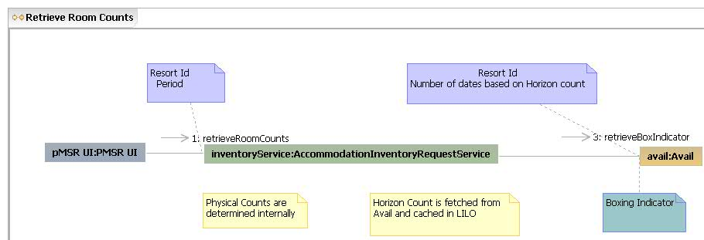

    - Assignment Owner State Transition
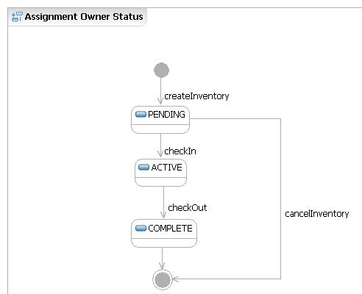
    - Status Transitions
The DREAMS system maintains status for reservations, room assignments , housekeeping and occupancies related to the room. These statuses are transitioned based on business events. The following chart specifies all the business events and the associated status transations in the system.
https://wdpr.sharepoint.disney.com/sites/dpmsr/Requirements%20Team/Status%20Values%20and%20Transitions.xls

    - Auto-Room Assignment Process
      - Pre-Condition
- All special needs attributes must belong to Attribute Type named “Special”, so that the system excludes the Reservation and Rooms from auto assignment.
- Connect attribute must have Attribute Type named “Connect”
- If Wing, Floor, Building, Theme attributes are not defined for all the Rooms then, Near Room assignment will not work as stated.
- All Reservations which needs Connecting Room must have Connect attribute associated to the Reservation.
- All Connecting Rooms must have Connect attribute defined in the system.
- If a Room has a late checkout request, then the checkout date’s night is considered as not available for auto assignment.
      - Auto Room Assignment Process
- Auto Room assignment process will pick up all the Reservations which are arriving in 10 days (Configurable per Resort), including the current date.
- Reservations having Special Needs and Manually Locked assignments will not be picked up for auto assignment.
- Rooms having Special Needs Attributes will be excluded from auto room assignment process.
        - Assign Closed Floor (Pre-Blocked) Rooms for Groups Reservations
- Fetch the Rooms which are put on Closed Floor for Groups which are arriving in 10 days (Configurable per Resort), including the current date.
- Assign Reservations which belong to the pre-blocked Closed Floor Rooms by matching the Group Code.
- The Rooms on Closed Floor are not marked as Completed, even if all the Rooms on Closed Floor are assigned to all the Reservations
        - Reservations Prioritization Criteria
  - The Reservation will be prioritized in the following order for assignment.

Reservation Prioritization Order
Prioritization Order
- Full Lock-Off Room (Virtual) Types.

- Reservations of the following types get the highest priority. MEMBER_POINTS, MEMBER_DISCOUNTED_CASH, MEMBER_NON_DISCOUNTED_CASH, EXCHANGE_OUT, EXCHANGE_IN, EXCHANGE_ZERO

- Connects Attributes
- Multi- Room Reservation
- Earliest Arrival Date first.
- Non-Wholesaler Group or Gathering(MG/GG/TW) Reservation.
- Max LOS first.
- Reservation with most number of Attributes first.
- All others.

        - Auto Assignment Criteria:
  - Share: When one reservation of a ‘Share’ has been assigned a room, the reservation(s) with the same Share Number will automatically have the same room number assigned
  - Closed Floor or Out of Inventory: The system will not allow a reservation to be assigned to a room number that is associated to a room that is in a “closed floor” or “out of inventory” status grouping (elements of the status definition) between the arrival and departure dates of the incoming reservation.
  - Contiguous Reservations will be assigned same Room: If there are multiple reservations within a same Travel Plan having continuous stay & same Resort, Room Type; the system will assign the same Room for all those Reservations.
  - Reservations with Sellable Room Type will not be assigned to any of its related Fulfill able Room Type for DVC Resort only. The algorithm will assign Rooms with Room Type same as booked Room Type only.
  - Room Qualification: The Algorithm should find only a matching room for a reservation. A Matching Room is a room matching the booked Room Type without a reservation assigned for the period starting on the Arrival Date and ending on the Departure Date, is not on hold, is not currently assigned, and fulfills all Attributes.
  - Connecting Attribute Handling : Connecting Rooms will only be assigned to Reservations which belong to the same Travel Plan (TP) and all Room reservations have Connect attributes (as Coded Comments) when it was booked.
  - Determine applicable Room Rack: The system will use the lowest resort occupancy percentage among each day of the reservation to determine the applicable room rack sequence. For example, if the resort occupancy is 80%, 50%, 50%, 30% for a Reservation with four days of a stay, the system would utilize the 30% occupancy percentage to determine the room rack sequence for all 4 days. If there are no Rooms available in 30% Rack, the system will try to assign in one level higher Occupancy % Rack. The system will always try to assign Rooms is least Occupancy % Rack first.
Resort Occupancy Percentage = (number of occupied rooms + number of due in rooms + rooms in Out of Inventory status – number of due out rooms) / (total number of rooms in Resort ) multiplied by 100.
  - Proximity of assignments for Groups & Multi-Room booking: Reservations which are part of Non-wholesaler Group, Travel With or Gathering will be assigned near each other, in the following order:
  - Same Wing >> Floor >> Building >> Theme
  - Lockout period is configurable per resort (e.g. 5 days): The system will always try to minimize the Lockouts (Holes). E.g. If the Lockout period is defined as 5, the system to try to avoid creating holes of length less than or equals to 5.
        - Post processing
Handling Lock-Off Rooms:
If a “Full Lock-off” (Virtual) Room is assigned, the system should not assign any other Booking to the individual “Part of Lock-off” (Physical) rooms.
If any one of the “Part of Lock-off” (Physical) Room is assigned then, “Full Lock-off” (Virtual) Room cannot be assigned to any other booking.
Sending Alerts:
The system sends alert to Room Assigner, if the Reservation is not able to be auto-assigned and arriving in “X” days (Configurable per Resort).

        - High Level 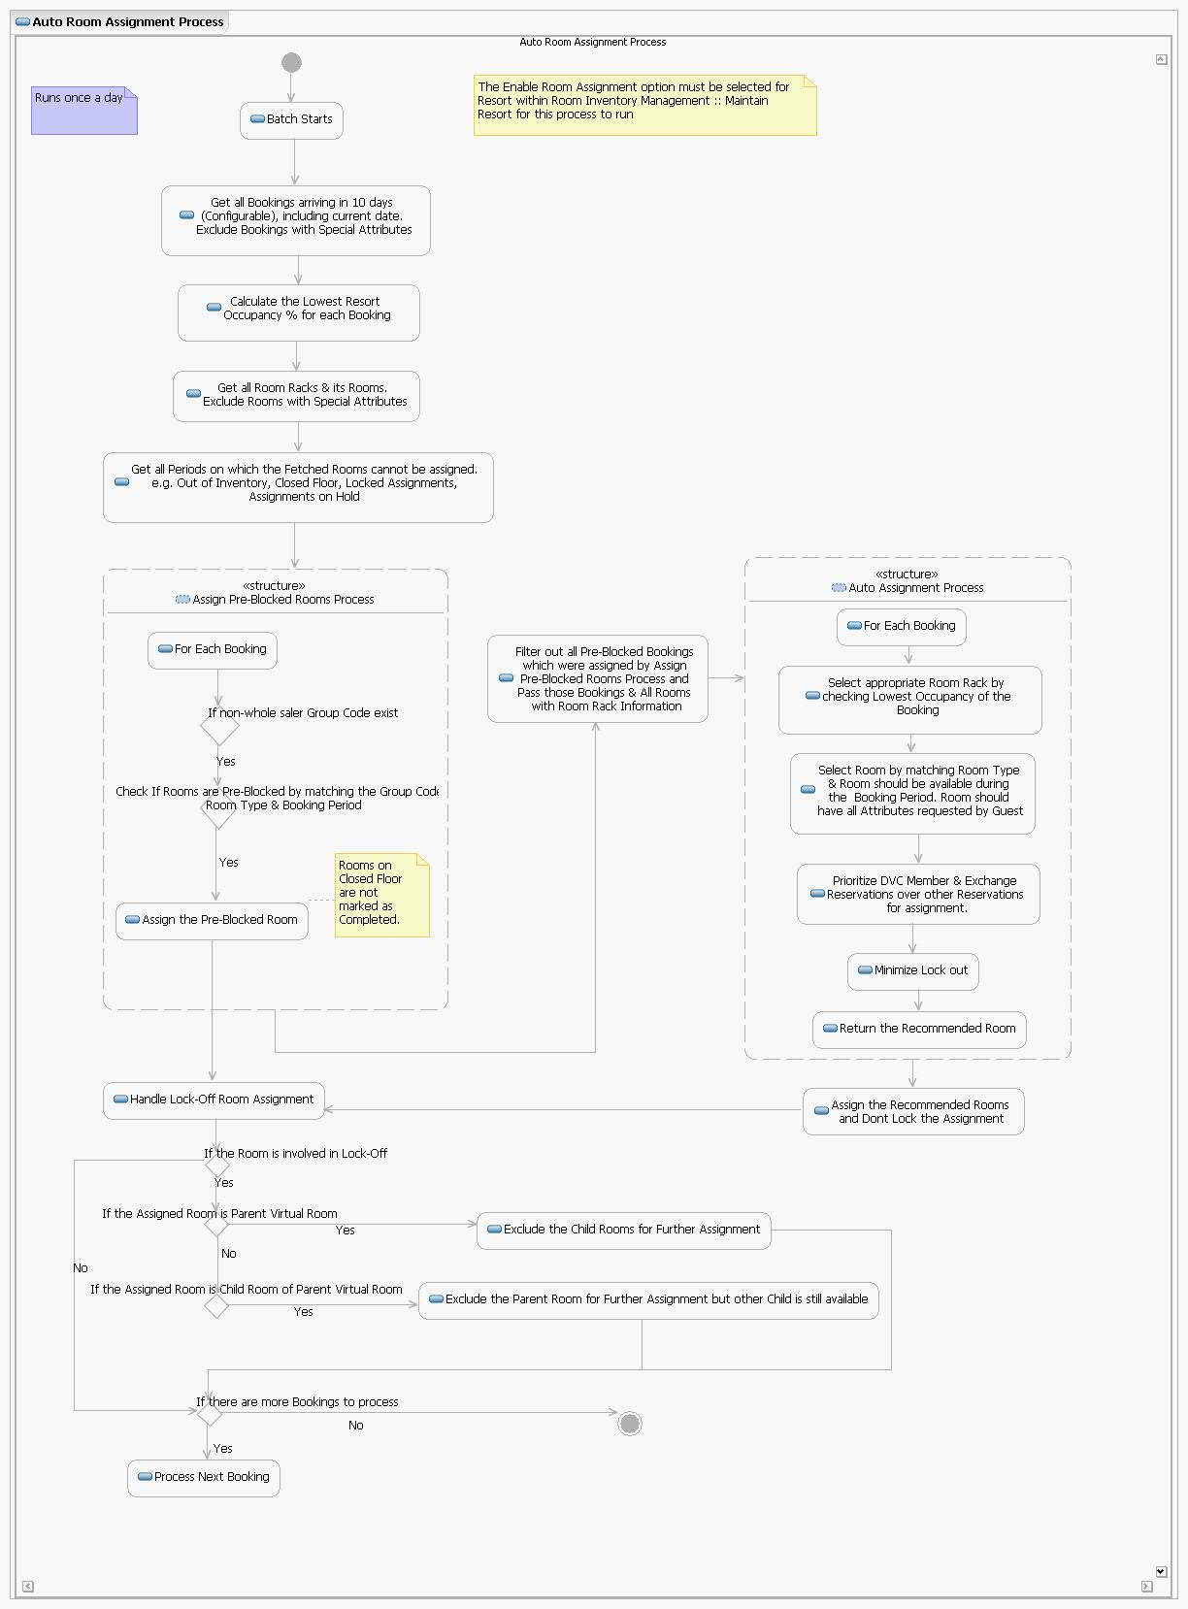

    - Lock Off scenarios
      - Handling New Reservation for LockOff Room Types and the Child Room Types
• Scenario 1: For a new reservation made against a Lock-Off Room Type, the system tracks inventory for the lock-off room type and the child Room Types that form the lock-off room type.
e.g. Lock-Off Room Type KL and Child Room types KA and KB
If there are 10 lock-off room types in a resort, there are 10 each of child room types that form the lock-offs. Every time a res is made for a lock-off room type, the physical count is adjusted for the lock-off and the child room types also.
Room Type Physical Count Booked Available
KL 10 1 9
KB 20 1 19
KA 20 1 19
Note: The inventory updates for the child room types are not sent to Availability Server real-time or in the EOD reconciliation process.
In the example above, the counts for the child room types are more as there are room types for KA and KB that are not part of the lock-off room type.
KL – 10
KA (Part of Lock off) – 10
KA (Not part of Lock Off) – 10
KB (Part of Lock off) – 10
KB (Not part of lock off) - 10
• Scenario 2: For a reservation against a child room type, the inventory is tracked only for the child room type.
At the time of booking, the determination cannot be made that the room that will be subsequently assigned to the child room type will be part of any lock-off room type.
For example if the booked room type is KA, inventory is tracked for the booked room type only.
      - Room Assignment for LockOff room types and Child Room Types
• When a room is assigned to res made for a lock off room type, the inventory is tracked for the room for the lock-off room type and the rooms for the child room types.
• When a room is assigned for res for child room types, there are two possibilities:
- Room assigned is part of a lock-off room type
  - In this case, the inventory decrements the available count of the lock-off room type for every child room type.( There are advanced scenarios described in a later section to build on this scenario)
- Room assigned is not part any lock-off room type
  - In this case, the inventory is tracked only for the child room type
• When there are two different reservations on child room types (KA and KB) that are part of the , Assignment Process should create two Assignment Owner record with Res Type as Dummy and Assignment Records for Virtual Room Type (KL) for both the child Room Types.
      - Managing Room Counts in Adjust Room Count:
Some Rooms of child Room type may not be part of a Lock-Off room. In that case, House total for Child Room type in Adjust Room count should reflect the total number of child rooms of child room type (Participating and not participating in LockOff).
Say 10 KA Part of Lock-Off
10 KA not part of Lock-Off
Say 10 KB Part of Lock-Off
15 KB not part of Lock-Off
House Total
KL 10 (nKL)
KA 20 (nKA)
KB 25 (nKB)
Threshold (To touch the LockOff child rooms for reservation on child room types)
TKA = nKA – nKL (20 – 10 = 10)
TKB = nKB – nKL (25 – 10 = 15)
To calculate the availability:
E.g. Number of Reservations for a given date
nRKL = 3
nRKA = 12
nRKB = 16
Availability on KL = nKL – (max (nRKA-TKA, nRKB-TKB) + nRKL)
= 10 - (max (12-10, 16-15) + 3) = 5
Availability on KA = nKA – (nRKA + nRKL) = 20 – (12+3) = 5
Availability on KB = nKB – (nRKB + nRKL) = 25 – (16+3) = 6

      - Upgrade for counts into a fullfillable room type
The Assignment process will track the impacts of available counts for the Lock-off rooms due to assignment of the child rooms for the following scenarios.
      - Upgrade to a child room:
• Upgrading to a room (room type), that is part of a Lock-Off (upgrading from KD to KA) (assigning a room that is part of Lock-Off).
• During downgrade, if room gets reassigned from Room participating in Lock-Off to a room not part of a Lock-Off.
      - Upgrade to a parent Room:
• When upgrading the Room to a Virtual Room say from KC to KL.
• When downgrading the Room from Lock-off Room to a 2 bedroom room (from KL to KC).
      - Change Room
Change Room process follows same approach as Upgrade and downgrade child rooms or Parent Room.
      - CheckIn/CheckOut:
Along with the Original room Checkin/Checkout process, system tracks inventory in the check-in/checkout process for Lock-Off and/or Child rooms.
      - Request Late Checkout:
On Request for Late checkout for the Original Room, Late checkout will be processed Lock-off and the Child rooms.

    - Adjust Room Counts Process
This diagram describes the process of Upgrading Reservations for Adjusting Room Counts.
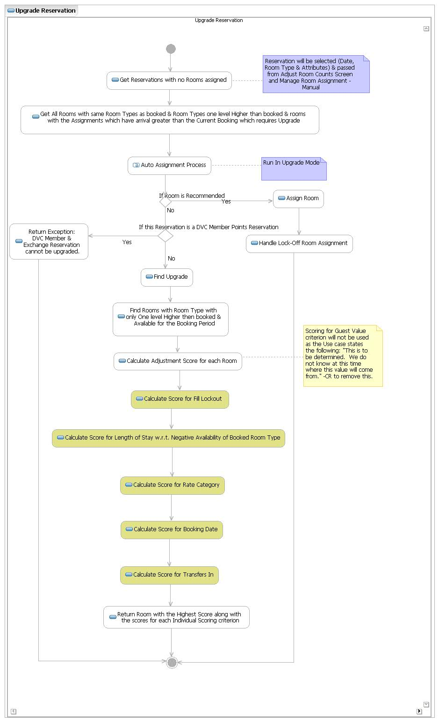

Profile Management

Domain Model
    - Profile Management
Profiles (a.k.a) Coded Comments are pre-defined codes added to the reservation to represent the following.
- Additional Guest requests in the course of their stay
  - Requests for specific rooms
  - Certain Services to be provided by resort
- The information Guests need to know on behalf of the resort
  - Check-in , Check-out time of the resort
  - Location of the Building within the resort etc
- Any Proof that Guests have to produce at checkin e.g. Tax exempt certificate, AAA Membership etc.
These profiles are configured in DREAMS. Each Profile has a brief description to convey the purpose of that profile code. In DPMS, some of these profile codes are sent to Maximo for delivery or dispatch. The fulfillment of other profiles, however are handled manually. Also, any profiles on the reservation requiring additional cost are manually charged to the Guests Folio.
As part of the PMSR Solution, the profile management has been enhanced. The configuration of the profiles can be done using a User Interface. Also, at the time of configuration, the profiles can be categorized into the following.
- Attributes – These typically represent any preference for connects or bedding or a specific amenity provided in the room. The same is also used to specify special needs rooms.
- Alerts for Front Desk validation - The Coded comments are also added for certain Id validations at the front desk e.g. tax certificates, Id etc.
- Service requests – Several requests for housekeeping, bell services are also added using coded comments.
- Comments – A Coded Comment is also used for informational purposes. E.g. the Checkin and Checkout time for the resorts, The Travel with code etc.
Profiles can also be specified for a Specific Resort or a Group of Resorts. They can also be specified for specific room types within a resort. Profile can be configured to be “default” for a combination of a Resort or a Room Type.
Profiles can also be setup for a specific package. E.g. a reservation for MYW Dine Package drives the default profile “Please call 407-WDW-DINE for making dine reservations”.
Default Profiles on an accommodation cannot be removed. Additional profiles can be added to the accommodation reservation. The list of profiles available while booking an accommodation is displayed on the package, resort, room type being booked for that reservation.
This model shows the entities which are used to create/update/delete the profiles (coded comments) and their associations. Entities associated here are used to create Profiles of type Alert, Service, Attribute, Message or coded comments and the routings associated with these profiles. It also stores the association of the profile with the facility.(resort, room Type, Package). This information will be used while creating the reservation to classify the coded comments which are received in the booking request to create Service Requests or Alerts or Room Attributes.

Services
    - ProfileService
The ProfileService is a component service and is mainly used by the following clients to populate the list of profiles applicable for the reservations being booked. This service is also used to create profiles from the LILO UI.
- LILO UI
- DVC Member Services UI
- DREAMS UI

Service Request Management

Domain Model
    - Service Request
The concept of Service requests in the PMSR Solution has been added to capture the following
- Guest Requests made in the context of reservation requiring an action from the Cast Members for fulfillment of the request.
These requests can be either made at the time of making a reservation, on the day of check in, mid stay or even on the day of check out. Each of these requests has to be fulfilled. Some of these requests require the Guests to incur additional charges and are not covered as part of their stay.
Listed below are the types of Service requests handled by the PMSR Solution.
- Special request
- Bell Service Request
- Late Checkout request
- Inventory Requests
    - Special request
Special request are added in the context of the Guest Stay to the accommodation. They can be requests that require the following actions from the Cast Members.
- Delivery – e.g. request for water bottles, hair dryer, crib etc.
- Pickup – e.g. hair dryer, crib etc.
A Special request of this type requires a cast member to be assigned to complete the task. Maximo is the System of Record used by the Resort Ops to create Work Orders to assign the tasks for special requests. PMSR sends these requests to Maximo interface for eventual work order creation and fulfillment. Some Special requests that are added require housekeeping services. These types of requests are printed on the housekeeping boards. Some Special requests incur additional charges. The PMSR Solution handles these chargeable requests by creating products for these requests. The requests are priced like a normal product and charged to the Guest.
    - Bell Service Request
These are created for Guests requesting Bell Services at the time of checkin, mid stay in case of room changes or checkout. A Bell Service also needs to be sent to the Maximo Interface as it involves assignment of a Cast Member to fulfill the request.
    - Inventory Request
These can be maintenance requests to fix any operational issues with the room. The maintenance requests can be in the context of a Guest Stay. An Inventory request is created in the System and sent to the Maximo interface for fulfillment.
Additionally, the Resort Operations can close a Wing, Floor for refurbishment or regular maintenance. These rooms are taken out of inventory. These requests are also created and tracked in the System as Inventory requests.
    - Late CheckOut Request
Late Checkout requests are requested typically on the day of checkout. The PMSR Solution does not restrict the creation of the late checkout requests before the day of checkout. A Late Checkout request is created in the System and goes thru a manual approval process by the Housekeeping Manager.
The PMSR Solution tracks the status of the late checkout requests. All approved late checkout requests are priced based on the policy of the resort and the room type at the time of actual checkout and charged to the Guest.
This model shows the entities which are used to create/update/delete the service request and their associations.

Services
The diagram below covers the service and the corresponding methods available for the different business processes for Service Request management.
    - ServiceRequestService
ServiceRequestService is a component service that is used mainly by the AccommodationFulfillmentService to perform service request related tasks.
Some of the Key business functions of this service are
- Create and Fulfill Service requests
- Track the Status and Display requests in the context of a reservation

Entitlement Management

Domain Model
    - Entitlement Plan
Entitlement Plan is the “Bucket” which holds all the coupons issued for that resort stay for a Travel Plan for all the Guests. Entitlement Plans are created when the Travel Plan is checked in. One entitlement plan per each dine plan in the package is created. Each entitlement plan will have a starting balance. Entitlement Plans can optionally be shared with guests who have the same plan and who are in the same reservation
    - Coupon
Coupons are the electronic entitlements that are issued to the Guest for the components in the package that can be redeemed thru the Key to the World Card.
Coupons are of several types:
- Guest Count
- Dollar Count
- Unlimited Recreation
Every Coupon maintains the running balance based on its type. Each Coupon is redeemed against a coupon charge. Each coupon charge that is posted will redeem coupons from the entitlement plans and will decrement the available balance.
    - Coupon Profile
For each coupon, a coupon profile is created that defines the coupon code and the mapping to a tender code. Coupon profile allows setting up the usage restrictions of the coupon and the redemption requirements per accounting center.
.

The following diagram depicts the concepts for entitlement plans and coupons.
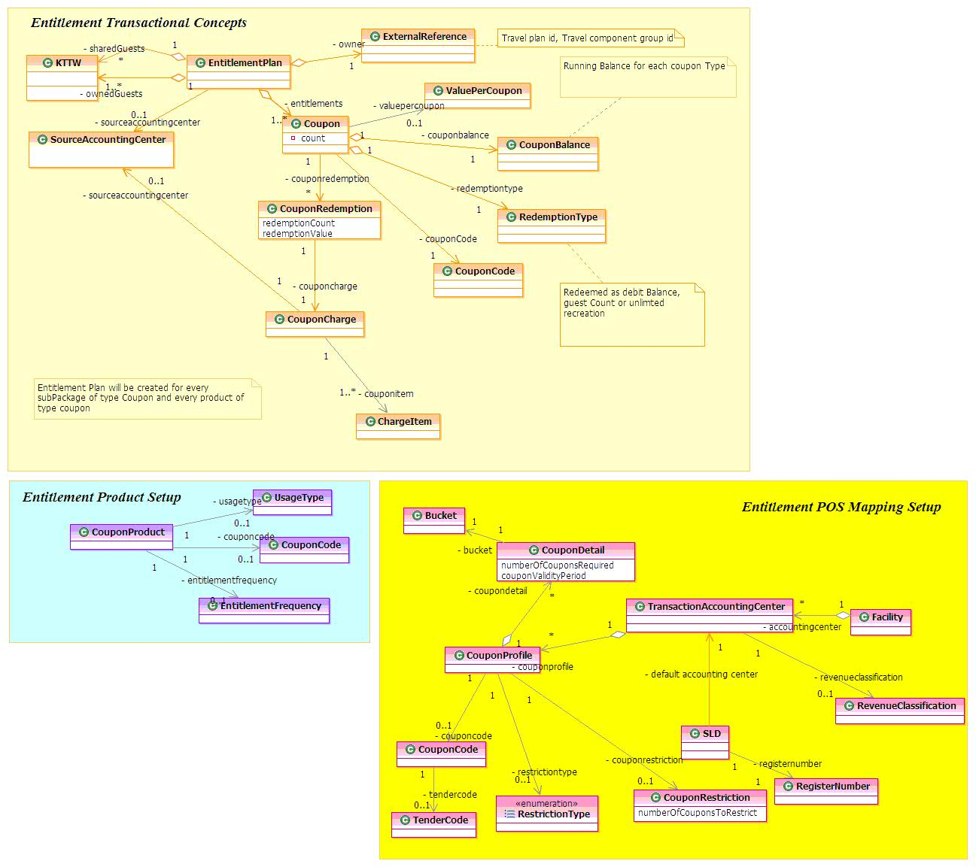

Services
This diagram depicts the services provided by Entitlements Management component. This service is used by Resort Ops and the Charge Service.
- ChargeService – uses this service for entitlement postings
- LILO UI – Sharing , unsharing , transferring coupon charges and viewing coupons and posting coupons manually.
    - Entitlement Service

System Interactions
    - Share Un-Share Entitlements
The below collaboration depicts the process of sharing entitlement plan between guests.
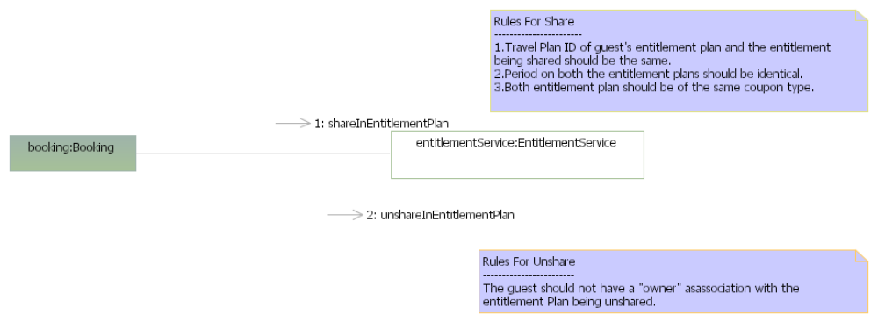
    - Remove Entitlements
The below collaboration depicts the process of a guest un-sharing a shared entitlement plan.

Accounting Management

Domain Model
This domain houses two transactional entities (1) AnalysisLedgerTransaction (2) AnalysisLedgerEntry. Additionally, it holds the configuration entities that are used for mapping a folio item to a SAP account for creating an analysis ledger transaction.
    - Accounting Centers
Accounting centers are means to account a financial transaction to SAP’s cost center, profit center, company and GL account numbers. Each accounting center can play the following roles:
- Transaction Accounting Center – Identifies the origin of a charge transaction
- Banking Accounting Center – Identifies the origin of a payment transaction. Each location is associated to a banking accounting center.
- Charge Accounting Center – Identifies the destination from which revenue is earned. A Charge Accounting Center is derived from a combination of the following. The charge accounting center defines the Tanami accounting for the transaction (i.e. profit center, cost center, company code, etc
  - Transaction Accounting Center and a Posting Item
  - Banking Accounting Center and a Method of Payment
- Source Accounting Center – Identifies who owns the revenue for the transaction.
    - Natural Posting Item Configuration
This configuration is used in looking up a natural posting item in the process of creating analysis ledger entries for a transaction.
    - Offset Posting Group Configuration
This configuration is used in looking up an offset posting item in the process of creating analysis ledger entries for a charge transaction.
Note: There will not be suspense posting items setup in case this lookup fails. The transaction will fail in this event.

    - Analysis Ledger
The diagram depicts the composition of an analysis ledger transaction. Each charge or payment transaction creates one analysis ledger transaction per each offset posting item or payment method determined. Analysis Ledger Transaction is associated with a source accounting center and source company information.
Each analysis ledger transaction is composed of a natural and an offset Analysis Ledger Entry. Natural entry is created for the natural posting item. Offset entry is created for an offset posting item or payment method. Analysis Ledger Entry identifies the charge accounting center, general ledger account number and the charge company information.

Services
The diagram depicts the services that are provided by Accounting Management.
    - AccountingService
The AccountingService is a component service used by the Revenue recognition daemon process to recognize the revenue. This service is also used by the PaymentService to retrieve payment validation information.

System Interactions
    - Accounting Process
The Accounting process in DREAMS includes determining the appropriate General Ledger Account numbers for all of the financial activity recorded for the folios maintained in the system for reservations. It involves the determination of the “true” accounting structure maintained by the financial System of Record based on the concepts used in the Folio Domain.
SAP is used for recording the financial activity and is designed with some the concepts such as the following
- Company
- Profit Center
- Cost Center
- WBS
The accounting process in DREAMS is used to “bridge” the folio domain concepts to derive the SAP concepts and map the folio entries to SAP entries.
Once the data is mapped, the EOD feeds use this information stored in Analysis Ledger to produce the financial feeds to be sent to SAP.

The following illustrates the process from Folio to the Analysis Ledger:
- Determining Sign of the Entries
  - Any entry in the Folio which increases the balance of the Folio is recorded as a positive entry
  - Any entry in the Folio which decreases the balance of the Folio is recorded as a negative entry
  - The sign of the Folio item ( Charge or Payment) is used to drive the sign of the Natural Entry
- Objective of the Accounting Process
  - Create an Analysis Ledger transaction.
  - Each Analysis Ledger has to be created with two entries , Natural entry and Offset entry
  - The Natural entry represents the owner account
  - The Offset entry represents the account of the revenue, clearing or the method of payment clearing account to balance the natural entry
Note: The data used in the example below is for illustration purpose and does not reflect the actual data.
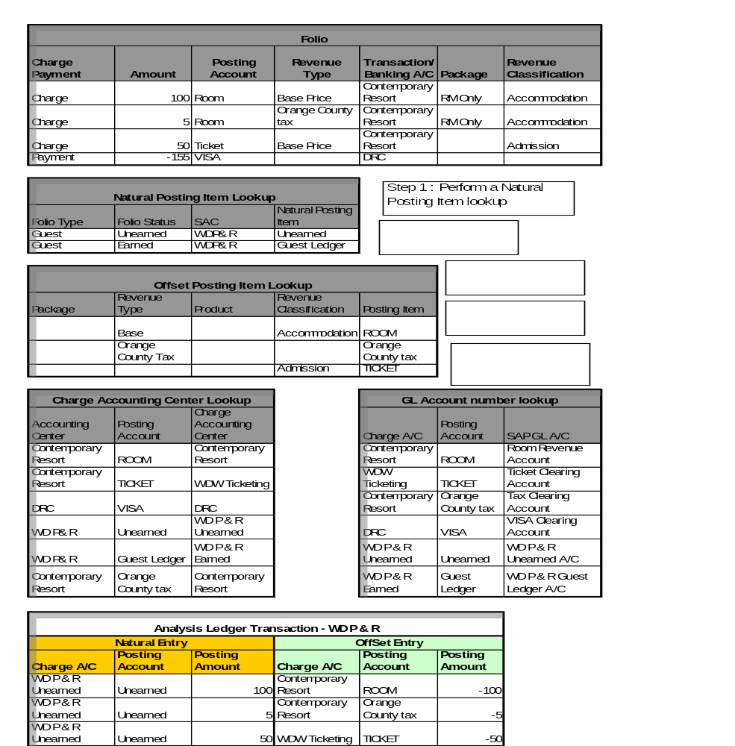

System Interfaces

User Interfaces
The user interface for the resort operations developed as part of the PMSR project is called LILO UI. It houses the following functional areas:
- Reservation Management
  - View and Modify Reservations
- Check-in Process
  - The Process from the Guest verification till completing the check-in process
- Folio Management
  - Display Folios
  - Payment and Charge Processing
- Group Enhancements
  - Rooming lists
  - Template Imports and exports
- Recommend Tickets
  - The ticket recommendation and sales process
- Room Inventory Management
  - Resort, Room, Campus and Location Configuration Screens
  - Inventory requests, Adjustments and Manual Room Assignments
- Accounting Administration
  - Enhancements to existing DREAMS Accounting Admin Screens
  - Additional Accounting administration screens
  - Reconciliation screens for commissions and general ledger
    - Reservation Management
The following site map covers all the reservation related user interface flows.
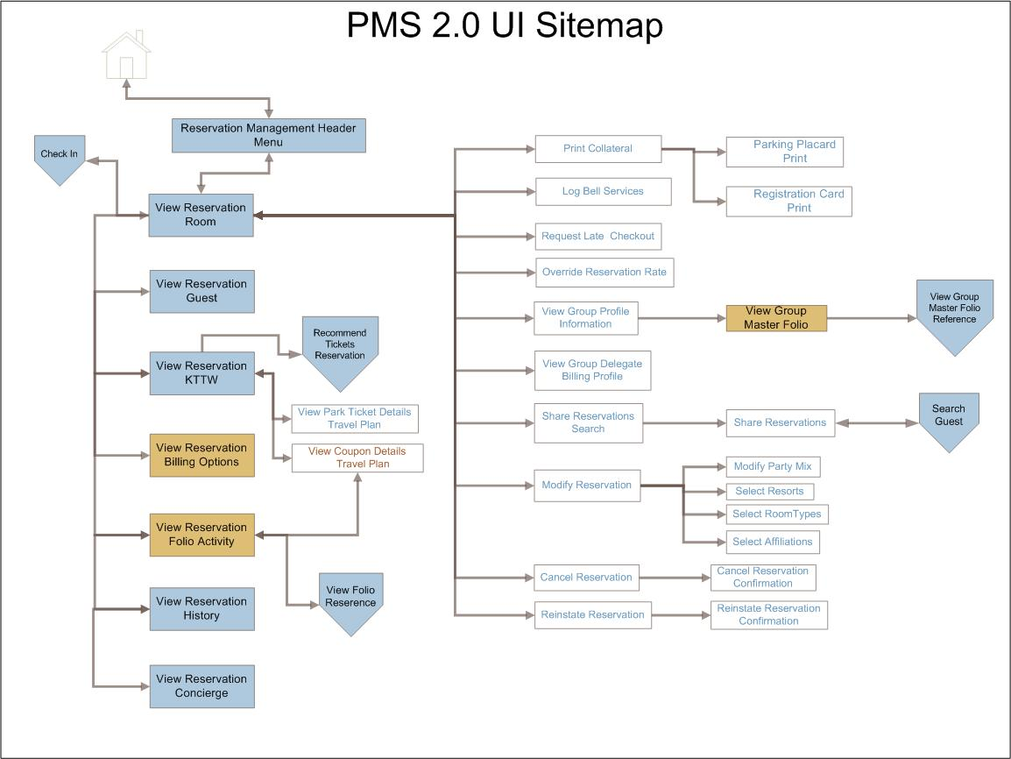
    - Check In Process
This sitemap covers the check-in process.
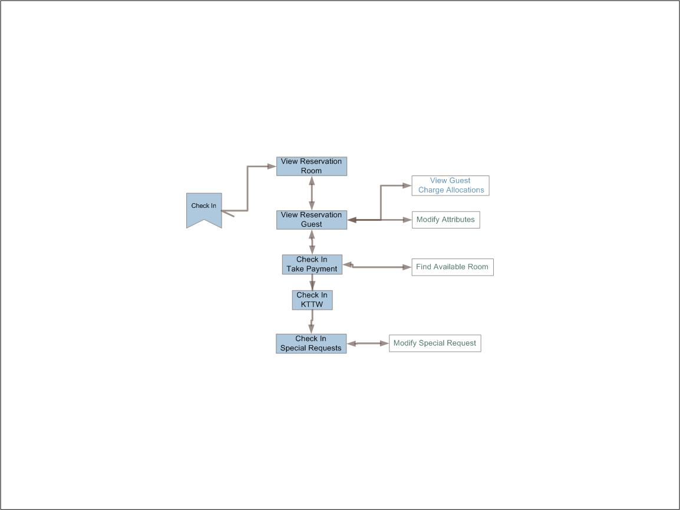
    - Folio Management
This sitemap covers the Folio Management functionality
    - Recommend Tickets
This sitemaps covers the tickets sales flow.
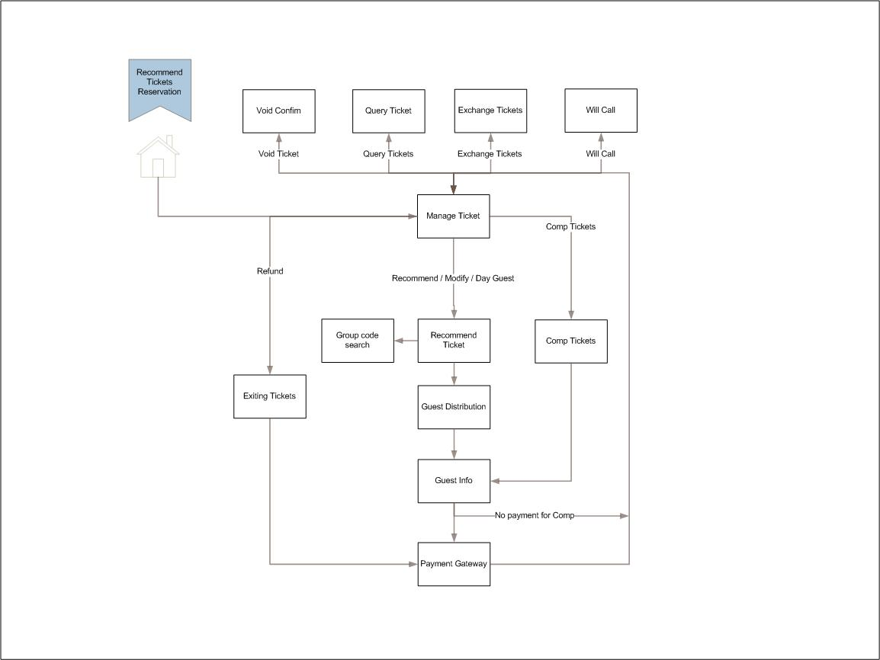
    - Resource Inventory Management
This sitemap covers the configuration screens for the room and resort setup and also the room assignment and adjustments.
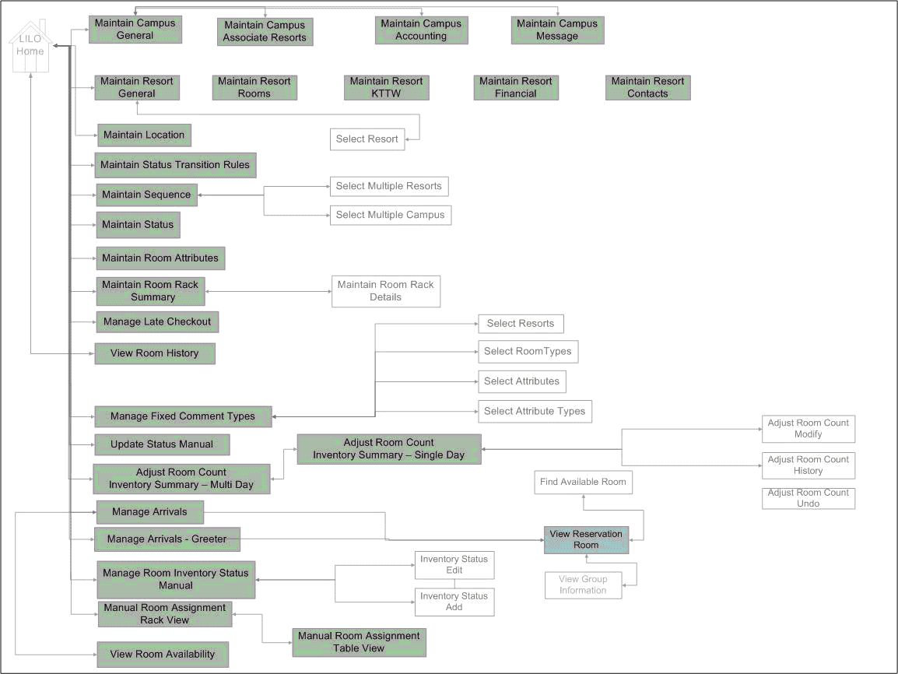
    - Group enhancements
This sitemap covers the Group enhancements screens for rooming lists and also DREAMS Accounting admin screens.
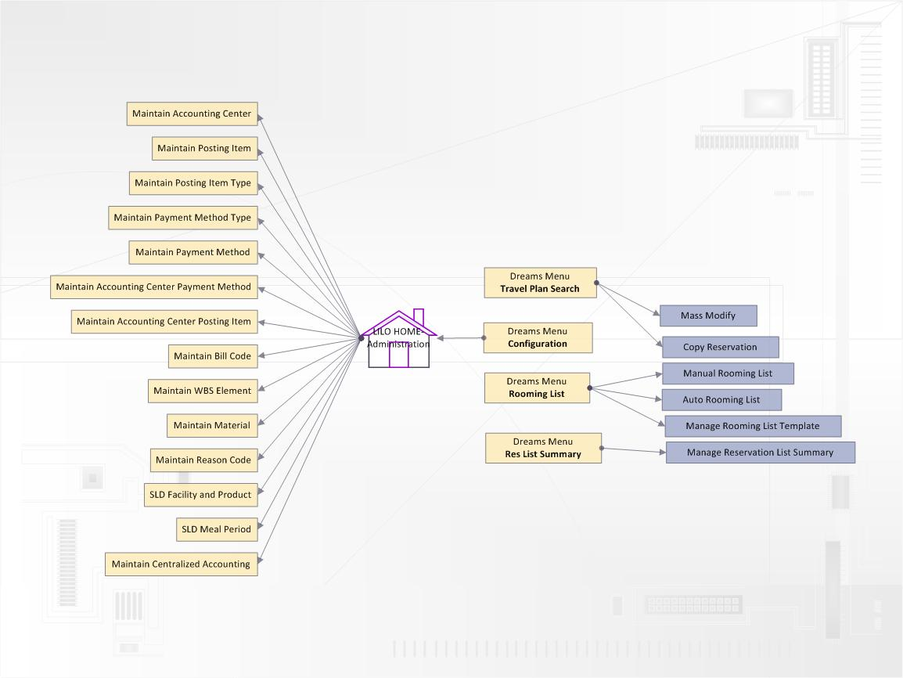
    - Accounting Admin Screens
This sitemap covers the additional accounting configuration screens and the reconciliation screens.
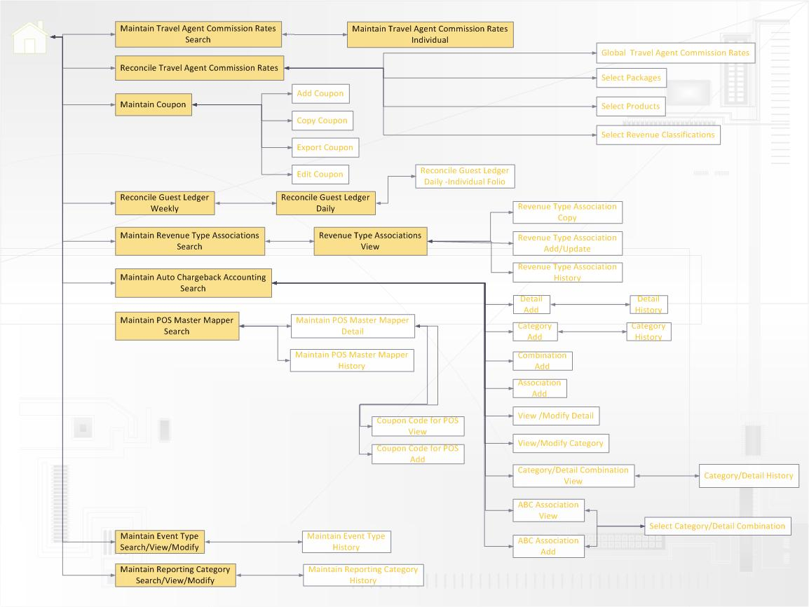
    - UI Storyboards
UI storyboards are maintained in the Share point at following location.
https://wdpr.sharepoint.disney.com/sites/dpmsr/User%20Interfaces/Forms/AllItems.aspx?RootFolder=%2fsites%2fdpmsr%2fUser%20Interfaces%2fFinal%20PDFs&FolderCTID=&View=%7bC5E8DC7A%2d6302%2d4E92%2dBC43%2d7F0D6B062D28%7d

External Interfaces
As part of PMSR Solution, DREAMS interacts with about 30 different systems through more than 100 interfaces. The list of interfacing systems and their functionality at a high level is listed below, followed by a model that depicts the same pictorially.
External System | Interface with that System | Purpose
Avail | Get Horizon counts for a Resort | 1. Horizon count is the number of days inclusive of today that the resort users are allowed to box inventory in Avail. So if the horizon count is 2 (which all facilities are currently set to), it means that the resort users would be allowed to box inventory today and tomorrow.  2. DREAMS will use the information from the AVAIL Horizon Count interface to limit the calls to the AVAIL Box Information.
Avail | Retrieve Boxed Dates for a Room Type within the horizon count | DREAMS will retrieve the boxed information from Avail.  The Boxed status of the room helps the room assigners aware that they need to remove the boxed status to release or allocate inventory to Guests.
Avail | RoomInventoryDecrement | This interface is used by DREAMS to block inventory for booking with Avail.
Avail | RoomInventoryIncrement | This interface is used by DREAMS to release blocked inventory with Avail
Avail | UpdateInventory | Updates logical inventory for every booking, modification to a booking, cancellation, reinstate, share or an Unshare. This helps keeps the inventory synched up real time between Reservation Management and Availability thus reducing the margin for overbooking.
Avail | Reconcile Inventory | This is a process which calculates the inventory in Campus for active bookings, summarizes the information for criteria of resort, room Type, service date, block (If applicable) and the associated book counts at end of each day. Campus reconciles these counts with Availability Server which validates the book counts against block and Freesell inventory in Availability Server. In case of discrepancies, Availability adjusts the inventory count by the information sent by Campus. This process is also used to reconcile off the market counts to Availability Server.
Card Reader | Card Reading | This interface describes how to parse the magnetic strip information stored on the magnetic strip. The interface lists all valid cards that can be read by the card reader and how to parse them
D3 | Guest History | The purpose of the Guest History is to provide information for the following.  Recognition of repeat guests  Fulfillment requests ( i.e. housekeeping)  Package history  Future Disney experiences – DCL / ABD / DLR etc.  Continuation of guest online experience  DREAMS will receive Guest history from D3 for all arrivals 3 days out. This feed will be created by the CMR process and stored in GDM. GDM will route this feed to D3.
D3 | Reservation History | All the reservation history. Bookings, modifications, checkin, check outs, etc events with relevant reservation data will be captured by D3. DREAMS will retrieve reservation history from D3.
DCL | GuestInfo | To provide a seamless experience for the Guest in case of a Land and Cruise reservation, DREAMS sends the KTTW information for each Guest and the settlement method to DCL.  Also, because of PCI Compliance, since DREAMS does not store the credit card information, DREAMS will send the masked card number with the RRN. DCL will retrieve the credit card information from GoldMaster
DCL | Payment File | DCL Payment file processed in DREAMS for DCL Reservations
DCL | Transfer Code | DCL sends DREAMS a transfer code. This code is used for validation when transferring DCL guests from either the airport / port/resort. This transfer code is printed on the KTTW Card
DME | Guest Landed Status | DME notifies DREAMS of guest landed status. This happens when the guest has checked in at the DME Welcome Center OR has been scanned into the Welcome Center’s motor coach queue OR has been scanned while boarding the resort-bound motor coach.  This notification helps the Resort Ops ensure that the room is assigned for DME arrivals and it ready for occupancy.
DME | Flight arrival time | DME sends DREAMS the flight arrival time for arriving guests
DME | Motorcoach Number | DME sends the Motorcoach number to DREAMS for with reservation numbers of arriving guests. This is sent from DME on a Motorcoach departure
DME | Notify Pickup Times | DME notifies DREAMS of motor coach pick up times for a guest’s departure from the resort.
DME/RVS/HSIA | Check In | DREAMS sends the check-in information
DME/RVS/HSIA | Check Out | DREAMS sends the check-out information
DME/RVS/HSIA | Cut Keys | DREAMS sends the KTTW information
DME/RVS/HSIA | Retrieve Guest Summary | DREAMS provides the Guest Summary for a Room
DME/RVS/HSIA | Room Change | DREAMS sends the changed room numbers to these systems
DSCS | Post GroupMaster Charge | DSCS posts event charges in DREAMS
DSCS | Update Rate and Inventory for Groups | DREAMS sends the rate and inventory information nightly to DSCS
DTI  (TicketService) | Create Empty Tickets | To enable guest ID cards to be encoded by providing a empty entitlement number to be encoded on a guest’s ID card.  DREAMS creates the ticket transaction in ATS to get an entitlement number from ATS thru DTI
DTI  (TicketService) | Create Tickets | To enable guest ID cards to function both as room keys and “entrance tickets” to Disney parks, shows, and events by providing a unique entitlement number to be encoded on a guest’s ID card.  DREAMS creates the ticket transaction in ATS to get an entitlement number from ATS thru DTI
DTI  (TicketService) | Upgrade Tickets | To allow an entitlement to be changed or replaced once assigned to an ID card.  DREAMS sends the new product and an existing entitlement number for upgrade of a ticket.
DTI  (TicketService) | Exchange Tickets | Transferring the ticket details to the new ticket with the same product and Voiding the existing ticket.
DTI  (TicketService) | Retrieve Ticket Details | DREAMS retrieves ticket Details including Gate History, Remaining Value, usage , can be refunded or exchanged
DTI  (TicketService) | Void the ticket | DREAMS uses this interface to allow an entitlement to be invalidated if an ID card is lost or stolen
DTI  (TicketService) | Fulfill Will Call Reservation | DREAMS creates tickets for the reservation and provides the list of tickets for the products bought as part of the reservation
DVC Corp | Package Rate Update | DREAMS sends the rates for DVC packages to DVC Corp nightly
DVC Corp | Room load | The initial load of rooms is sent from DVC Corp to DREAMS for DVC Resorts
DVC Corp | Reservation reconciliation | DVC Corp reconciles reservation with DREAMS using this interface
DVC Corp | Load Reservation | DREAMS uses this interface to create a copy of the Member reservation in DVC Corp for Member reservations.
Facility Service | Accommodation Facility Service | DREAMS uses this service for retrieving accommodation facility information for all the resorts maintained in DREAMS.  DREAMS also uses this service to retrieve room types for the resorts
Facility Service | Food and Bev Facility Service | DREAMS uses this service for retrieving food and beverage facility information for all the SE reservations maintained in DREAMS.
Travel Plan Service | Create Travel Plan | DREAMS uses this service to create a Travel Plan in Siebel
Travel Plan Service | Update Travel Plan | DREAMS uses this service to update a Travel Plan in Siebel
Travel Plan Service | Get Component Travel Components | Siebel uses this service provided by DREAMS to retrieve the components in a Travel Plan
GSR | Incremental Records | This information is sent for Guests that have complimentary tickets issued or some other benefit extended because of Guest inconvenience or some other issue. The Guest Service recovery captures the Guest behavior and helps the frontdesk in Guest Service recovery
GSR | Full Repost | The entire days information is sent daily at 5 am
Honeymoon Registry | Retrieve Travel Plan | Honeymoon Registry will use this service provided by DREAMS for both WDW and DVC Resorts
Go Master | Create Individual | Creates Guests in GoMaster and generates a transId
Go Master | Update Individual | Updates existing Guests in GoMaster
Go Master | Search Individual | Searches for Guests in GoMaster
Go Master | Get Language list | Get the list of languages
Go Master | Find State and Country by Zip code | Find the State and Country by Zip Code
Go Master | Find Organization by Name | Find an Organization by Name
Go Master | Find Organization by Agency Id | DREAMS uses this service to retrieve Travel Agencies from GoMaster by using the IATA/CLIA number
Go Master | Find Organization by Id | DREAMS uses this service to retrieve Travel Agencies from GoMaster by using the ODS Id
Jazz | Check in ( CHKI) | DREAMS notifies the Call Accounting System that the Guest has occupied the room DREAMS sends the room number and the reservation number; It also sends the KTTW number of the guest and the Affiliation of the Guest. This helps the Phone System to price the phone calls
Jazz | Check out ( CHKO) | DREAMS notifies JAZZ that the Guest has checked out
Jazz | Post Charges ( POSU) | Jazz sends the Phone Charge once the Guest uses the room phone. The pricing of the call is made on the affiliation and the type of call
Jazz | Date Roll ( DROL) | DREAMS notifies Jazz of the accounting date roll to signify that any subsequent charges are to be posted to the next date
Keystone | Admin Services | DREAMS adds or removes a user from a role using these services provided by KeyStone
Matra | Retrieve Matra Receipt | MATRA is the POS system. Currently MATRA sends the summarized amount for a POS charge to PMS. This service is to provide a detailed receipt information for a single POS charge
Maximo | Create Work Order | Maximo is an interface for amenities for Guests such as Bell Service Dispatch, Housekeeping and Engineering.  It creates a work order for the service requested. Maximo will provide this interface for creating requests for the following e.g. Delivery, Maintenance, Miscellaneous, Pickup and Service
Maximo | Retrieve Work Order Status | DREAMS retrieves the work order status from Maximo
WDW PBX | Call Party Name Display Change | PBX is a call switch system. DREAMS notifies a Check In of a Guest in a room to PBX. PBX uses this information to set the Guest Name to Display on phones when a call is made from that room.
WDW PBX | Set Status | DREAMS notifies PBX to set the VIP status of the reservation, In case of Guest Messages DREAMS sends the Message light on/off notification to PBX.
WDW PBX | COPY MAIL BOX | DREAMS sends PBX message to copy the voice mail box from one room to another in the event of a room change.
WDW PBX | Maid Dial In | DREAMS receives status codes dialed into room phones by housekeepers to change the room status.
WDW PBX | Voice Mail Count | PBX sends DREAMS voicemail counts. DREAMS forwards this information to Xtend.
WDW Timelox | Create Original KTTW | DREAMS sends this information to the Timelox Database for establishing access for the KTTW for that room number
WDW Timelox | Check out | DREAMS Checks out one Guest in an accommodation or grouping of accommodations using this interface with Timelox.
WDW Timelox | Room Change | DREAMS Changes the access to the Key from old accommodation to new accommodation using this interface with Timelox.  When a reservation changes accommodations and KTTW have been issued.  When a reservation is Checked-in with a Room Assigned (KTTW was previously created w/o a room)
WDW Timelox | Reporting Card | When a House Keeper inserts a report card into Door Lock, a Message is sent from Timelox to DREAMS to update the room status. This capability is only applicable in case Timelox Wireless capability enabled at the resorts.  DREAMS updates the room status similar to the Maid Dial interface from PBX
WDW Timelox | Create Joiner Card | When a KTTW is requested for additional guest in the room that has already got a card assigned, DREAMS creates a card for a guest added if Original card is assigned to this room in Timelox
VING | Register | DREAMS initializes the interface with Vision using this interface
VING | Create | DREAMS uses this interface with VING when a KTTW is requested to be created. This is per Guest.
VING | Add Guest or Replace Card | DREAMS uses this interface with VING when KTTW gets lost or broken. Or when an additional guest is added to an accommodation.
VING | UnRegister | Disconnects DREAMS from the VING interface
Stratus | Post Charges | Stratus Processes Payments made by KTTW Cards and Room Charges by posting charges to Guest Folios in DREAMS
Payment  Service | Post Card Payment | All Clients posting card payments in DREAMS will use the Payment Service.  After obtaining authorization and RRN number, the request structure is modified and posted to DREAMS
Payment  Service | Post Cash Payment | This posting routes the processing directly to DREAMS as no authorization is required.
Payment  Service | Post Voucher Payment | This posting routes the processing directly to DREAMS as no authorization is required.
Payment  Service | Post Check Payment | This posting routes the processing directly to DREAMS as no authorization is required.
Payment  Service | Post System Payment | This posting routes the processing directly to DREAMS as no authorization is required.
Payment  Service | Post Refunds | DREAMS UI uses this service to post refunds. This service will call out to AuthSvc to get the authorization and the new RRN.
Payment  Service | Set / Update Settlement Method | For credit card settlement methods, this service will authorize the card and obtain an RR# before passing forward the request to PMSR
Payment  Service | Get Refund RRN | For posted card refunds that have just been ‘APPROVED’, DREAMS should seek the new RRN for the refund using this service by authorizing the card for the refund amount.
Auth Service | Authorize Payment and Balance Enquiry | • Credit Card Transactions: Pre-authorization, authorization, and some reversals on all major credit cards (Visa, American Express, MasterCard, Discover Card, JCB, etc…) coming from various sales channels (POS, internet, telephone, mail-order, etc…).  • Rewards Card transactions: Redemption Hard Decline, Redemption Positive Authorization, and Returns on Rewards Cards coming from various sales channels (POS, internet, telephone, mail-order, etc…). These requests will return an approval or a decline along with the remaining balance in some cases.  • Gift Card transactions: Activation, Redemption Hard Decline, Redemption Positive Authorization, Return, Reload, Cash Out, and related voids on Gift Cards coming from various sales channels (POS, internet, telephone, mail-order, etc…). These requests will return an approval along with the remaining balance or a decline
Pricing | Price for Room Upgrades | This interface is required for Guest being upgraded either by Guest Paying the difference or the upgrade cost being picked up by the wholesaler.
Pricing | Price Late Checkout | On approval of a late checkout request, this interface calculates the late checkout fee on the actual checkout time
Pricing | Retrieve Late Checkout Pricing Policy | DREAMS uses this interface to display the late checkout policies
Pricing | Calculate Cost of Ticket Modification | Provide the additional amount that is charged to the guest for the new ticket. This should take the usage of the existing ticket and the channel into consideration when calculating the additional amount.
Pricing | Price Service request | Service requests which are chargeable are setup as products. The service request products are priced for charging to the Guest
Pricing | Price Package | Existing Interface for Pricing Package
Pricing | Price with Overridden Rates | Existing interface which calculates taxes off the overridden rates for room
Pricing | Calculate Taxes | Retrieve taxes for manually posted charges which have a posting group configured
Pricing | Price KTTW | Prices Key to the world ticket
Pricing | Price Ticket Product | General pricing service required to price a ticket product which can be fulfilled on a KTTW Card
Pricing | Query Ticket Products (Ticket Type and Add on Options) | Need Base tickets with add on options for each product based on channel( affiliation or groups)
Pricing | Get list of Ticket Product Add ons | Retrieve the list of additional ticket features
Recommender | Retrieve Ticket product Recommendation Template | A ticket recommendation template based on the recommendation criteria is:Existing entitlements, Party Mix, Affiliation, Zipcode, Date Range> This will help provide appropriate tickets to the Guests based on the above information
Recommender | Get Recommender Template for Frontdesk Bookings | A recommendation template for rooms tailored for the frontdesk needs. Abilities such as searching available rooms by the same tier and on the Guests affiliation are primary driving factors.
Recommender | Recommend Room Offers for Frontdesk | Based on the above preferences , provide an appropriate offer set for Guest Selection
Recommender | Get Recommended ticket products by ticket product preferences | Recommend KTTW tickets and or ticketed events based on the guests preferences
RTP | RTP Repost | The Retail Transaction Processor (RTP) will send daily hotel charge or electronic coupon tenders into the DPMS repost file. The RTP will ensure that no duplicate transactions and that no duplicate files are sent through to DPMS. The following POS systems will send their hotel charge and electronic coupon sales information through RTP to the DPMS:  Matra  RVS  Cashless Arcade  Pin Machine  Flora Magic
ATS Repost | Repost | ATS repost is a collection of charges that occurred from the Automated Ticketing System. The receiving system parses through these charges extracting Room Charges. These charges are verified they have been posted. The Room Charge will be posted if the validation fails
Special Events | Payment File | Special Events sends a file to DREAMS for payments to be processed for Special Events reservations
Accovia | Payment File | Accovia sends a file to DREAMS for payments to be processed for WDTC reservations
LockBox | Payment File | This interface sends a file to DREAMS for payments to be processed for lockbox payments
GEMS | SPARCS | Provide Labor Schedules to the PMS
DMNS(SmS Provider) | Room Ready Notification | Alerts a Guest on the Phone that the room is ready for occupancy when the Keys have been issued when the room is getting cleaned
SAP | Accounts Payable (Refunds) FI001 | Summarizes the check refund information for the day
SAP | Accounts Payable ( Commissions ) FI001 | Summarizes the Travel Agent Commissions per reservation per product for each Travel Agency
SAP | General Ledger FI008 | Summarizes or details the financial transactions for a Charge Accounting Center by GL Accounts for the day based on configuration.
SAP | Charge Code Interface FI008 | Creates charge code interface for each Cast Member that has banked out with non-cash activity.  The charge code interface sends the information summarized by each non-cash payment method
SAP | Electronic Deposit Slip FI062 | Creates the electronic deposit slip information for each Cast Member that has payment activity and has banked out. The purpose of the electronic deposit slip interface is to report non cash payment activity for a single cashier and banking accounting center within an accounting date
SAP | Credit Settlement FI010 | Sends Details of the Credit, Gift and Reward Card Transactions for the day.
SAP | Accounts Receivable FI012C | Generates invoice information for Guests, Groups and Wholesalers
SAP | Retail Customer Interface FI095 | Summarizes all the payment activity for a Cast member and the System at a banking accounting center for an accounting date
SAP | Config Data Refresh FI027 | Campus maintains SAP configuration data for Chart of Accounts, Profit Centers, Cost Centers, WPS Elements and Customer Numbers. This process refreshes the configuration data received from SAP.
SAP | TA vendor information FI006 | SAP needs to send the SAP Vendor information which is the Travel Agency Id .This allows the commissions to be sent for each Travel Agency
Super Server / Xtend | Delete Record | Deletes Xtend Entry
Super Server / Xtend | Add/Update | Adds new or updates current Xtend Entry
Super Server / Xtend | Status Change Record | Sends the current reservation status of a reservation
Super Server / Xtend | Message Waiting Change Record | Changes Message Waiting Status of a Xtend Entry
Super Server / Xtend | Room # Change | Sends old and new room
Super Server / Xtend | Additional Name Add | Sends Add Additional Names
Super Server / Xtend | Additional Name Delete | Sends Delete Additional Names
Super Server / Xtend | Delete Fixed Comment | Sends Deletes Fixed Comments
DPMS | Res Download | All the reservations which are within the download window but did not download earlier are qualified for download. Also, Campus downloads all reservations to Property based on some nights in the future. Currently the value is 10 nights.
DPMS | Deposit Download | Campus sends money received within Campus to Property. This is done for checked in reservations or ones checking in today.
DPMS | Groups Download | DREAMS downloads Groups created to DPMS
DPMS | Comment Download | DREAMS downloads comments associated to a reservation DPMS
DPMS | Customized Package Update | DREAMS sends a Customized package creation and any updates to DPMS
DPMS | Internal Comments | DREAMS sends internal comments captured at a Travel Plan Segment level to all related property reservations
DPMS | Split Property Reservations | DPMS splits property reservations and send DREAMS the updates. DREAMS updates the Property reservation numbers
DPMS | Redeem Deposit | DREAMS sends the deposit to DPMS on the day of check-in
DPMS | Maintain OOO Inventory | DPMS sends DREAMS an update for every inventory that is taken out of order.
DPMS | Property Res Updates( Checkin, Checkout, Shares, Unshares) | DREAMS and DPMS have a bi directional sync process for Res updates.
EAI | Itinerary Cancel | SBC sends this request to cancel the Itinerary i.e. cancelling all the Travel Plan Segments for a Travel Plan which has a multi system booking. SBC has the ability to book Accovia components / rooms and campus reservations under the same Travel Plan. This interface is used by SBC to send the cancellation for the entire Travel Plan. EAI also sends this request for GDS Component reservations.
EAI | Itinerary Update | SBC leverages this interface for a dual purpose. The interface is exclusively used for a single functionality at a time even though it is accommodating the information for the both processes.  • Associate / Dissociate MG Information – SBC sends Magical Gathering information via this interface which Campus uses to update the Travel Plan Segment . This updates are used to update Siebel also.  • Extending Deposit Due Date – SBC uses this interface to extend the deposit due date for a booking.
EAI | Itinerary Query | SBC uses this interface for retrieving Travel Plans based on search criteria’s. Campus tries to qualify Travel Plans on the criteria sent by SBC and results in a list of Travel Plans returned to SBC.
EAI | Itinerary Confirmation | SBC uses this interface to update Confirmation Specific Information. In this case, SBC updates the confirmation Type and the associated locator information to be used for that confirmation Type.
EAI | Itinerary Notes | This service is used to add notes at Travel Plan Segment level.
EAI | Cancel Component | EAI uses this interface for requests sent by SBC to cancel Room or KTTW tickets.
EAI | Modify Guest Info | SBC via EAI sends this information to Campus for modifying Guest Information such as name and address on a Booking. This interface is not used for adding or deleting guests on a booking. Campus uses this information to update the guest information within Campus only.
EAI | Book KTTW Tickets | This service is used only by SBC through EAI for booking KTTW tickets.
EAI | Payment | Process Payments made by DRC and External Channels.
EAI | Res. Comments | This service is used to add comments at room Level. SBC is the actual initiator of this request.
EAI | Book/Modify Room | All bookings received thru EAI from all booking channels using this service
EAI | Create Shell TPS | All booking reservation numbers for Good Neighbor reservations are stored in DREAMS
EAI | Book DME | The DME Components booked are shadowed in DREAMS using this interface
EAI | Modify DME | The DME Components modified are shadowed in DREAMS using this interface
EAI | Store Free Sell Tickets | WDPRO and SBC use this service to store the tickets sold from their channels
EAI | Book Package Selectable tickets | EAI uses this interface on behalf of the wholesalers channel to add selectable tickets tor Wholesaler bookings
EAI | Retrieve Travel Plan | All Sales clients use this service for retrieving the Travel Plan Details
RMS | Rate and Inventory Feed | This process sends Inventory and Rate Information to HRMS. The data is sent to HRMS only if both inventory and price information is available for the block criteria (block, resort, RoomType, service Date, rate category). Campus will not send any information to HRMS if the rate information is not present for the above criteria.
RMS | Inventory Optimization | Optimizes Table inventory data nightly in DREAMS database
Confirmation WDW | Print Confirmation | Campus sends confirmation information to external vendors which process print confirmations.
Confirmation WDW | Email Confirmation | Campus sends confirmation information to external vendors which process email confirmations.
Confirmation WDW | Fax Confirmation | Campus sends confirmation information to external vendors which process fax confirmations.
CMR Process | Welcome Letter | CMR Process creates a Welcome letter for guest arrivals and sends a PDF document to DREAMS for printing.
ATSServer | Fulfillment Product Feed | This will provide package information with products which are fulfilled at the Front Desk and not as part of the Key to the World Card for arriving guests. The products generally include Pins, Lanyards, and AMC Tickets etc.

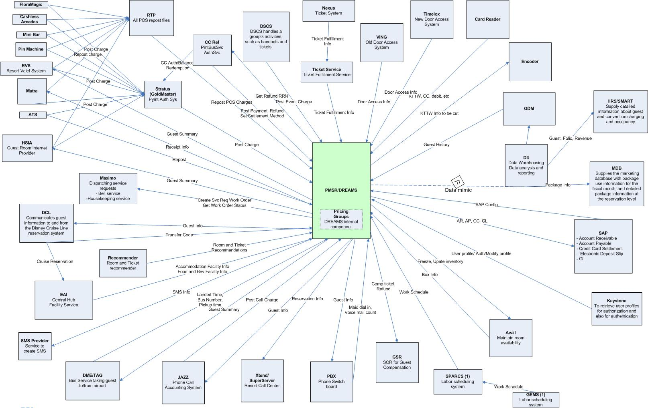
    - Interface Interactions
      - ATS Repost
This collaboration demonstrates the ATS Repost file processing. The daily batch picks-up the ATS file and calls Adapter to process the file. ATS Repost Adapter parses the file and calls Folio to post charges.
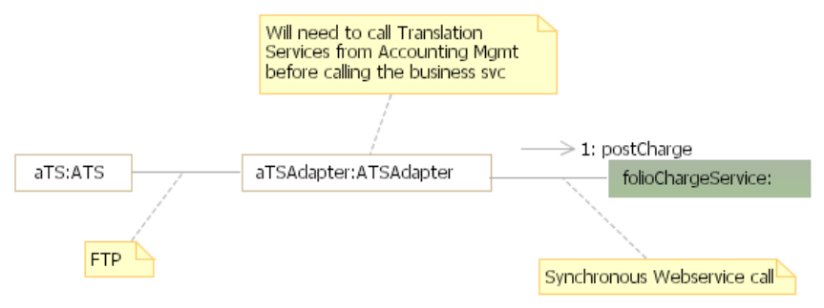
      - GSR
This collaboration demonstrates the process of sending comp tickets and comments to Guest Recovery System. AdmissionSalesService or FolioMgmtService throws the event when an Auto Charge Back, Comp Tickets are issued or posting of comments event occurs. GSR Adapter receives the event and calls Reservation Management to retrieve the guest summary, stores the information in a staging table. The hourly batch process reads records from staging table and calls FolioMgmtService to get glAccountNumber, glNumber and creditRevenueCenterLocation and sends the file to GSR. The daily batch process reads records from staging table and sends the file for the day.
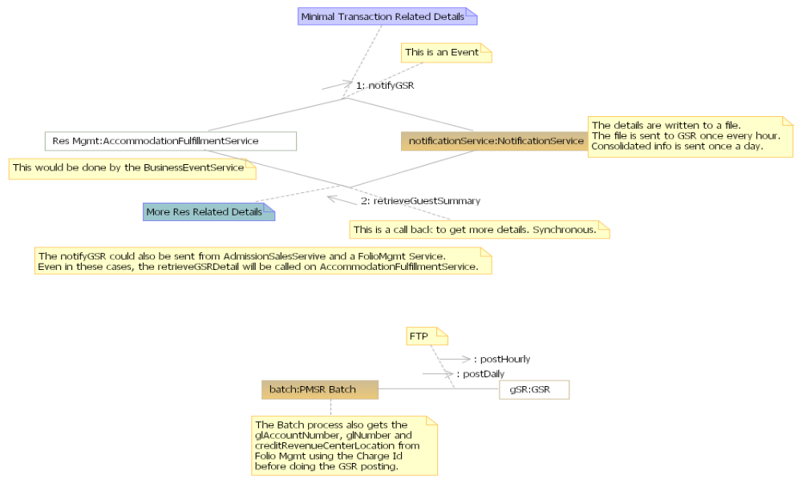
      - Jazz – Date Roll
The collaboration demonstrates the process of sending accounting date roll update to JAZZ. Accounting throws event when accounting date roll is happened. JAZZ Adapter receives the event and sends the date roll record to JAZZ.
      - Keystone Admin
PMS UI will directly invoke the web service exposed by Keystone Admin Service to Retrieve and update user role and its attributes.
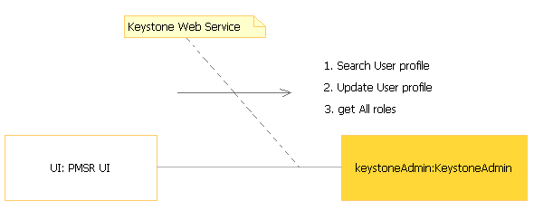

      - Check In / Check Out / Room Change
The collaboration demonstrates the process of sending guest reservation information to JAZZ. AccommodationFullfilmentService throws the event when guest checks-in, checks-out and changes a room. JAZZ Adapter receives the event, calls Reservation Management to get guest reservation details, formats the JAZZ record from the data and sends the record to JAZZ over socket connection.
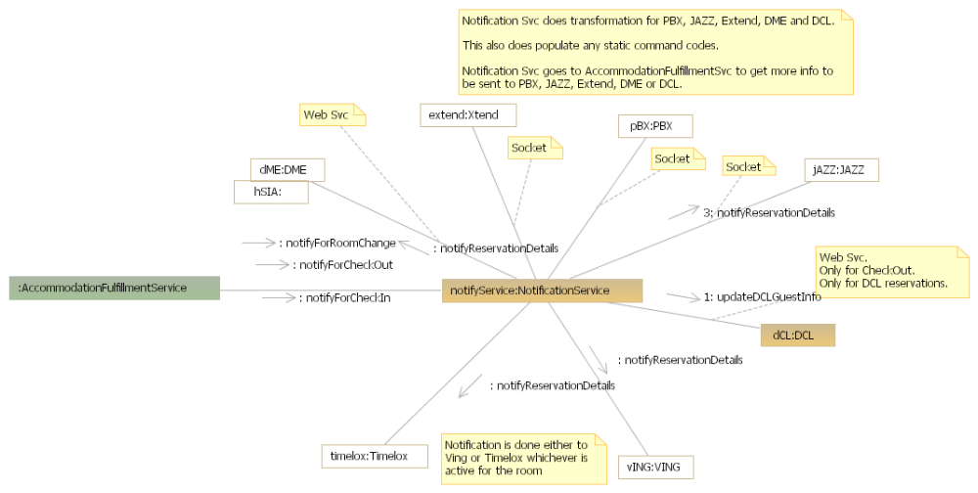
      - PBX
The collaboration demonstrates the process of sending display names message to PBX. AccommodationFullfilmentService throws the event when guest checks-in, and changes a room. PBX Outbound Adapter receives the events and sends messages to PBX as below
- Check-in event to party name message
- Check-out message to party name message with ROOM as party name
- Room change event to party name message to old room and new room
- Room change event to copy mail box message.
PBX Inbound Adapter receives:
- Room status when maid dials in the room and sends house keeping status code to AccommodationStatusService to update the accommodation status.
- Message waiting message every time a call is made from the room and sends an event to XTEND adapter with read/unread message count.
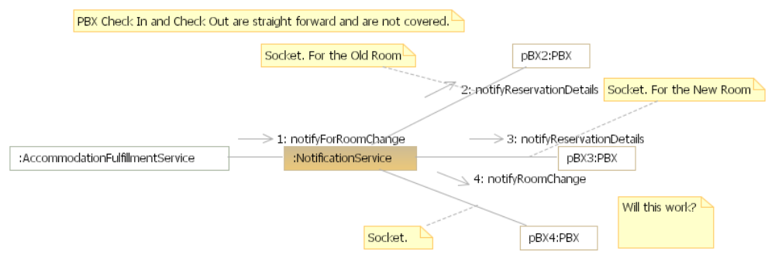
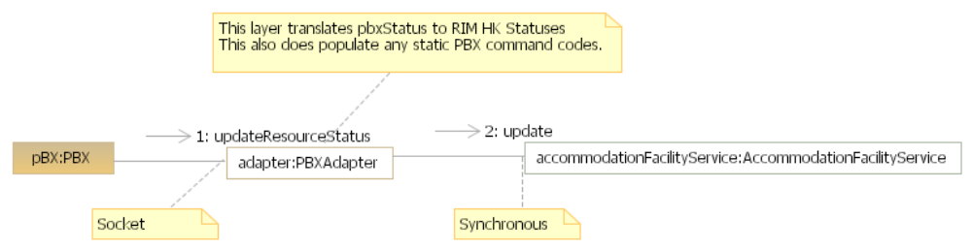
      - RTP Repost
The collaboration demonstrates the process of sending daily hotel charges or electronic coupon tenders to LILO from RTP. RTP InboundAdapter receives the file via FTP and call Folio service to post POS chages.
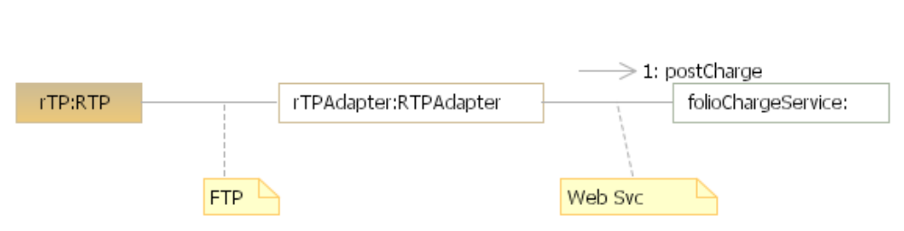

      - Maximo
Maximo is the external system that creates a work order for the service requested. Currently Maximo provides the interface that takes in the required data elements and generates a work order. Maximo is working on updating the existing system to make it more real times. It will provide a single web service interface for all request types (Check in, Checkout, Pickup etc) and return a work order number back to the user
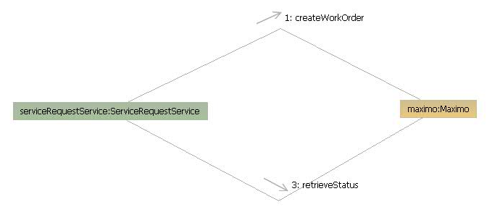
      - Stratus
The collaboration demonstrates the process of Stratus sending the charges from POS systems to LILO.
StratusInboundAdapter receives POS charges via socket connection and calls Folio Service to post the charges into guest folio.
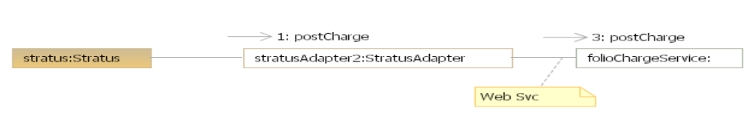
      - XTEND
The collaboration demonstrates the process of sending guest information to XTEND.
XTENDOutboundAdapter receives events from Reservation Management and PBXInboundAdapter and sends guest information as below.
- AccommodationBookEvent to add reservation record, guest added and fixed comments messages.
- AccommodationModifyEvent to update reservation record, delete reservation record, guests added or deleted record and fixed comment added or deleted record.
- ReservationStatusChangeEvent to update the reservation record with status.
- MessageWaitingStatus to update the voice mil count
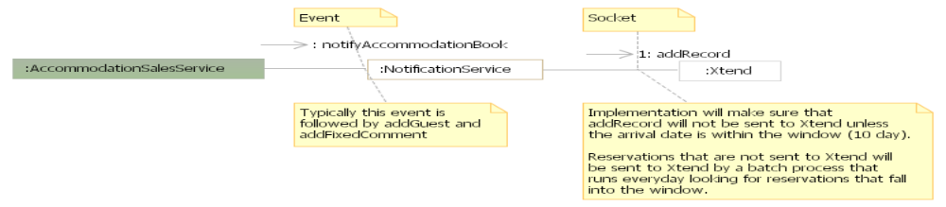
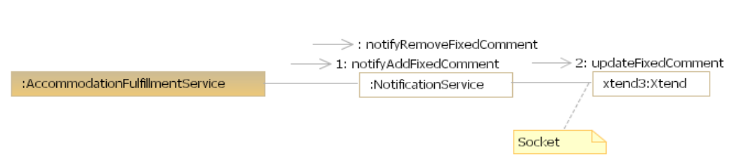
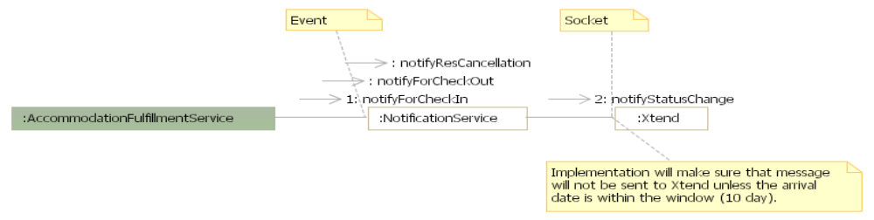
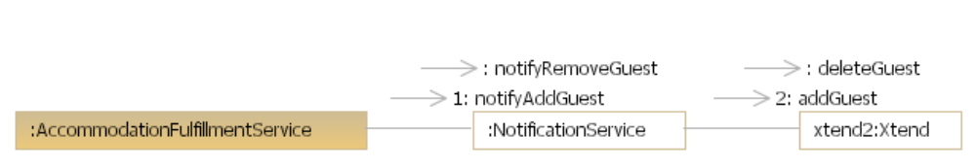
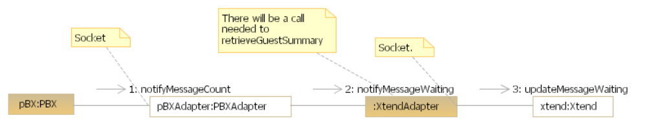

Batch Interfaces
Batch processes (jobs) are triggered by system time and can be broadly classified as –
- Nightly - Scheduled as end of day processes. E.g. Auto cancellation of bookings
- Recurring - Scheduled to execute (typically) every 30 minutes. E.g. Email confirmations
- Daemon - Scheduled to constantly run in back ground. E.g. Revenue recognition
    - System Dates
Nightly scheduled batch processes are run at the end of a business day. The nightly batch schedule for a business process is typically started after date roll. This ensures that the business is closed for that day and the system has all the data it needs to run the end-of-day job.
The application maintains 3 types of dates:

- Current Date: The system date is the operating system date and will roll every mid-night 12 AM EST. The system date is used to stamp the created and updated date-timestamp for all the transactions posted in the system.

- Posting Date: The posting date is recorded as the date against which all the sales and fulfillment transactions (ex. bookings, modifications, check-in, check-out etc) are posted in the system. It is configured at the Campus level. This provides a convenient mechanism for different Campuses to roll their posting dates based on the time zone of the particular Campus (ex. WDW can roll the posting date at 2AM EST while DLR campus can roll the posting date at 5AM EST)

- Accounting Date: The accounting date is recorded against all the accounting transactions. It is configured at a Business Unit level. It is a convenient mechanism to close the financial activity for different Business Units for a particular day (ex. DRC can close their financial activity at 10PM while WDW Resort Ops can close their financial activity at 3AM).
    - Batch schedule
The system maintains ‘batch schedules’ to define timings and dependencies of related batch processes.
      - Selection criteria
Following guideline applies to the selection of business entities in a particular batch process –
Business Process | At Level | Selection Criteria
Sales | Folio | Source
Sales | Inventory | Campus
Fulfillment | Folio | Source
Fulfillment | Accommodation | Resort
Financial Activity | Business Unit | Source
NOTE: Daemons run at the system level and are not configured in Batch schedule.

Batch Schedule | Batch Processes
Sales – WDW P&R | Nightly:  Room inventory feed to Avail  Block inventory feed from Avail  Block inventory feed to DSCS  Block inventory & rate feed to HRMS  Fulfillment feed to ATS  Auto cancel bookings  Send print confirmations  Send print confirmations – DVC  Settle cancelled reservations  Recurring:  Payment feed from Accovia  Payment feed from DCL  Payment feed from Lockbox  Payment feed from Special Events  Send Email confirmations  Send Fax confirmations
Sales – Scheduled Events | SE Inv feed to Avail
Fulfillment –WDW P&R | Nightly:  Roll current date*  Roll booking date  Notify reporting for booking date roll  Assign rooms – today  Assign rooms – future  Release inventory for No-Shows  Remove agent guaranteed flag  Process No-Shows  Forfeit deposits for No-Shows  Settle folios  Express checkout  RTP report  ATS repost  Daily feed to GSR  Recurring:  Incremental feed to GSR  Auto checkout
Fulfillment – Scheduled Events | Roll booking date  Auto arrival
Accounting – DRC Orlando | Roll accounting date  SAP vendor*  Refresh SAP config*  Post approved refunds  Create GL feed  Create CC settlement feed  Create AP – refunds feed  Create AP – commissions feed  Create AR feed  (& corresponding jobs to send each feed to SAP)
Accounting – WDW Resort Ops | Roll accounting date  Post approved refunds  Auto Bankout  Create GL feed  Create CC settlement feed  Create AP – refunds feed  Create AP – commissions feed  Create AR feed  Create Retail Customer feed  (& corresponding jobs to send each feed to SAP)
Accounting – Scheduled Events | Roll accounting date  Post approved refunds  Create GL feed  Create CC settlement feed  Create AP – refunds feed  Create AP – commissions feed  Create AR feed  (& corresponding jobs to send each feed to SAP)
Daemons | Revenue recognition  Room inventory status  Fulfill special request

(* Jobs at system level)

Data Model

Logical Data Model
Please refer to this link on the PMSR SharePoint for the detailed logical data models for DREAMS
<https://wdpr.sharepoint.disney.com/sites/dpmsr/Data%20Analysis/Forms/AllItems.aspx?RootFolder=%2fsites%2fdpmsr%2fData%20Analysis%2fLiLo%20Final%20Design&FolderCTID=&View=%7b889A0D4D%2d549E%2d48EA%2dBCA1%2d5516C09D51A9%7d>

Glossary

The following are the glossary of terms used in this document:

Terms | Definitions
SDS | System Delivery Specification
SE | Scheduled Events
TP | Travel Plan: TravelPlan represents the entire duration of the Guest at the Property. The TravelPlan holds all the reservations made for the length of stay. It stores the guest list for that TravelPlan alongwith the Primary Guest and Settlement Method information of the Guest.
TPS | Travel Plan Segment : TravelPlanSegment represents the owner of the transaction. The construct holds together all the travel components booked for a owner. E.g. WDTC , WDW, DVC etc.
TCG | Travel Plan Grouping: Travel Component Grouping groups together components which are fulfilled together. E.g, Accommodation , tickets for each guest , Dine Plans etc.
TC | Travel Component: These are the actual components booked while making a reservation. These are further categories as Package, Accommodation, Admission and Component Travel Components.
ChargeGroup | An abstracted concept to represent entities that require folios to maintained in the Folio Domain. The concrete concepts for the same are RootChargeGroup and NodeChargeGroup
RootChargeGroup | The RootChargeGroup is a surrogate entity created in the Folio Domain to represent the TravelPlan and Group
NodeChargeGroup | The Node Charge Group is a surrogate entity created to represent Block , Travel Plan Segment and Travel Component Grouping
RSR | Resort Special Reservations
Charge Allocation | The Billing rules defined for a Package, Resort , Revenue Classification for a Guest.
Revenue Type | Revenue Type represents the smallest unit of a charge used for specific accounting purpose e.g Tax ( orange county tax , resort tax), discount( WDTC discount ) , additional charge etc.
Revenue Classification | High level classification of a product sold.
Folio Items | Abstraction for either a ChargeItem or a Payment
Charge | A unit of posting for any sale. Each Charge is composed of one or more charge items
Charge item | Composition of a Revenue Type and the price for the revenue type
TCR | Travel Component Range: The concept of the inventory range for either a single accommodation component or a shared chain of accommodation components.  This has been renamed in the current release as “Assignment Owner”
TCI | Travel Component Inventory: A single unit of inventory. This concept is renamed as ‘Assignment Request’
PMSR | Property Management System Replacement
Release 1 | The first phase of the PMSR program that delivered the housekeeping module
Release 2 | The second phase of the PMSR program that is scheduled to deliver the remaining functionalities to replace DPMS in Fall ‘09
DREAMS | Disney Reservation and entry Management System. The suite of applications covering sales and fulfillment functionalities
RVS | Resort Valet Service
DVC Phase 1B | A Strategic initiative by the Disney Vacation Club business unit to use DREAMS as the reservation system for Member reservations
Member Services UI | The User interface used by DVC Member Services and Teamline to book DVC Member reservations in DREAMS
DVC | Disney Vacation Club
DVC Resort | A DVC Resort is defined as the resort that DVC Members can use the points from the contracts with DVC Corp to stay in the resort
WDW | Walt Disney World
SFTP | Secure File Transfer Protocol
Credit Card Reference Project | A strategic initiative to store Credit Cards in GoldMaster and all other applications in WDW Composite to store the retrieval reference numbers
Payment Gateway/Service | Interfaces defined that provide an implementation to communicate with Stratus for payment postings.
SSL | Secure Socket layer
PCI | Payment Card Industry
DPMS | Disney Property Management System. This is used to represent the legacy system currently deployed at the resorts
DLR | DisneyLand Resort
Nexus | XML Interface that communicates with ATS
Galaxy | Ticketing System at DLR
Maximo | Single Interface to communicate with the Dispatching Systems

Signature Page

Darla Morse, VP, Information Technology Date

Jerry Gaudette, VP, Information Technology Date

Jenni Johnson, Director, Information Technology Date

Lance Wilson, Director, Information Technology (Architecture) Date

Snehal Desai, Director, Information Technology (Data Strategy) Date

Len Dudis, PMSR Program Manager Date

Jason Harrell, DVC Program Manager Date

Paul Masterson, PMSR Application Architect Date

Beth Wenner, PMSR Project Manager / Requirements Lead Date

Paul Simons, PMSR Business Manager Date

Dusti Wojciechowicz, Resort Operations Manager Date

Trish Carlson, WDW Finance Manager Date

Margaret Martin, Senior Analyst, WDW Finance Date

Jeff Gades, IT Manager, Application Architecture Date

John Yancey, IT Manager, Data Architecture Date

Michelle Blackwell, PMSR QA Manager Date

David Guimbellot, IT Manager (Performance Testing) Date

Karthik Krishnamoorthy, PMSR Technical Manager Date

Brian McAulay, PMSR Data Conversion Lead Date

Gaurav Gupta, PMSR Data Quality Lead Date

Joe Richards, IT Manager (D3 / BI / Reporting) Date

George Masterson, IT Project Manager (DREAMS) Date

Tom Oliveri, IT Project Manager (Pricing, Recommender) Date

Kevin Fittro, IT Manager (Availability) Date

Caroline Musgrove, DREAMS Production Support Project Manager Date

Gary Daniels, IT Manager (One Source) Date

James Browne, IT Manager (Disney Ticketing Interface) Date

Kim Baker, IT Manager (Go Master) Date

Vicki Stone, IT Manager (EAI) Date

Dawn Ellis, Disney IT Security and Compliance Date

